What report should we see for PO with amend date greater than effective date?
We have a report for PO with amend date greater than effective date
PURCHASE&PROCUREMENT>>PURCHASE MIS>>1ST TAB (PO/PR Related)>>list of PO Amd.dt>effective dt
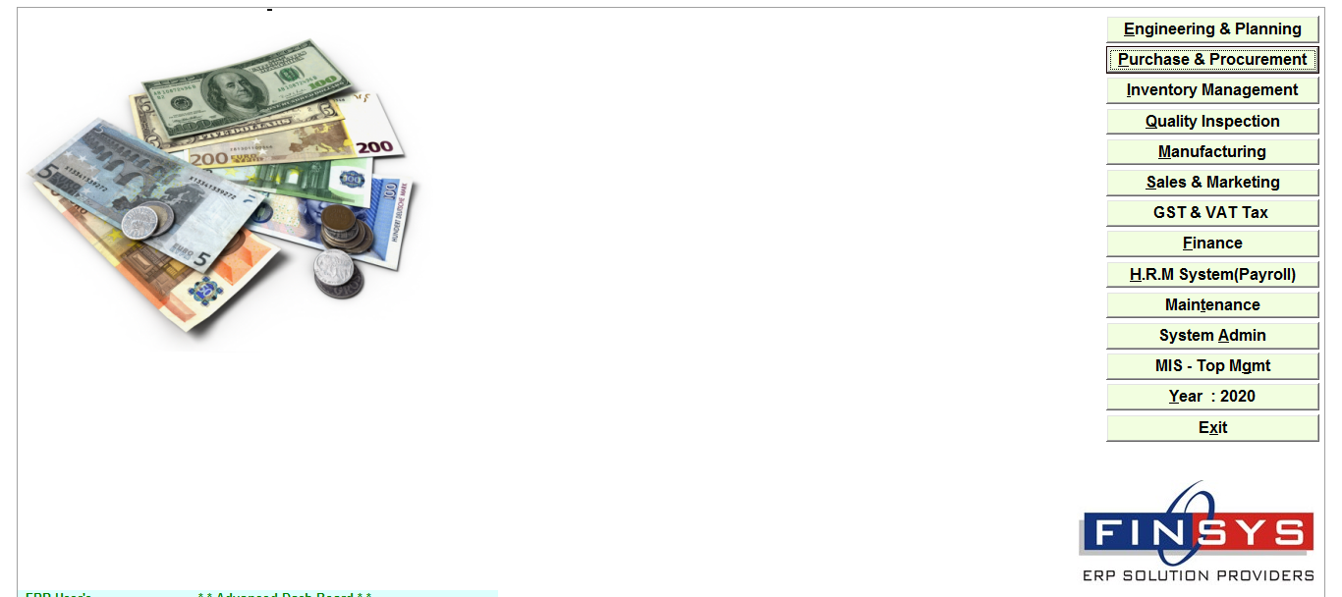
PURCHASE&PROCUREMENT
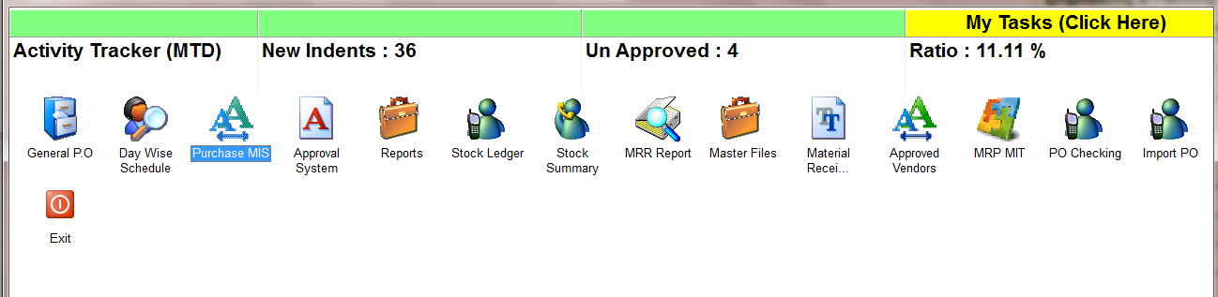
PURCHASE MIS
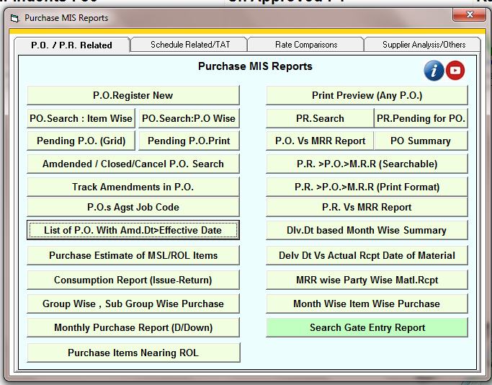
list of PO Amd.dt>effective dt
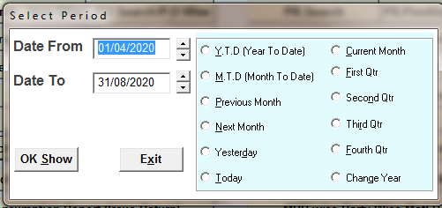
SELECT THE TIME PERIOD
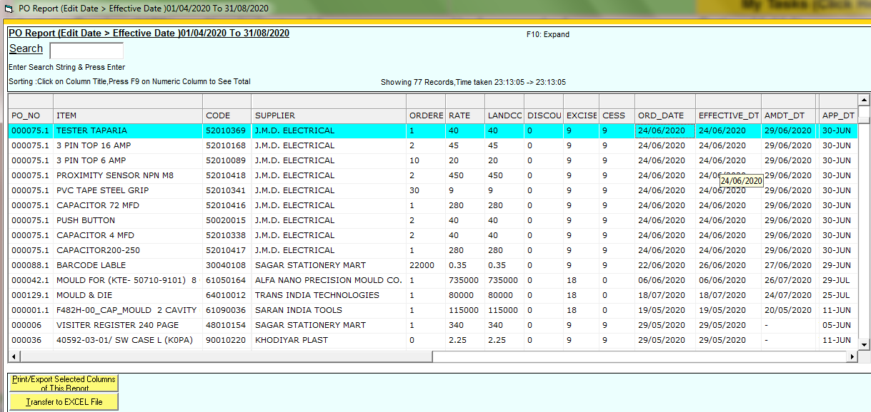
Here is showing the effective date of PO
And the amend date is exceeded with effective dt.

