What option should we use for clear multiple MRR/SRR.
We have option for clear multiple MRR/SRR
FINANCEVOUCHER ENTRYCLEAR MRR/SRR
This is use for 04(rejection MRR) and for inter unit transaction that you don't want to appear in accounting
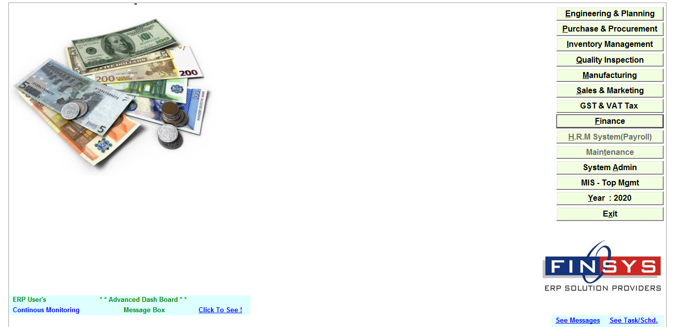
Click Finance module
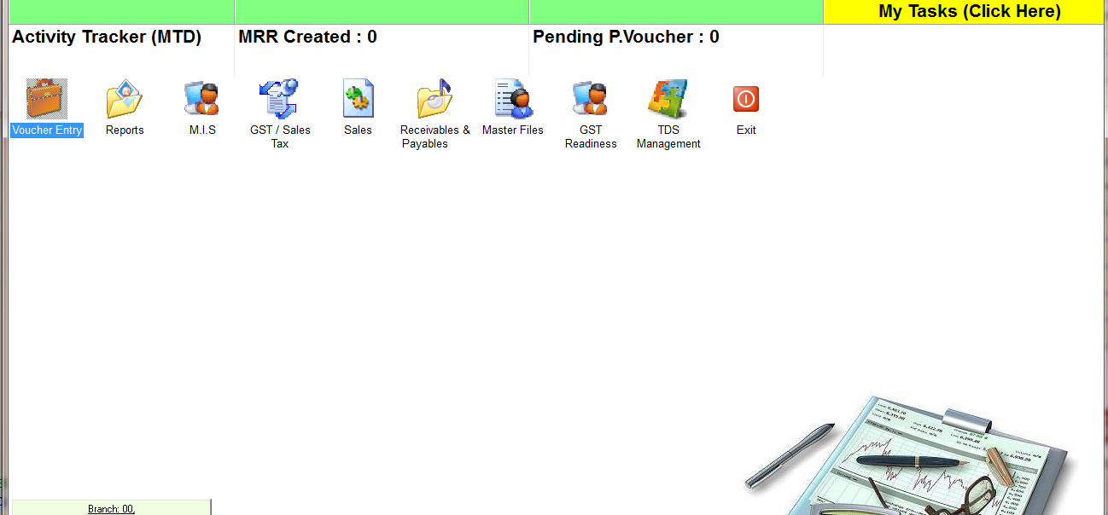
ClickVoucher Entry
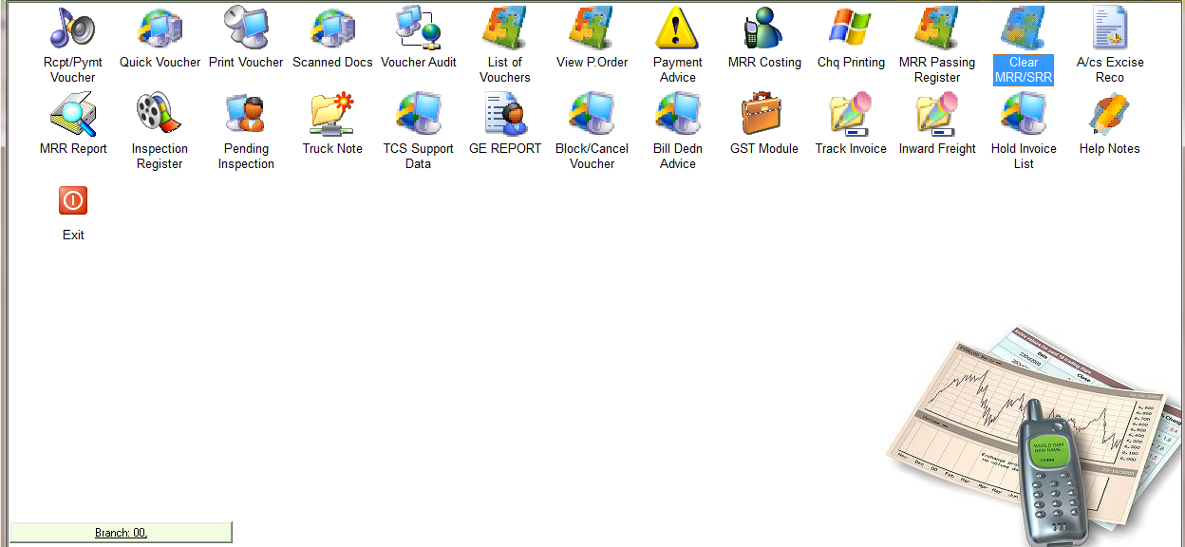
ClickClear MRR/SRR

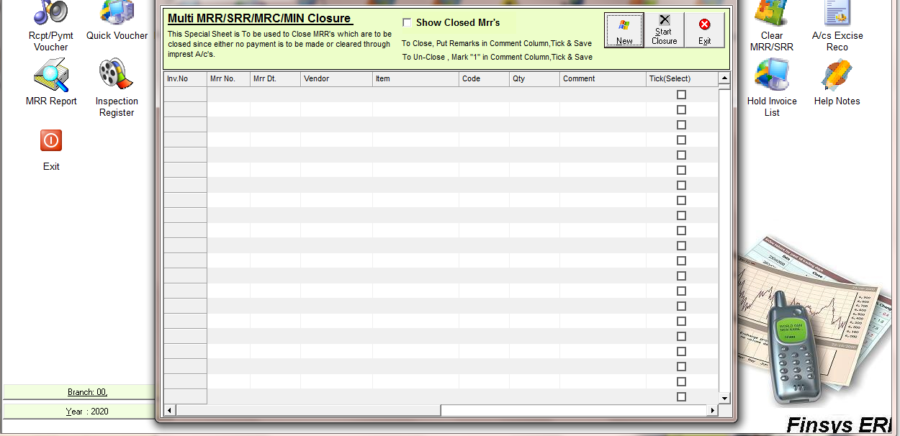
ClickNew button

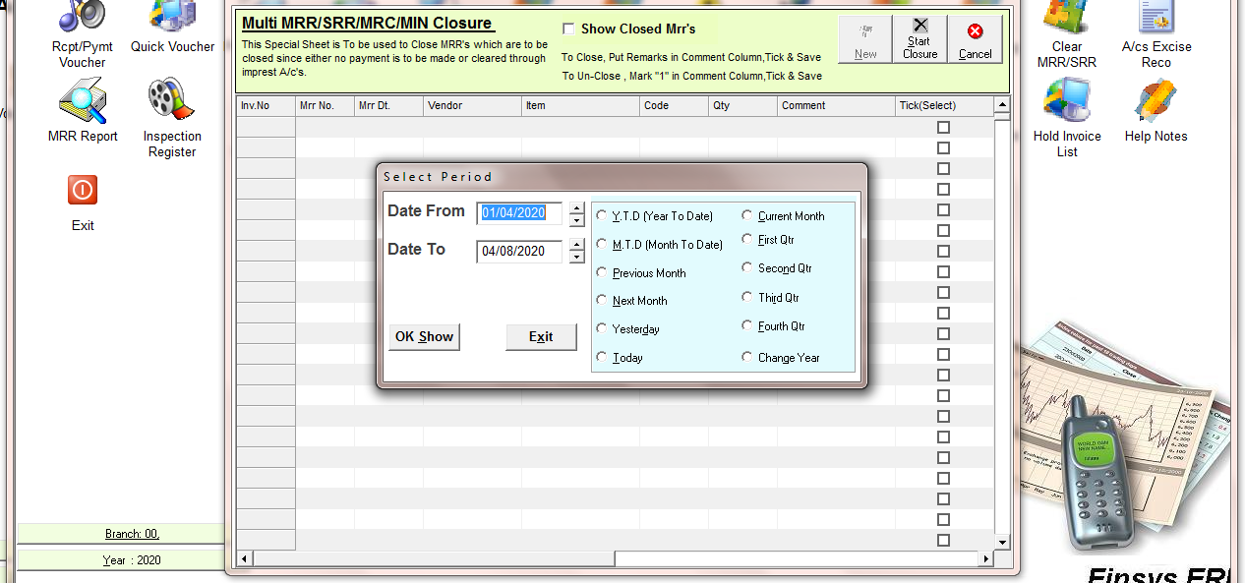
Please select time period
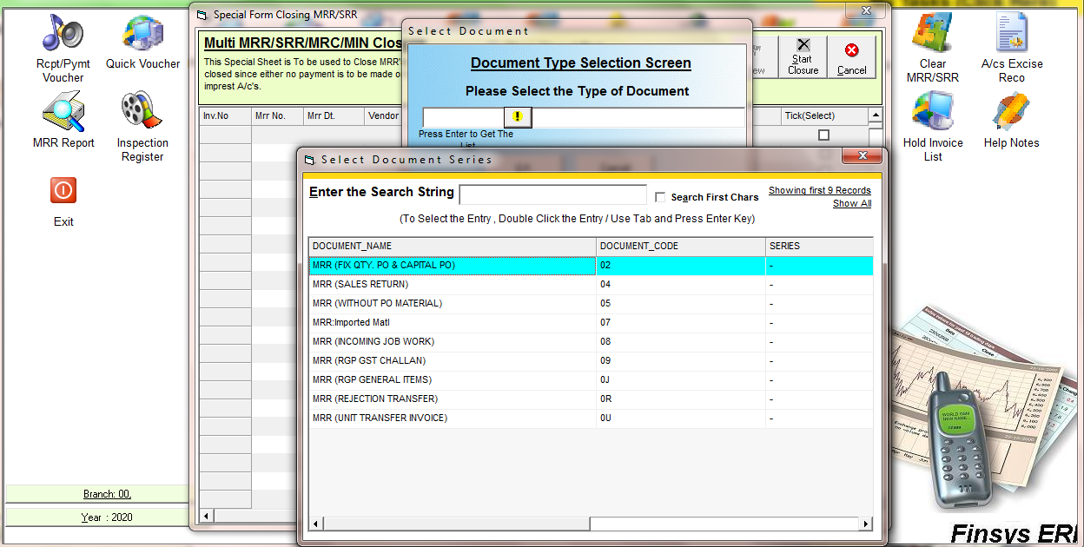
Select the MRR/SRR type

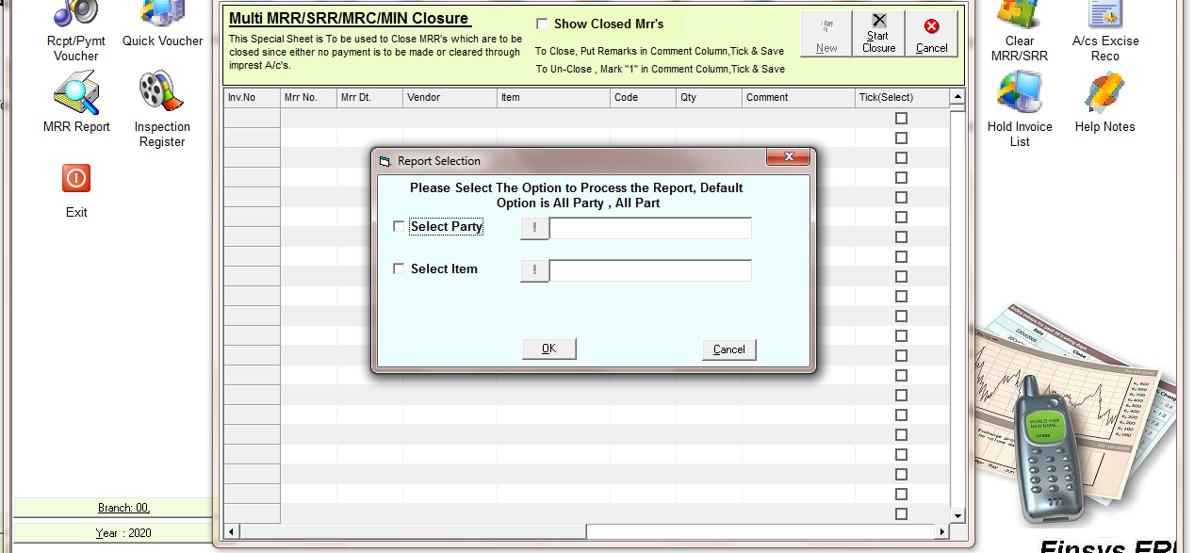
Select the party name if you want to see of specific party

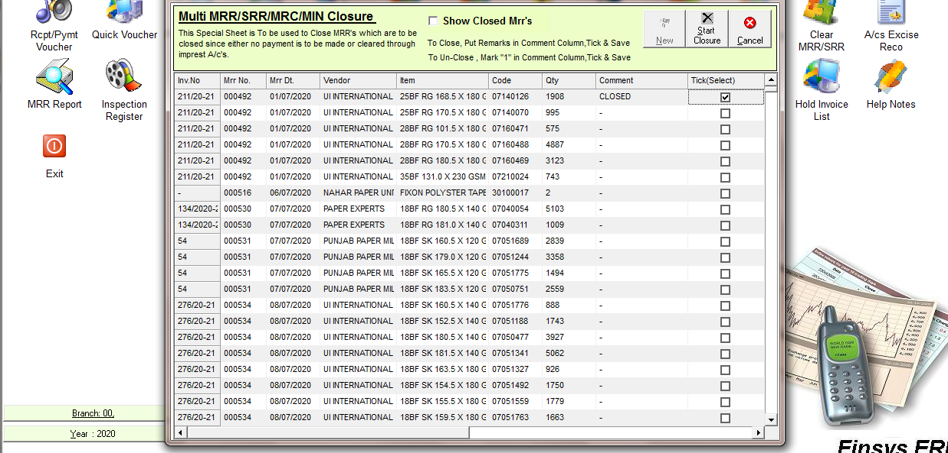
Put the Comment and tick the check box
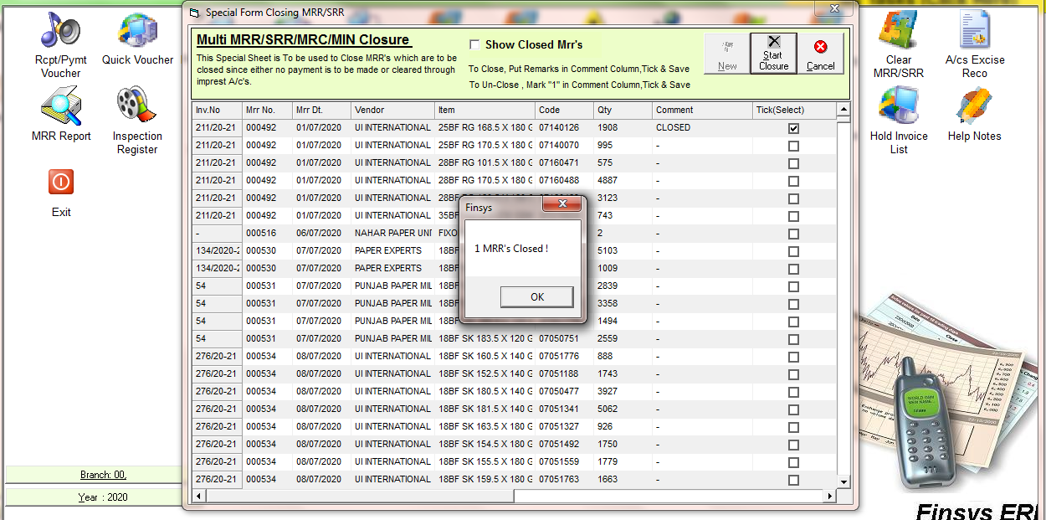
ClickSave

