Can we see the MRR report?
YES, we have MRR report
FINANCE>>VOUCHER ENTRY>>MRR REPORT
MRR report available
FINANCE
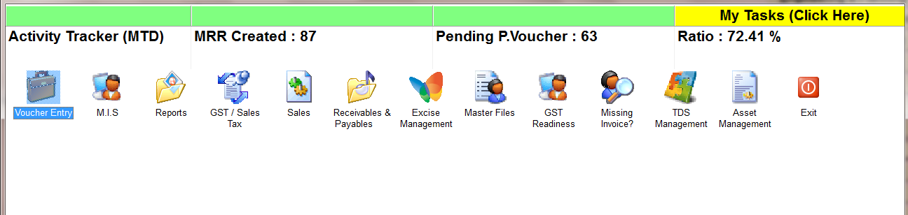
VOUCHER ENTRY
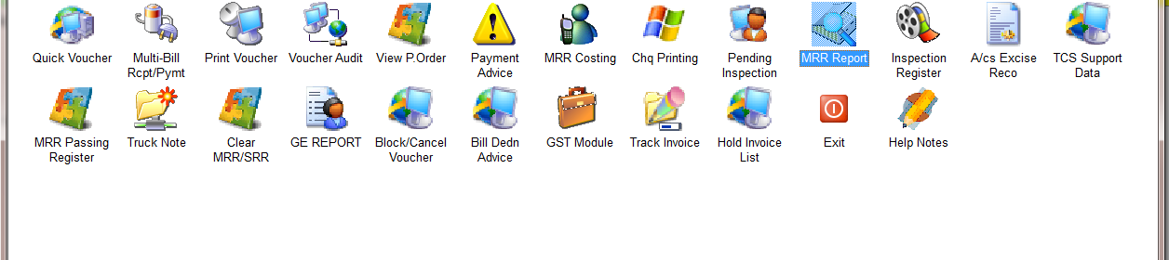
MRR REPORT
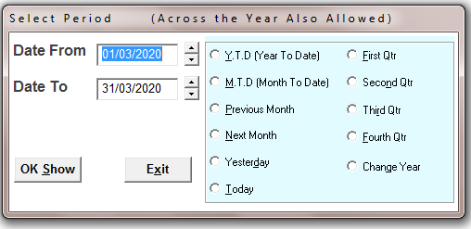
SELECT THE TIME PERIOD
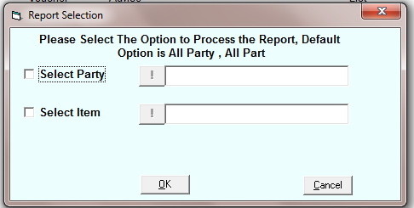
SELECT THE PARTY AND ITEM OR FOR ALL PRESS OK
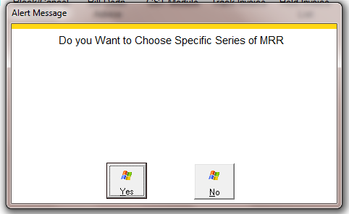
SELECT THE OPTION
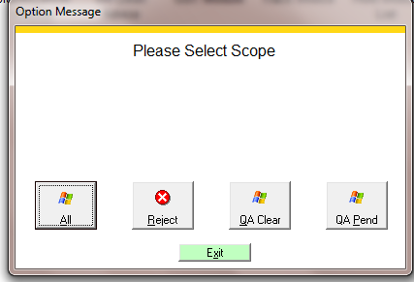
SELECT THE OPTION

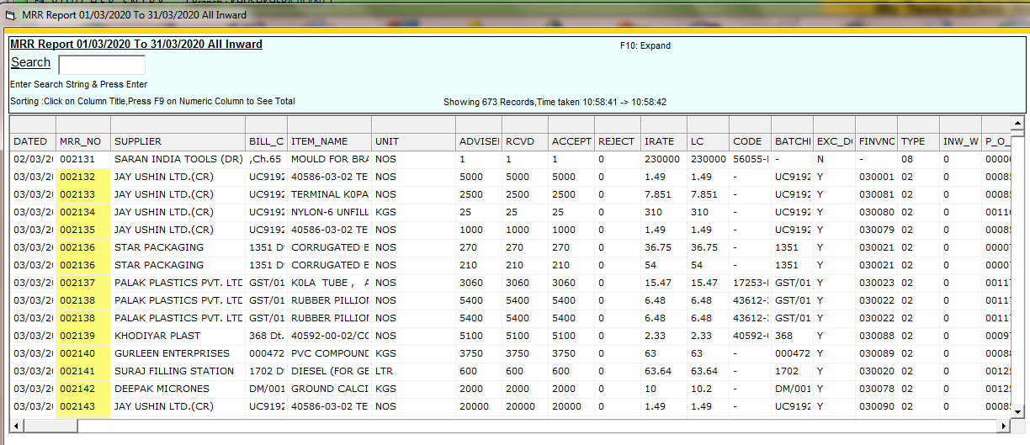
Left side
Shows me all item, quantity, vendor, MRR no etc details

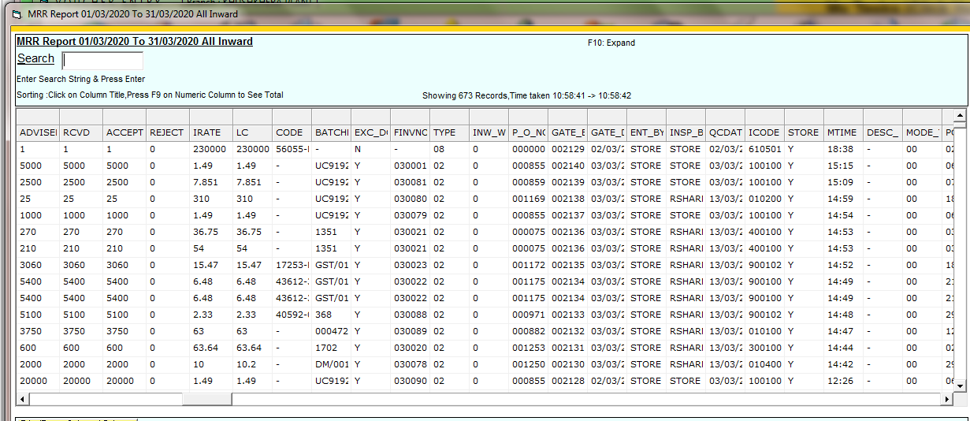
Middle side
Shows me the rate, the landed cost, the bill no, whether excisable or not
Which financial voucher etc

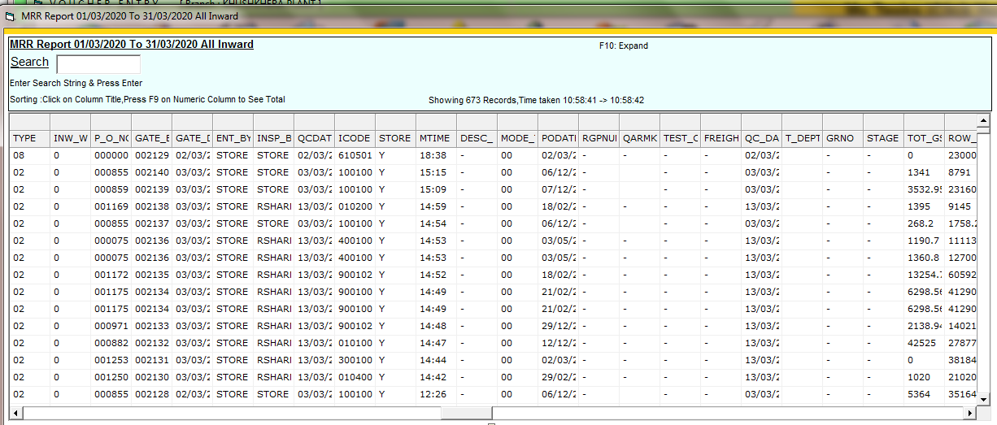

3rd part shows me the entered by
Inspected by
Gate entry Date time etc
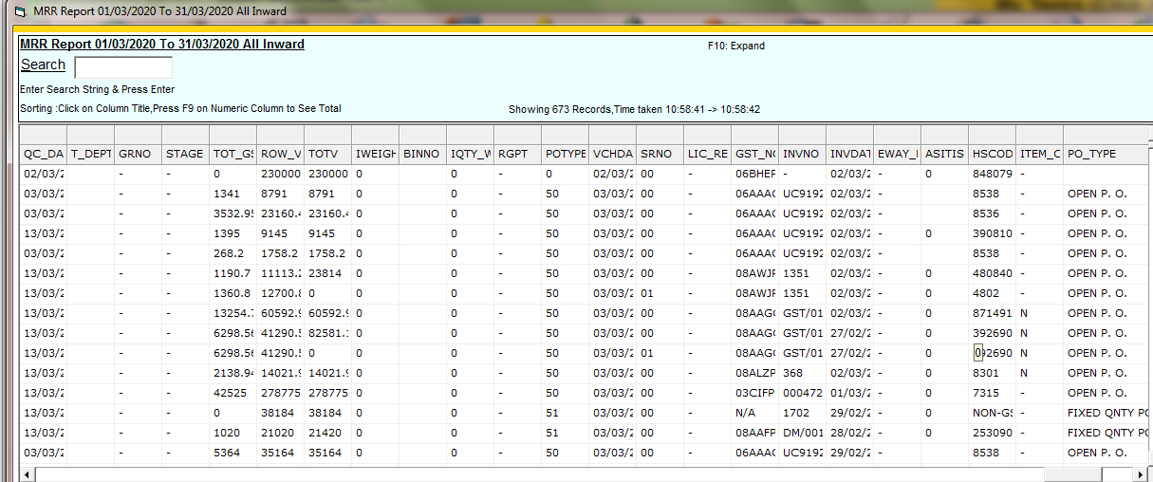

Last part shows me the transporter details etc

