How to see Raw Material Issuance against FG Production
ENGINEERING PLANNING>>BACK FLUSH
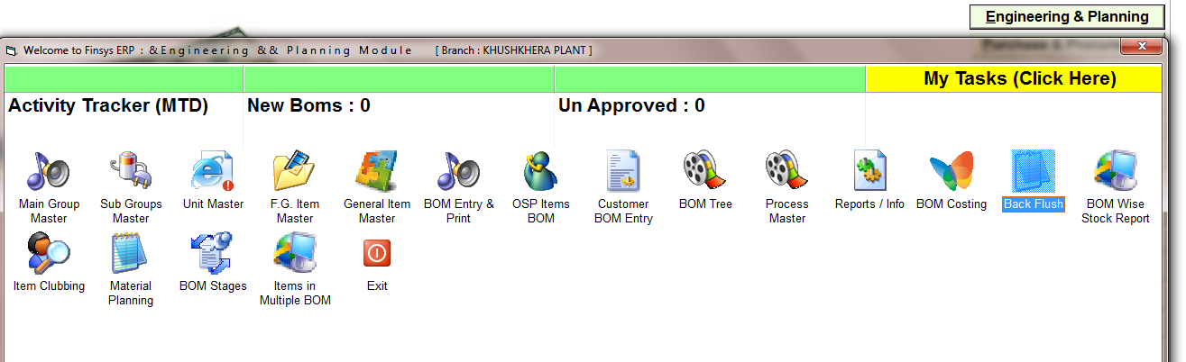

ENGINEERING PLANNING>>BACK FLUSH

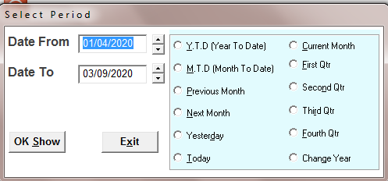

SELECT THE TIME PERIOD

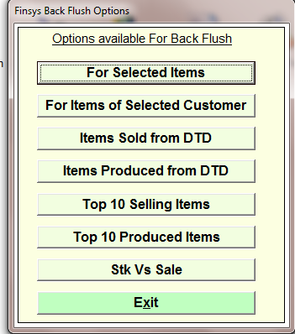
FOR SELECTED ITEMS

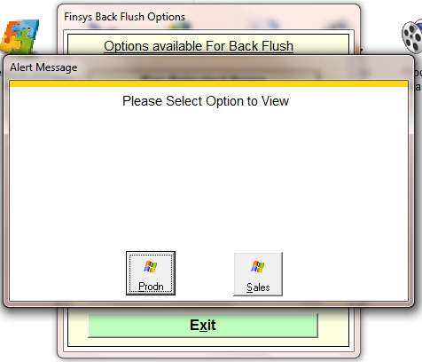
CHOOSE THE OPRION
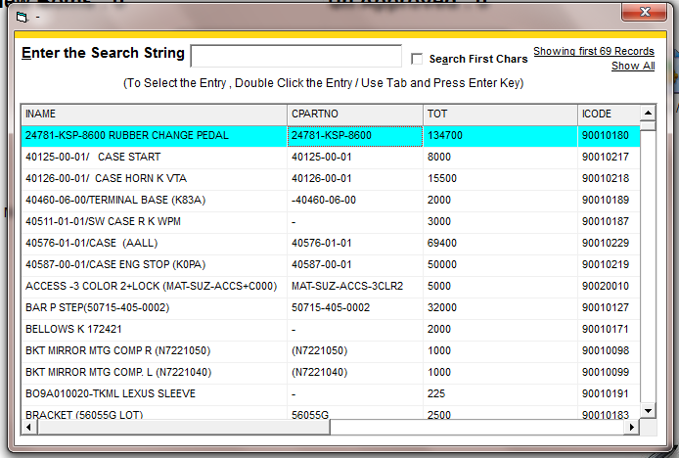
SELECT THE ITEM
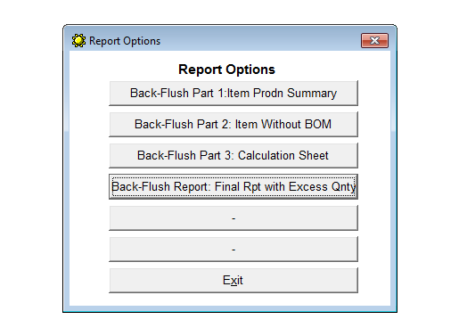
BACK-FLUSH REPORT: FINAL RPT WITH EXCESS QNTY
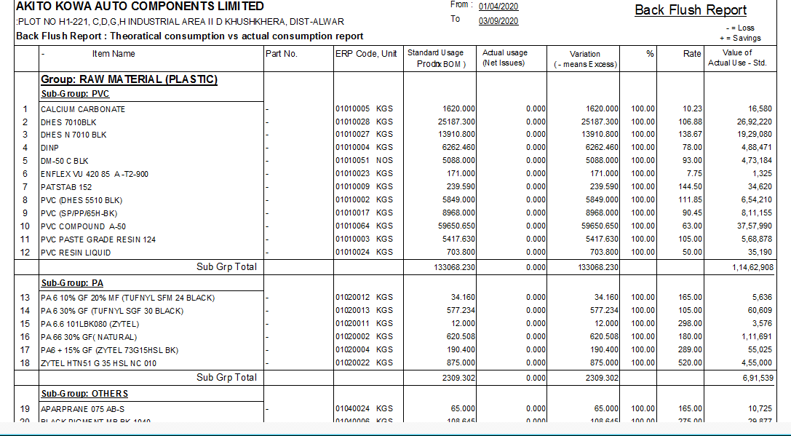

REPORT

