How can we use of conversion PO for material purchase?
The purchase cycle of conversion unit
Conversion PO=PURCHASE&PROCUREMENT>>GENERAL PO>>CONVERSION PO

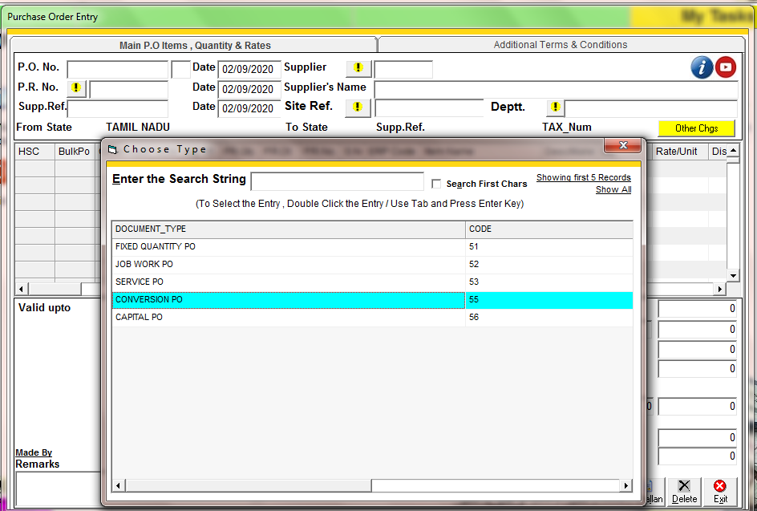
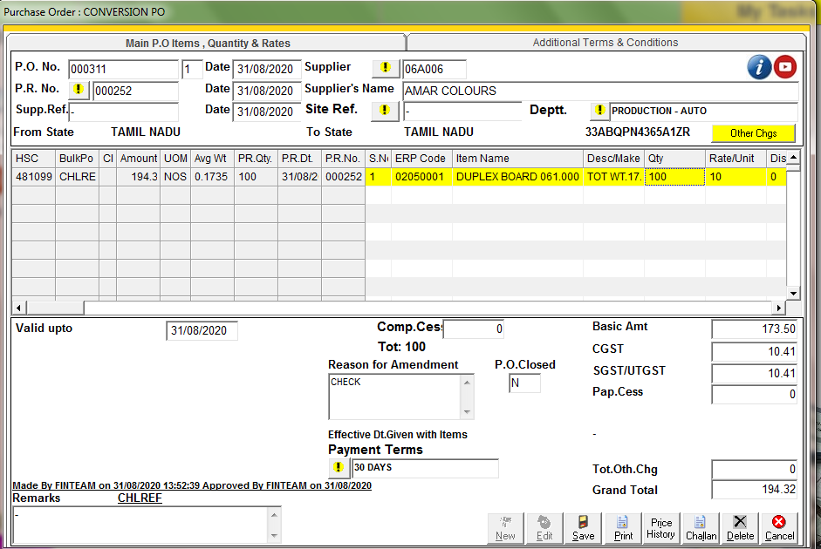CONVERSION PO
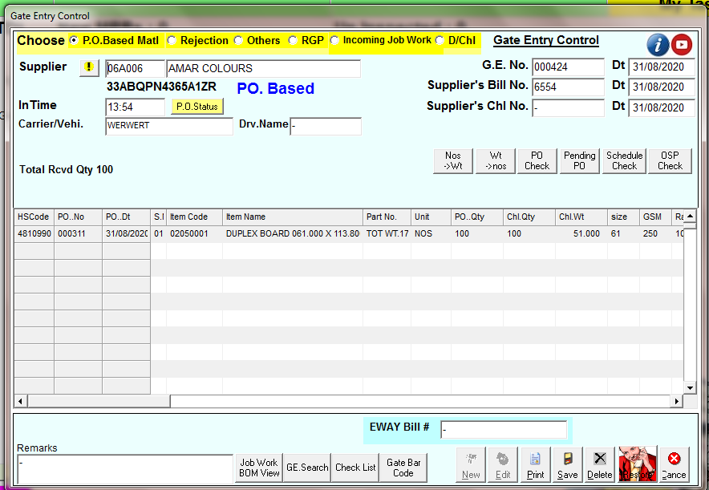
GATE ENTRY
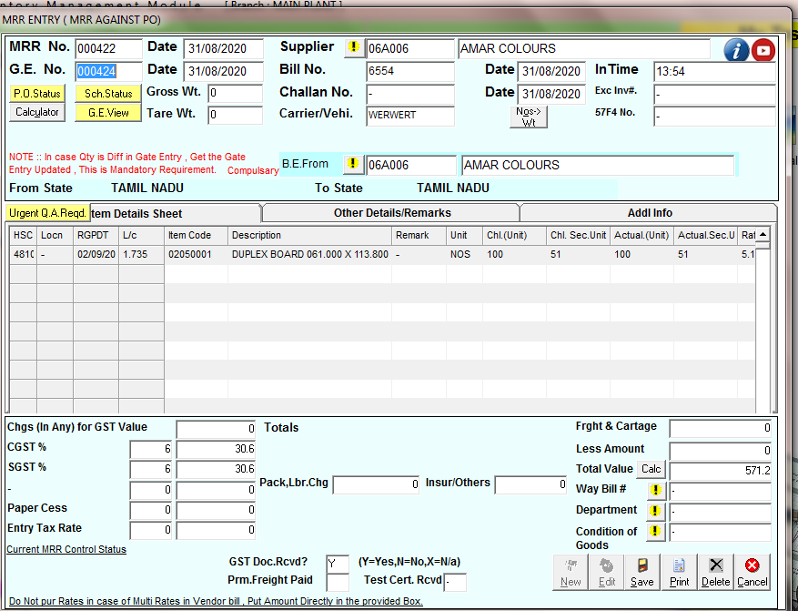
MRR ENTRY
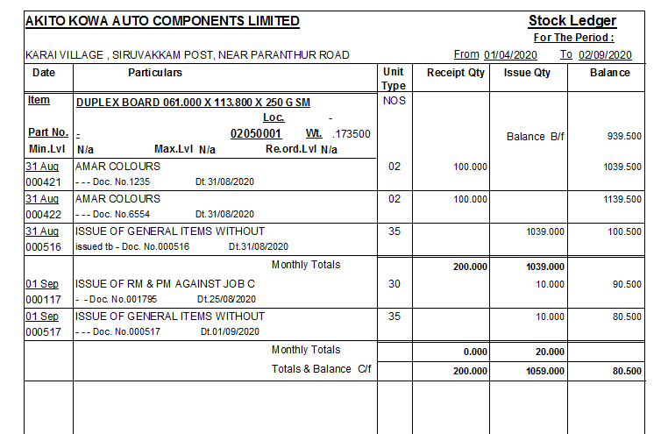
STOCK LEDGER REPORT:- HERE IS SHOWING THE QTY OF ITEM AND UNIT TYPE
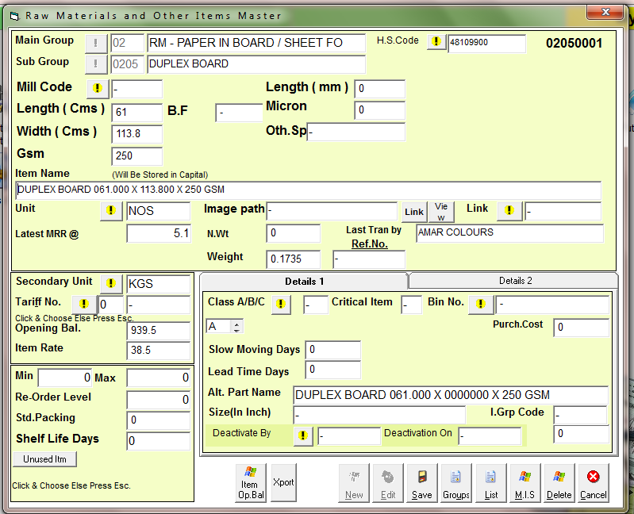
We have to put secondary unit in item master for conversion unit purchase

