How can we see where is an item how is it used?
We have a report for where is an item how is it used.
INVENTORY MANAGEMENT>>ITEM REVIEW

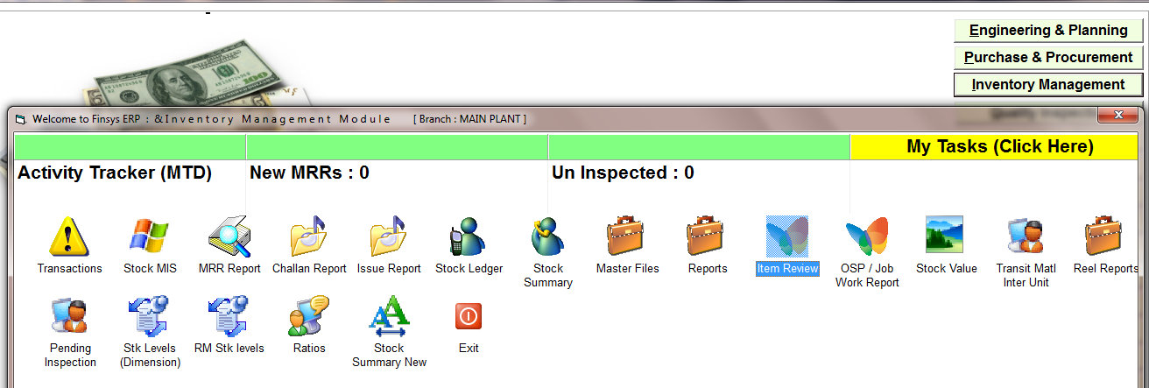

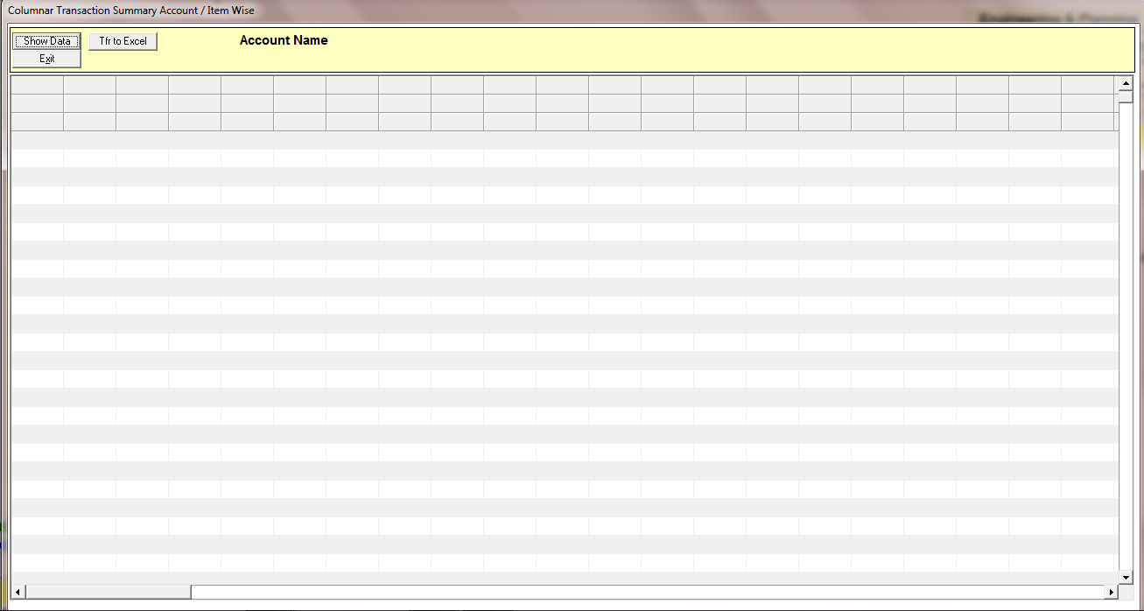
PRESS ON SHOW DATA

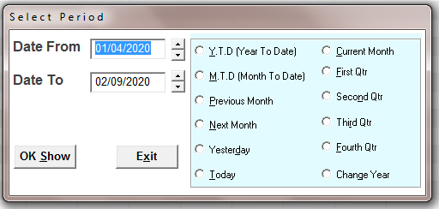
SELECT THE TIME PERIOD

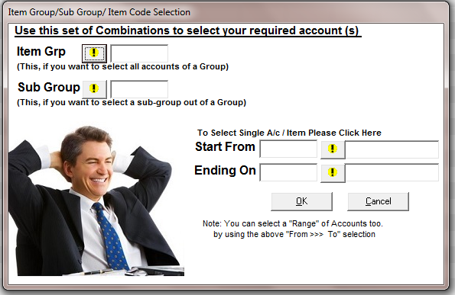

SELECT THE ITEM OR PRESS ON OK FOR ALL
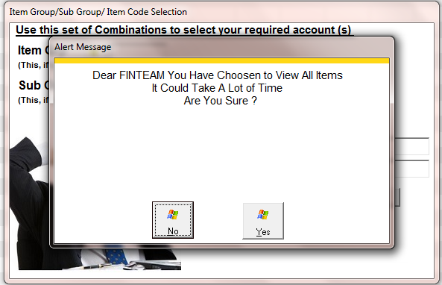

PRESS ON YES FOR ALL
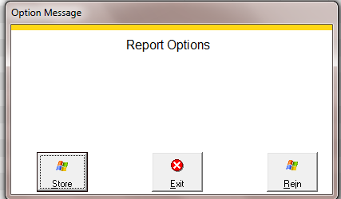
CHOOSE TE OPTION
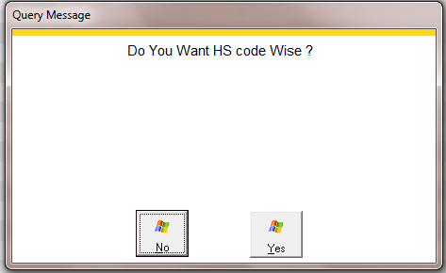

CHOOSE THE OPTION

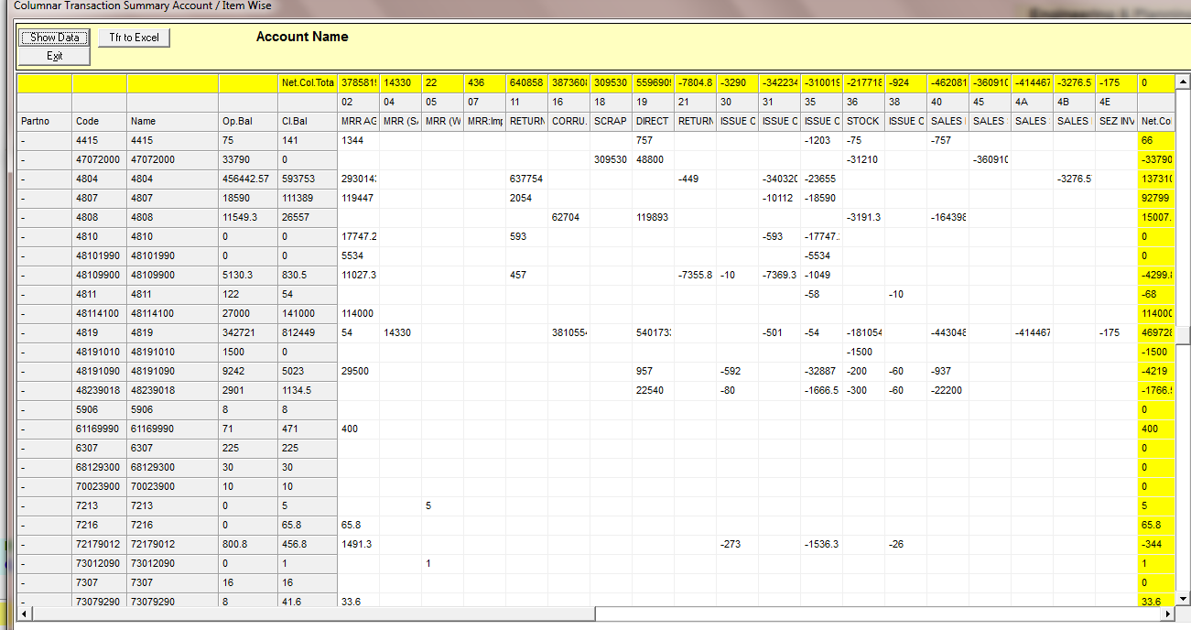
HERE IS SHOWING EVERY TYPE OF ENTRY WITH ITEMS LIKE- TYPE OF MRR, RETURN, ISSUE ENTRY, SALE INVOICE

