How can we see gate entry report without login with gate user?
We have a report in inventory management module
Inventory management>>reports>>GE register
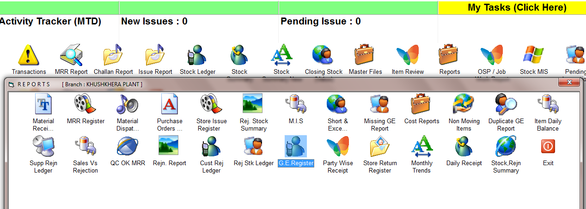

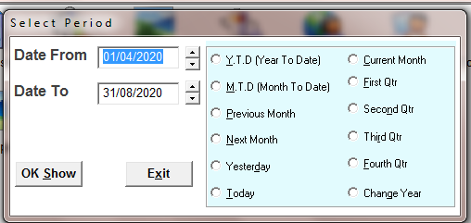
SELECT THE TIME PERIOD
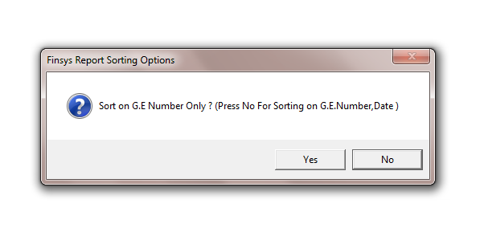
CHOOSE THE OPTION
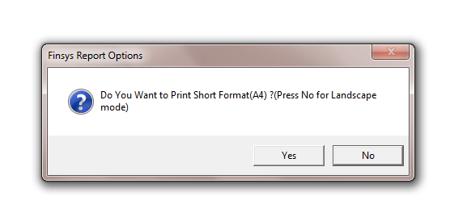
CHOOSE THE OPTION
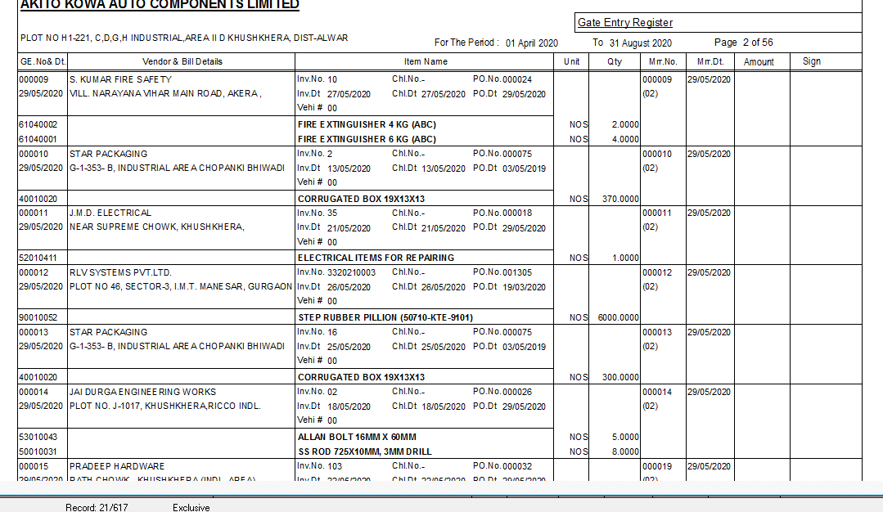
GATE ENTRY REPORT

