Can we see report of item group wise rate history?
Yes, we have a report for item group wise rate history
PURCHASE&PROCUREMENT>>PURCHASE MIS>>3RD TAB (RATE COMPARISON)>>RATE HISTORY SHEET
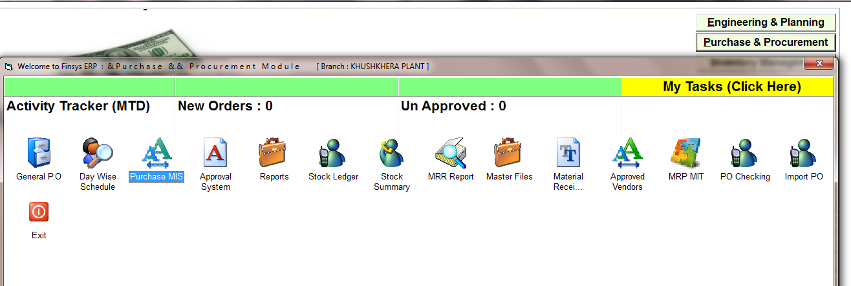

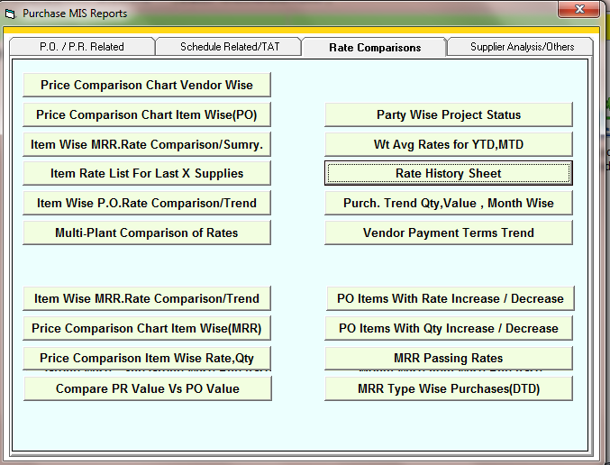
RATE HISTORY SHEET
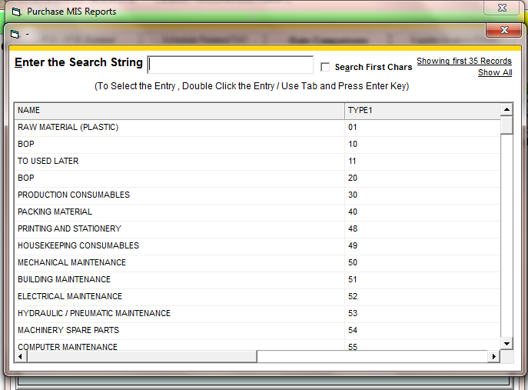

SELECT THE ITEM GROUP OR PRESS ESC FOR ALL

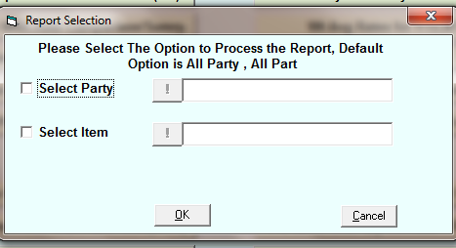

SELECT THE PARTY OR ITEM AND PRESS OK FOR ALL
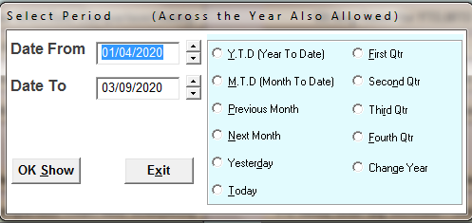

SELECT THE TIME PERIOD

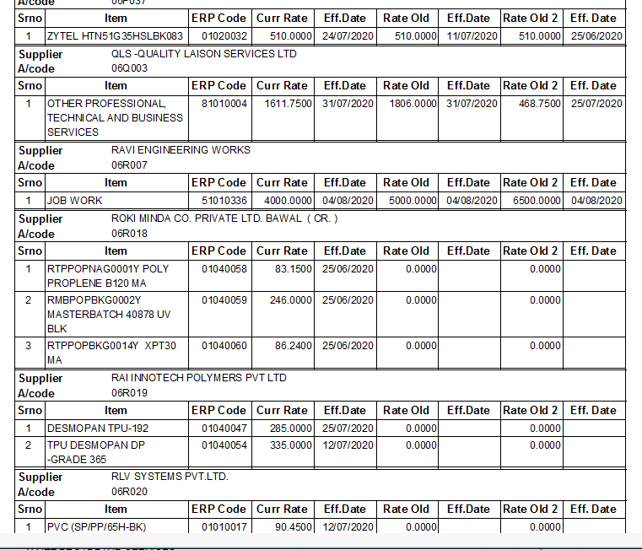
HERE IS SHOWING OLD AND CURRENT RATE OF ITEM

