Can we get the report of reel wise movement of MRR?
YES, we have a report for reel wise movement of MRR.
INVENTORY MANAGEMENT>>REEL REPORTS>>REEL INQUIRY
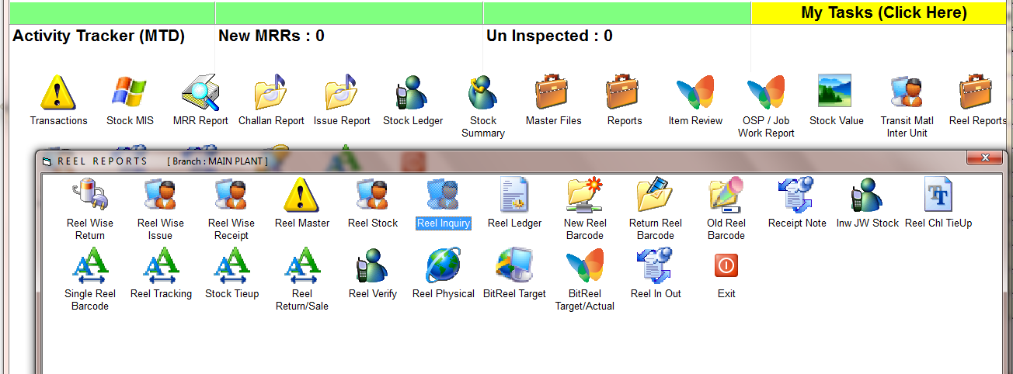

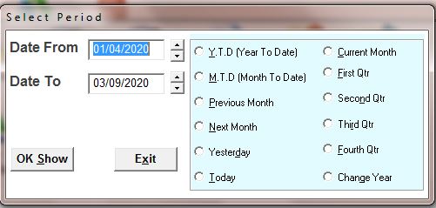
SELECT THE TIME PERIOD
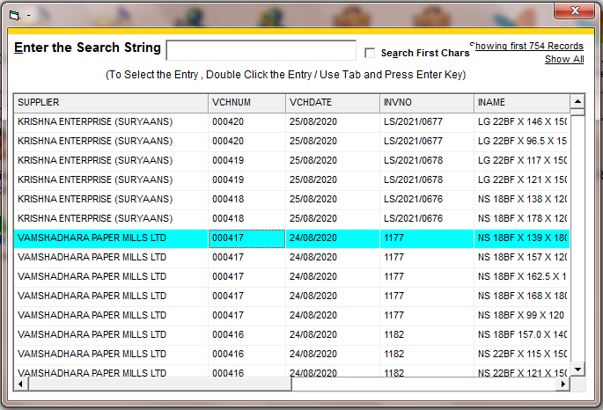
SELECT THE MRR
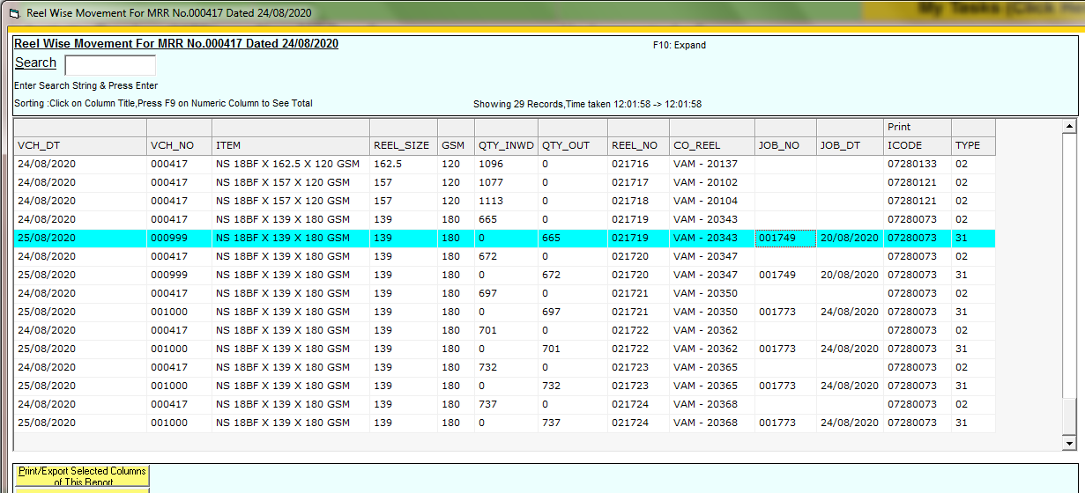
HERE IS SHOWING REEL WISE MOVEMENT REPORT.
IN THE LAST COLUMN SHOWING TYE OF ENTRY:- MRR, ISSUE

