Can we get the GST data to file return from finsys?
Yes, GST data is available in finsys for file return…
FinanceVoucher entryGST ModuleGST Tax Data
Click:- Finance module
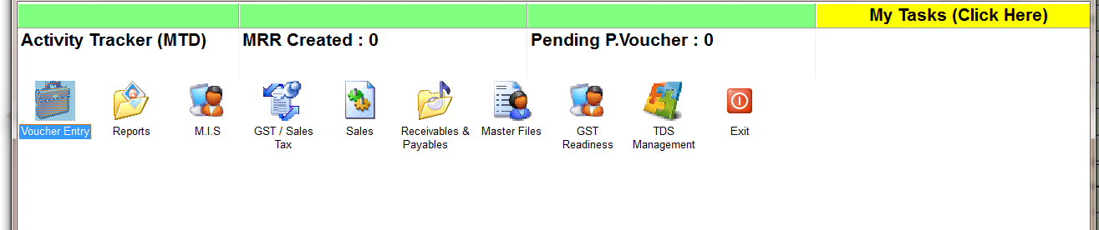
Click:- Voucher entry

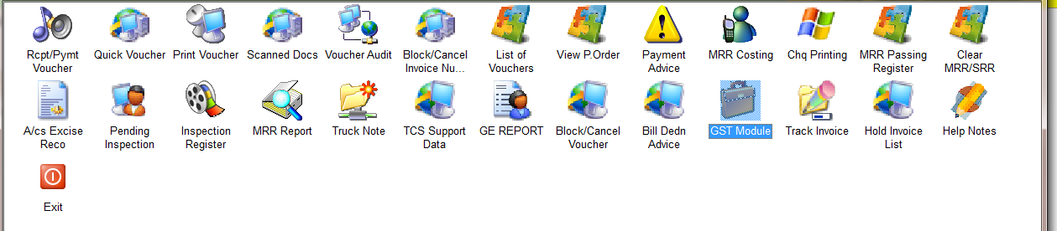

Click:- GST Module

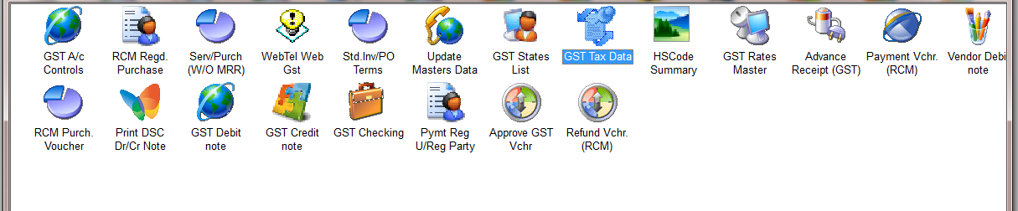

Click:- GST Tax Data

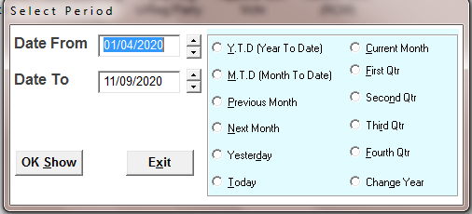

1Select the time period

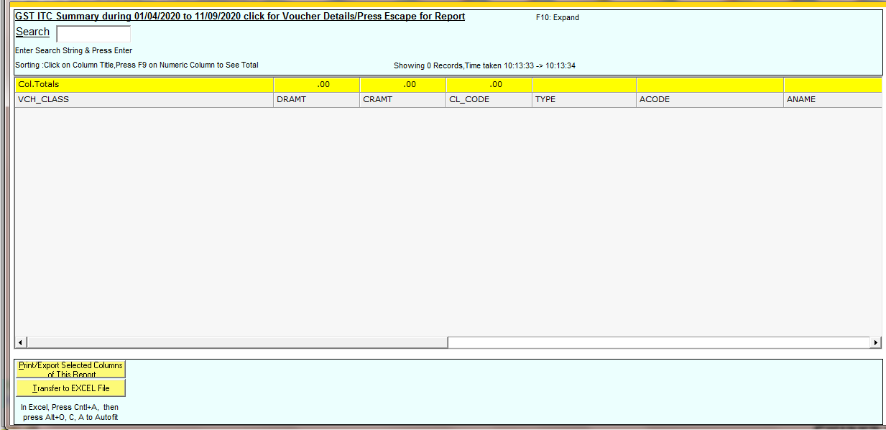

2Press Esc and select branch

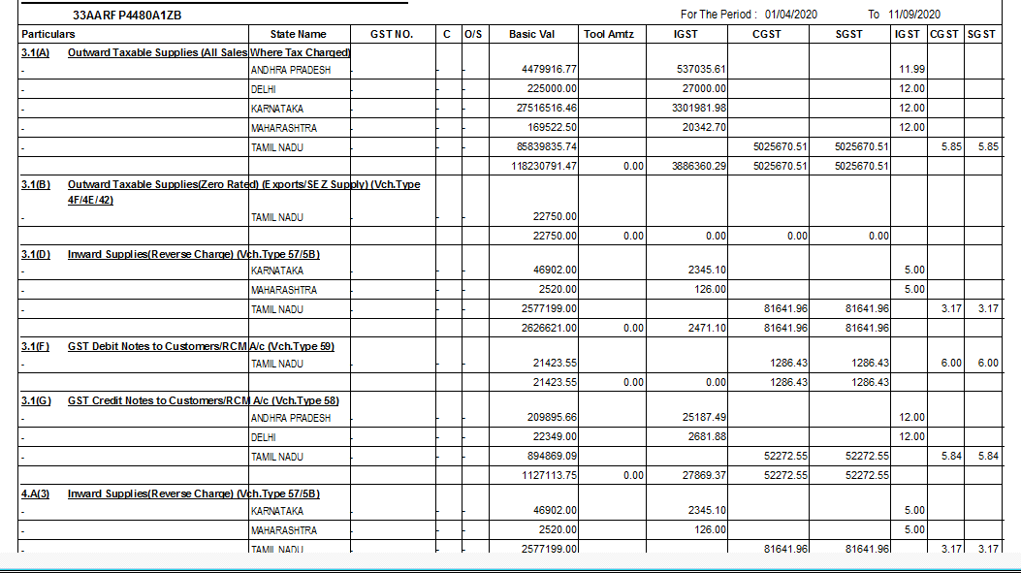

3 Data open

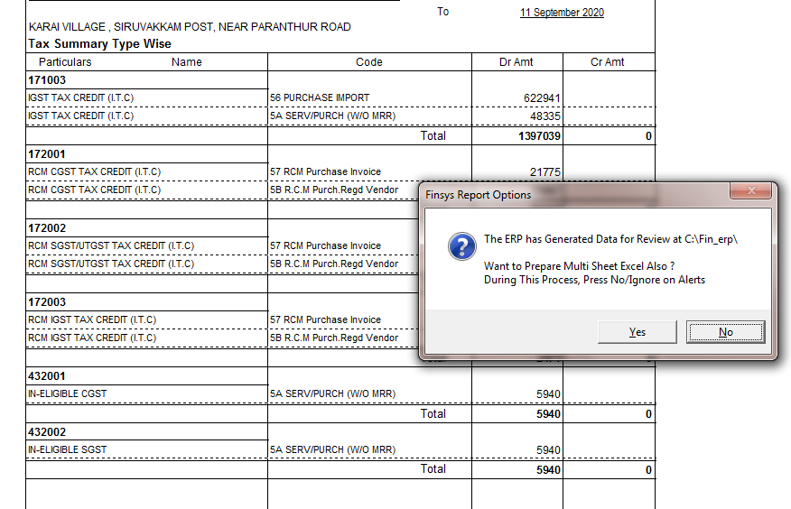

4 If you want to get multiple sheet in excel press on YES else No

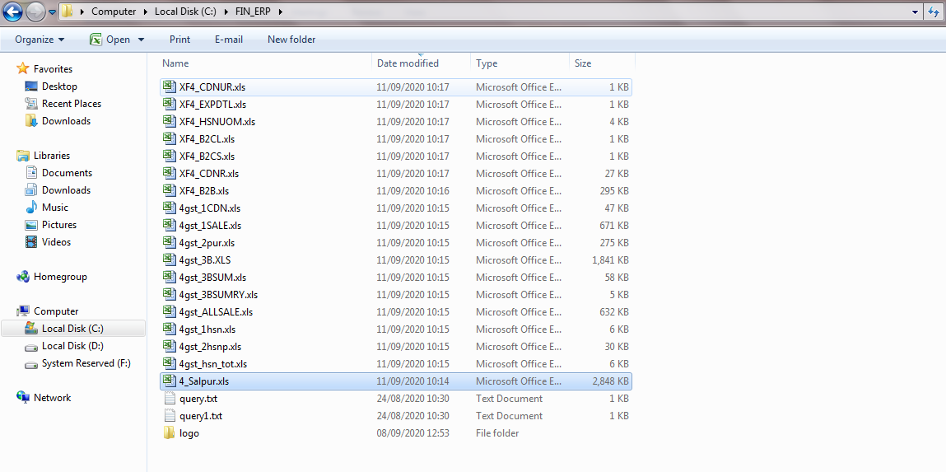
5Data saved in C driveFIN_ERP folder

