Can we do the cheque setting in Finsys from the front end?
Yes. In the finsys cheque setting is available
FinanceMaster FilesVoucher Type Master

Click:- Finance Module
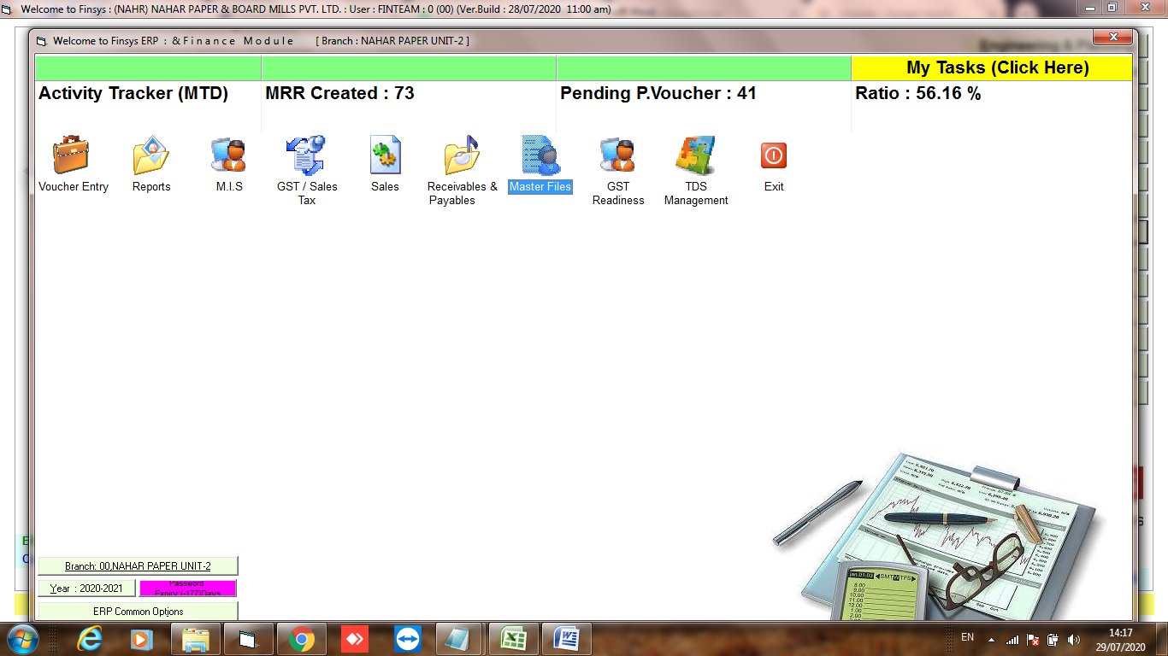
Click:- Master Files
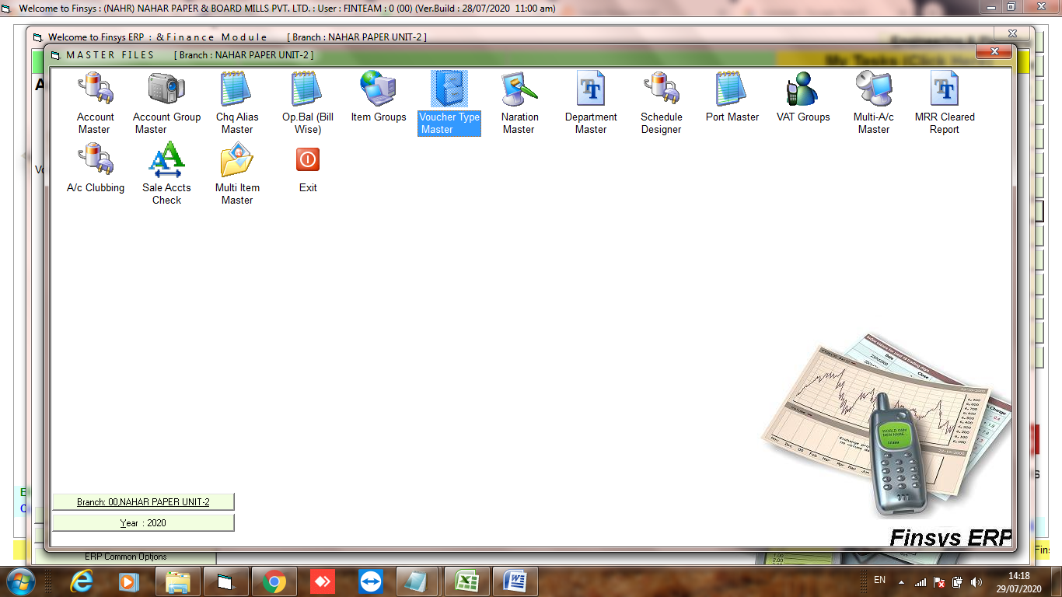
Click:- Voucher Type Master
Click:- Edit and open payment voucher type

Click:- 3rd Tab Cheque setting and do the changes then save
Change approx 75-100 pixel at a time
Increase left value to shift towards right
Increase top value to shift towards bottom
Put zero top and zero left for no printing

