Which report we should see for value of supplier? Rejection with us.
We have report for value of supplier? Rejection with us.
INVENTORY MANAGEMENT>>CLOSING STOCK VALUE.
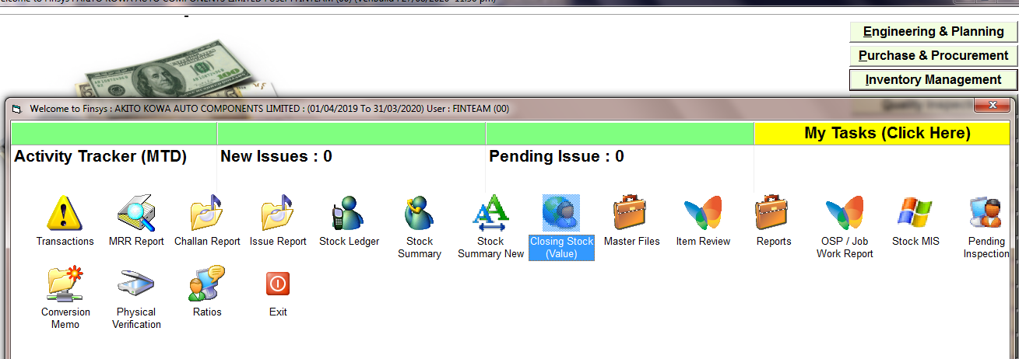

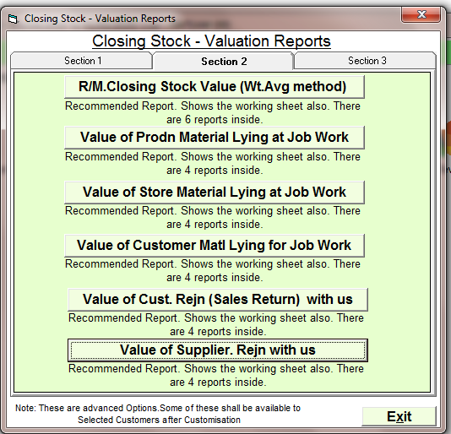
CLICK ON VALUE OF SUPPLIER. REJN WITH US
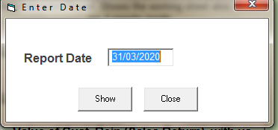
ENTER THE DATE
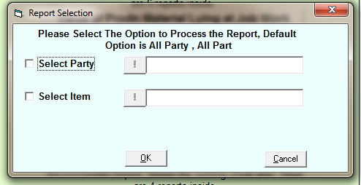
SELECT THE PARTY OR ITEM OR PRESS OK FOR ALL
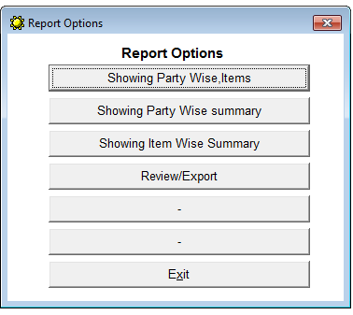
CHOOSE THE OPTION I PRESS PARTY WISE SUMMARY

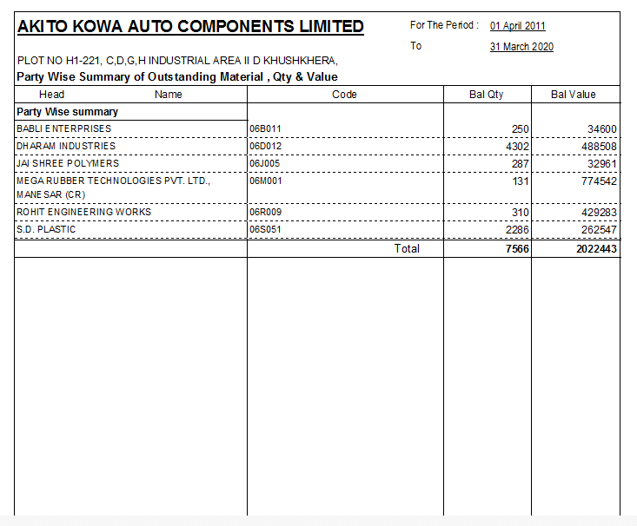
REPORT OF REJN WITH US
FOR THE RE CHECK THE REJN REPORT
WE CAN CHECK THE REJN IN THIS REPORT CLICK ON FOR CHECK
INVENTORY MANAGEMENT>>MRR REPORT
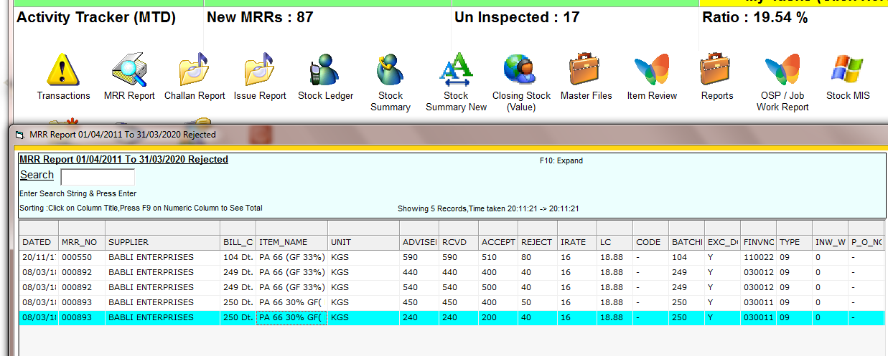
HERE IS SHORING THE REJECTION MATERIAL WITH US

