What report should we see for vendor PO pending MRR of multi plant?
YES, we have a report for vendor PO pending MRR of multi plant
PURCHASE&PROCUREMENTPURCHASE MIS2nd TAB (Schedule related/TAT)MULTI PLANT: VENDOR PO PENDING MRR
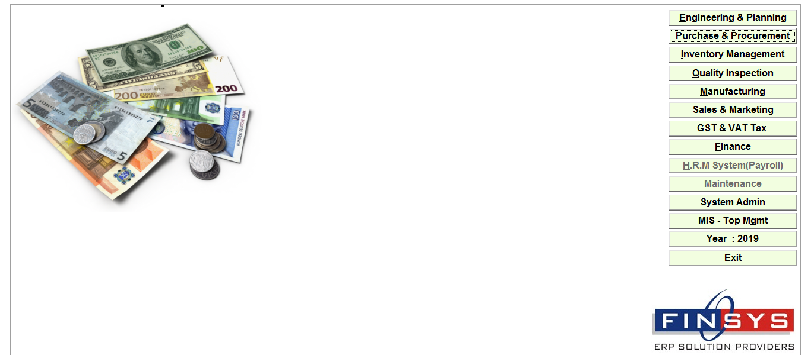
Click:- PURCHASE&PROCUREMENT
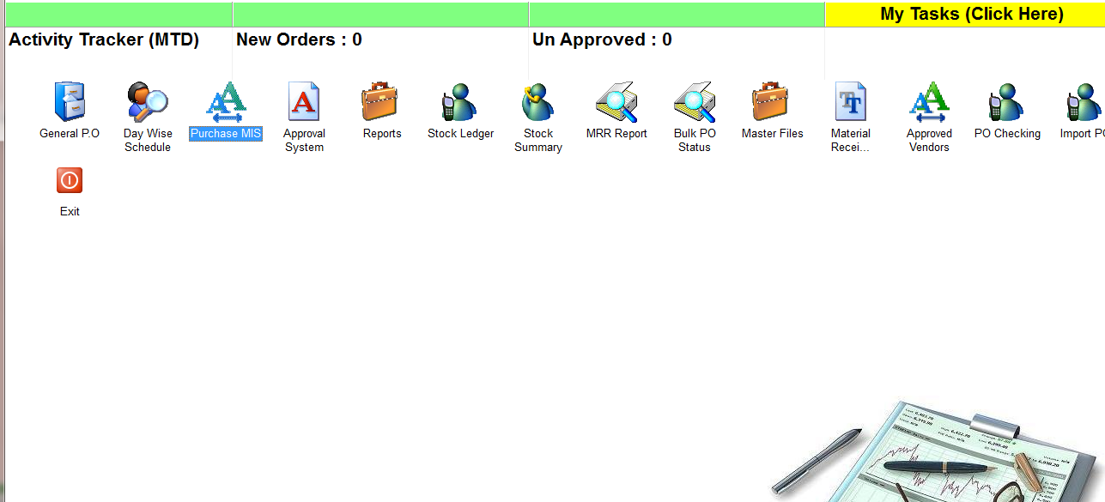
Click:- PURCHAS MIS
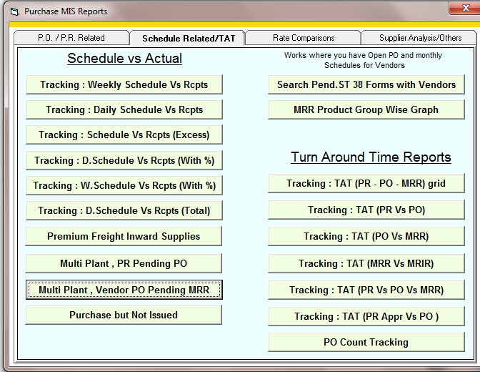
Click:- Multi plants, Vendor PO pending MRR
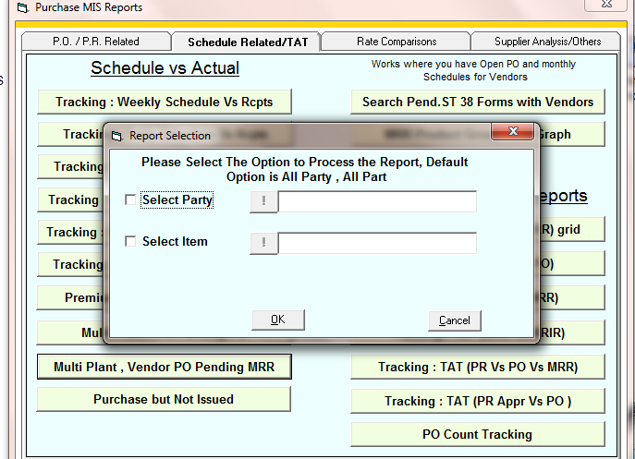
Select the party or item if you want to specific report of a item or party
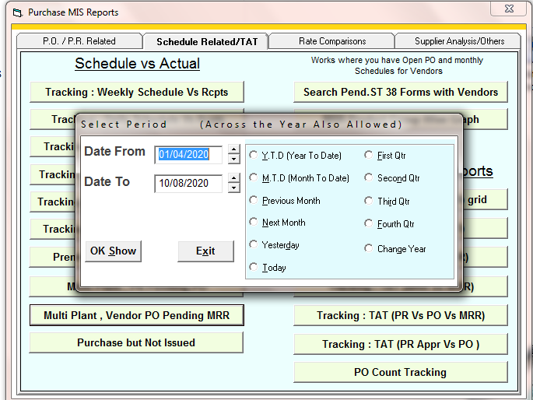
Enter the time period
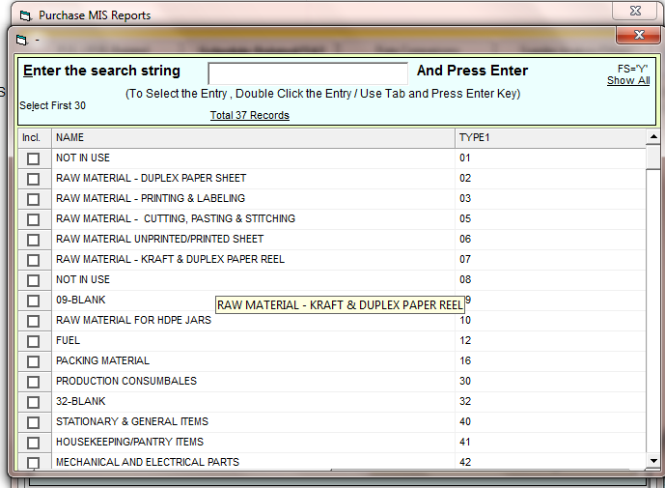
Select the item main group if you want to see report for specific group otherwise press ESC
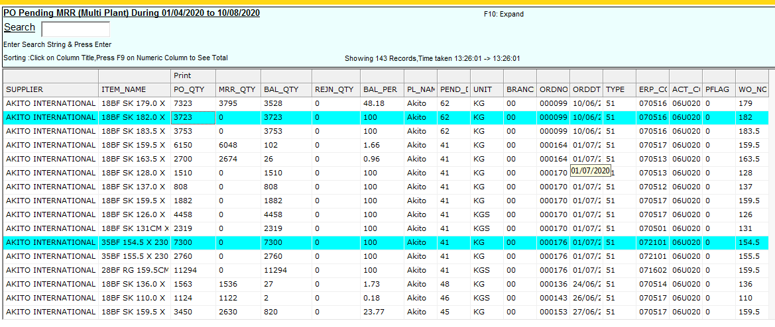
Report

