What report should we see for supplier performance of delivery vs. actual?
We have a report for supplier performance of delivery vs. actual
PURCHASE&PROCUREMENT>>REPORT>>RATING REPORT>>DELV VS ACTUAL
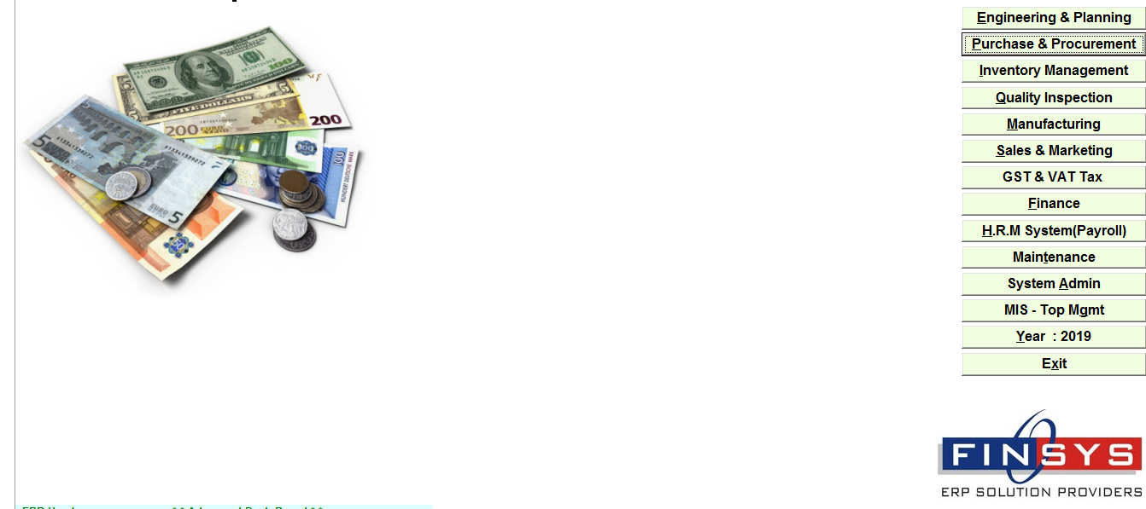
PURCHASE&PROCUREMENT
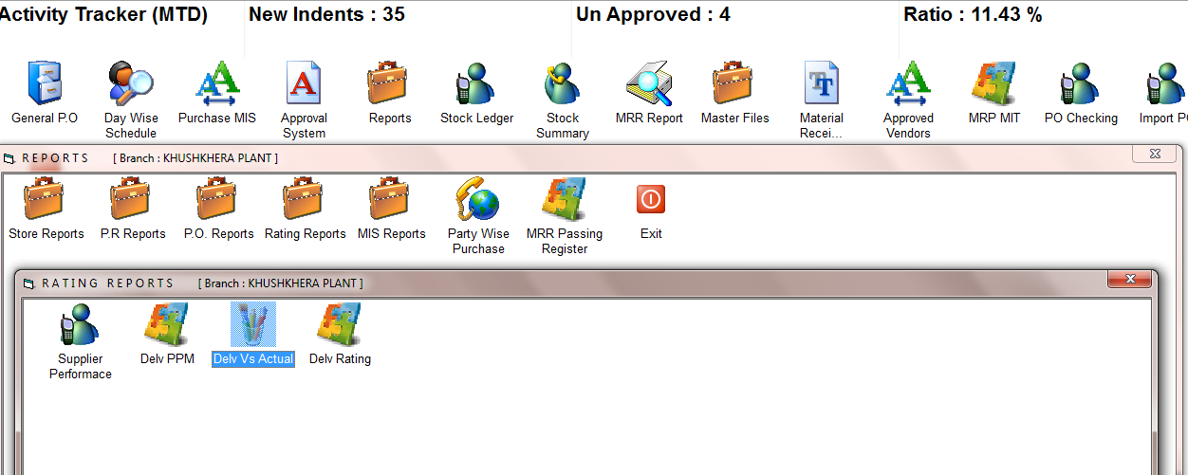
PURCHASE&PROCUREMENT>>REPORT>>RATING REPORT>>DELV VS ACTUAL
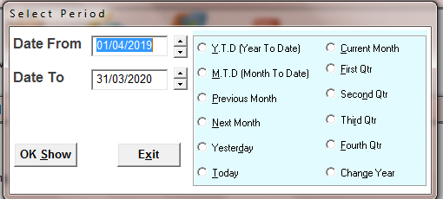
SELECT THE TIME PERIOD
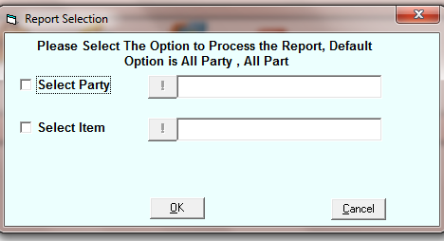
SELECT THE PARTY OR ITEM OF SEE REPORT FOR SPECIFIC PARTY OR ITEM AND PRESS OK FOR ALL
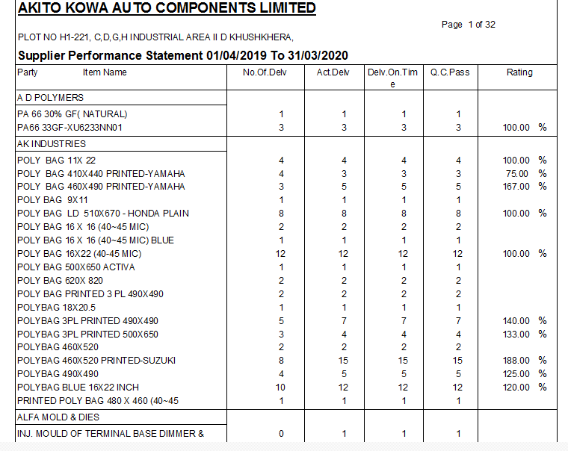
Supplier performance of delivery vs. actual

