**What report should we see for reel differences?**

We have a report for reel differences

Inventory Module🡺Reel Report🡺Stock TieUp

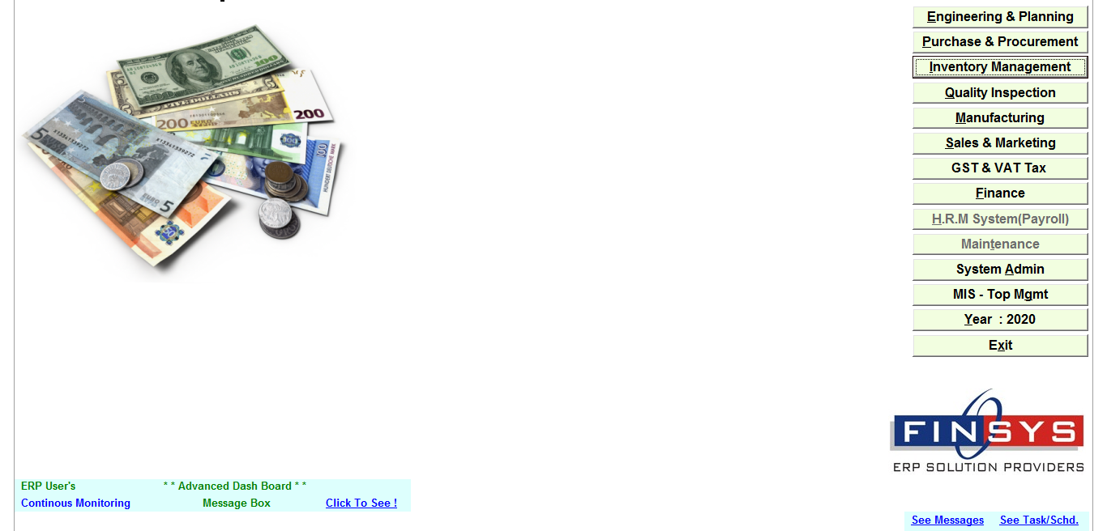

**Click🡺** Inventory Module

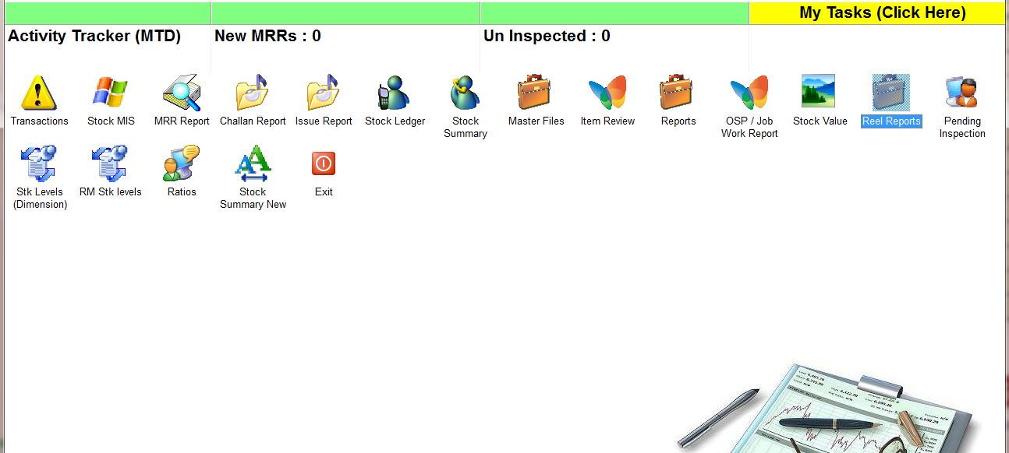

**Click🡺** Reel Report

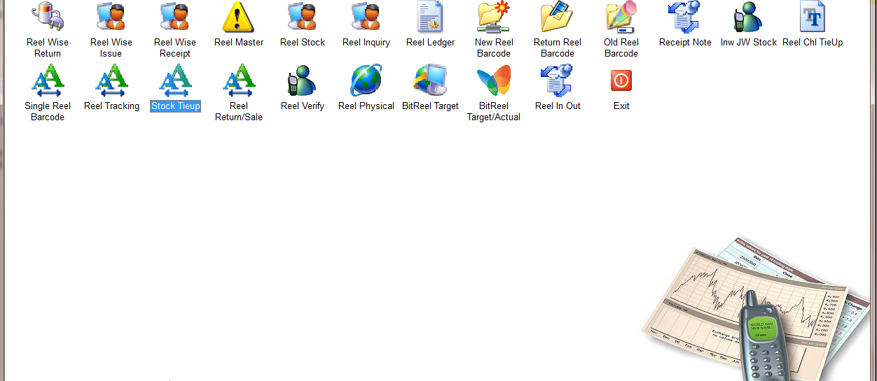

**Click🡺** Stock TieUp

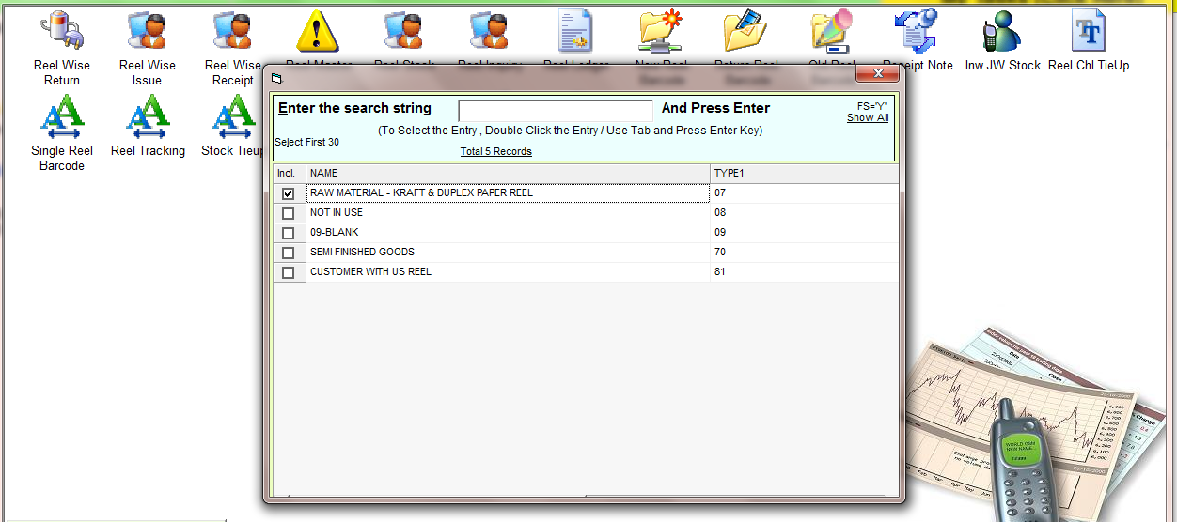

Select the type

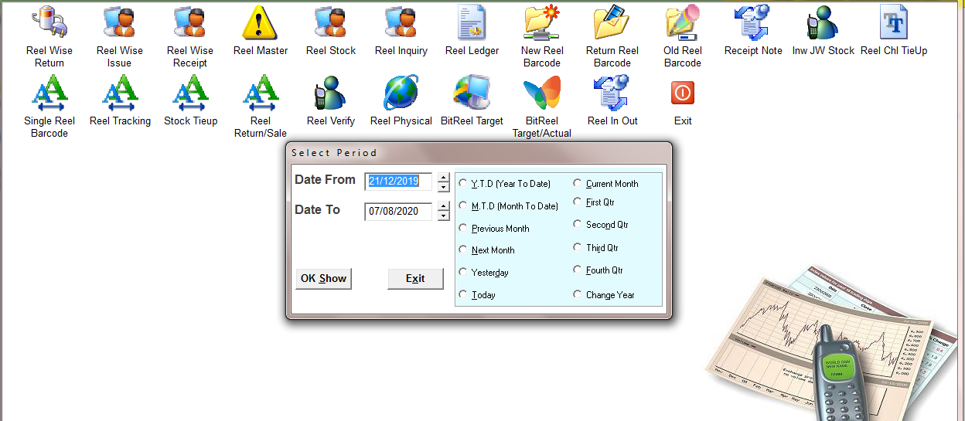

Select the time period

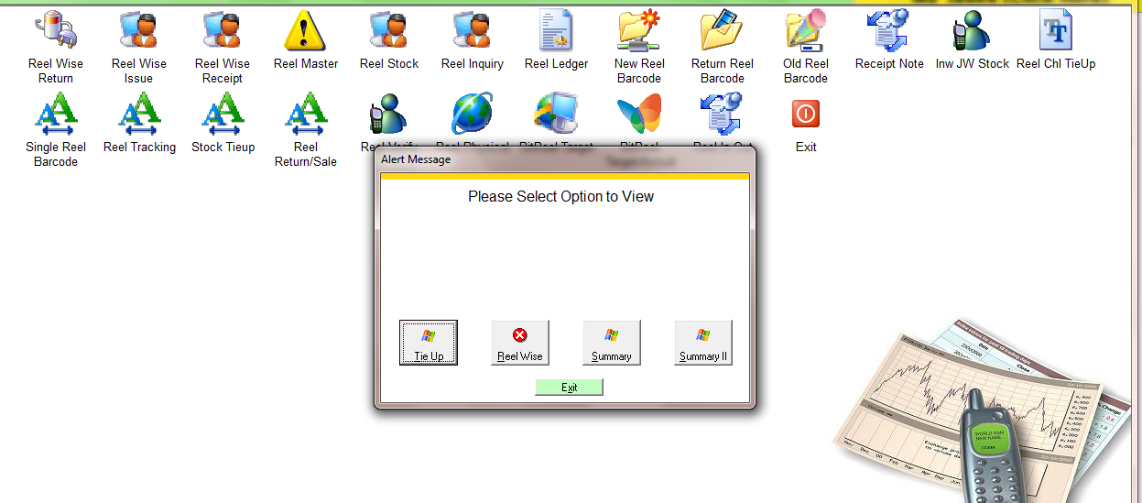

Select the option

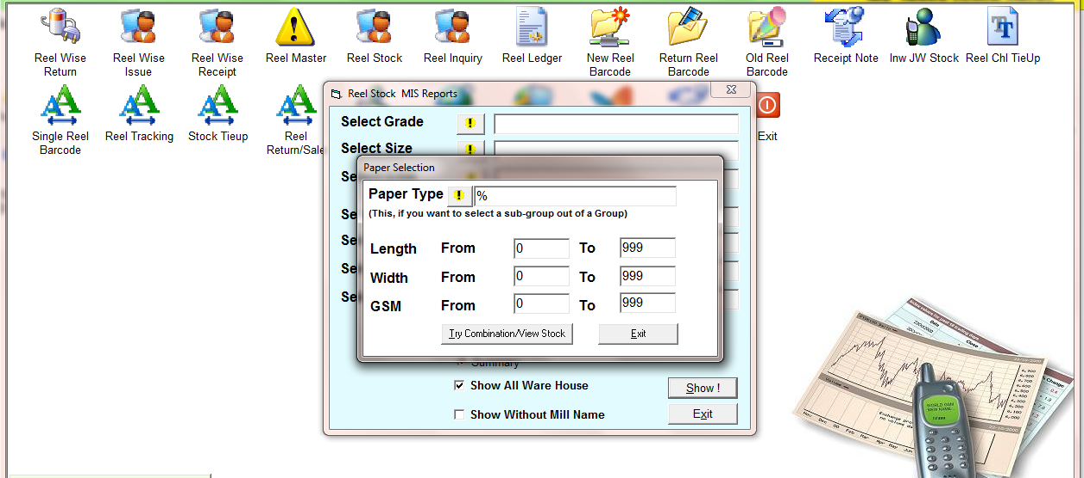

Select the paper if you want to select specific paper

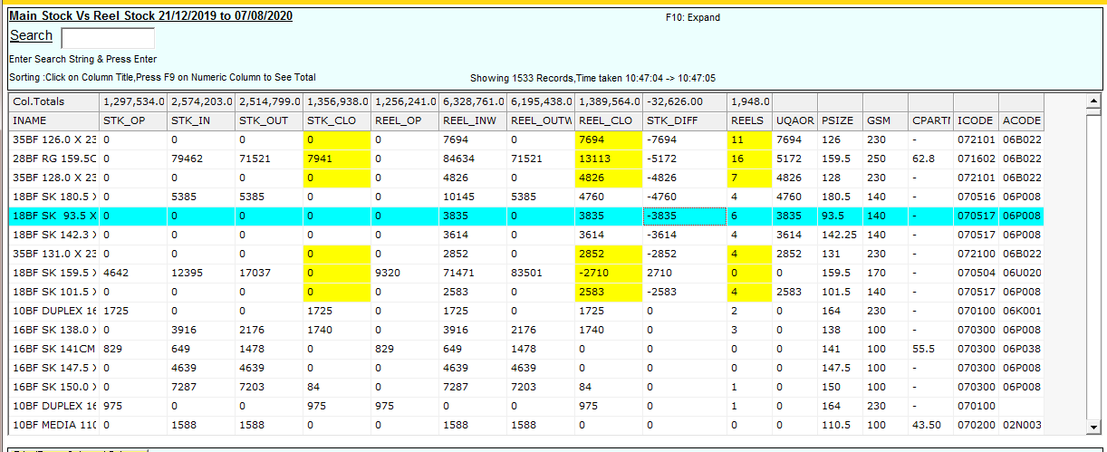

Report