What report should we see for purchase order details?
We have a report for purchase order details
PURCHASE&PROCUREMENT>>REPORT>>PO REPORTS>>PURCHASE ORDER REGISTER
Here we can see that the PO details e.g. item, rate, supplier etc….
PURCHASE&PROCUREMENT
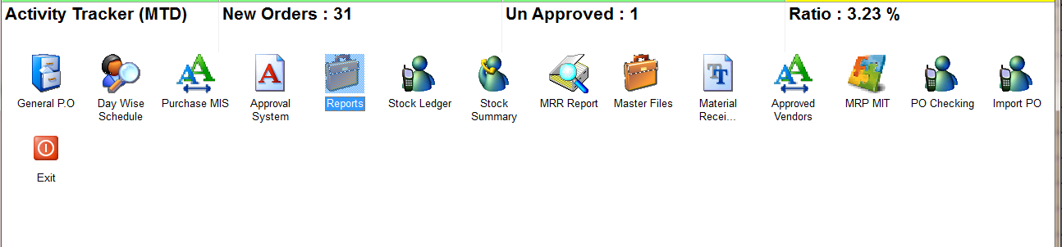
REPORTS
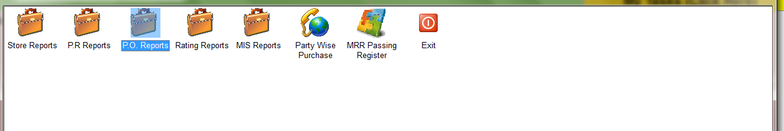
PO REPORTS
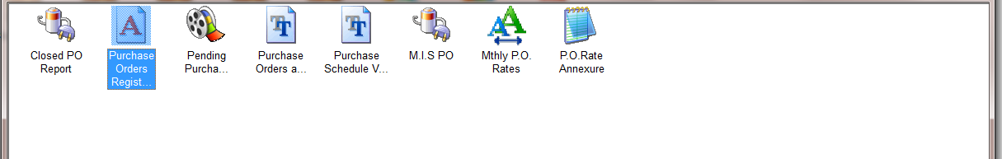
PURCHASE ORDER REGISTER
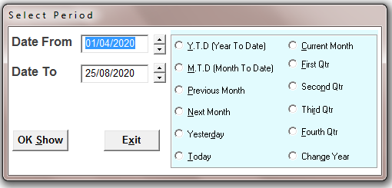
SELECT THE TIME PERIOD
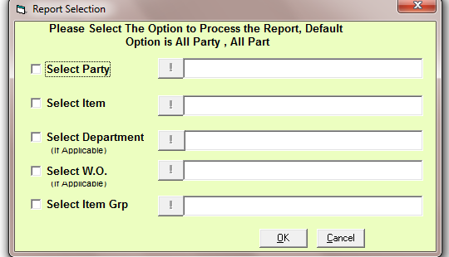
SELECT THE OPTIONS IF YOU WANT TO SEE A SPECIFIC RECORD
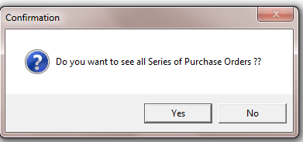
SELECT THE OPTION
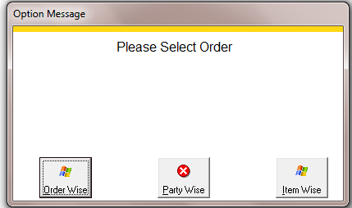
HERE IS 3 OPTIONS TO VIEW REPORT ORDER WISE, PARTY WISE, AND ITEM WISE
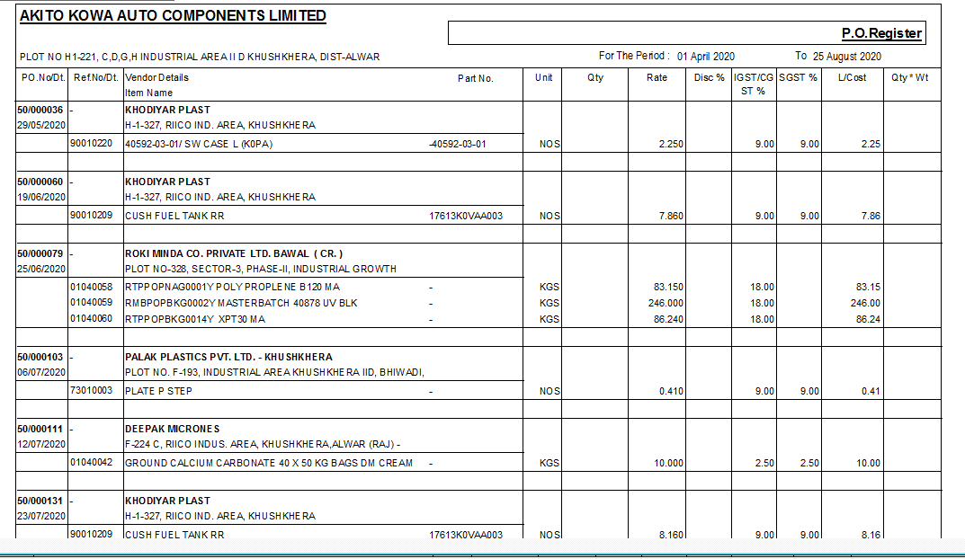
ORDER WISE REPORT

