What report should we see for job work ledger with quantity?
We have a report for job work ledger with quantity.
INVENTORY MANAGEMENTOSP JOB WORK REPORTJOB WORK LEDGER WITH QUANTITY
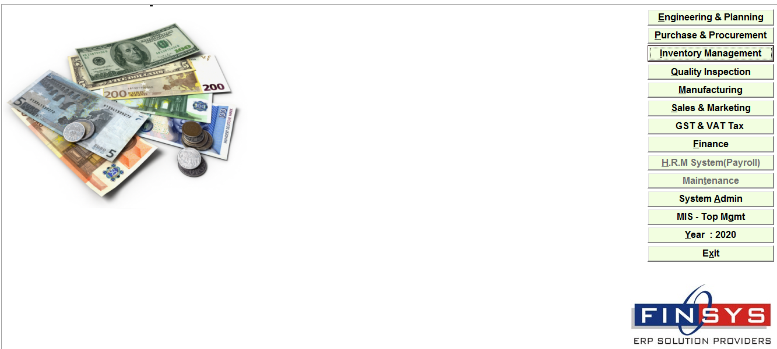
ClickInventory Module
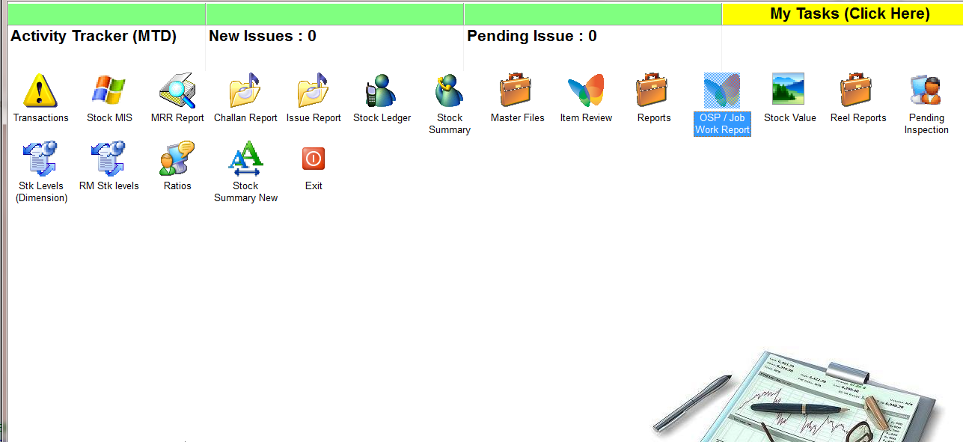
ClickOSP Job work report

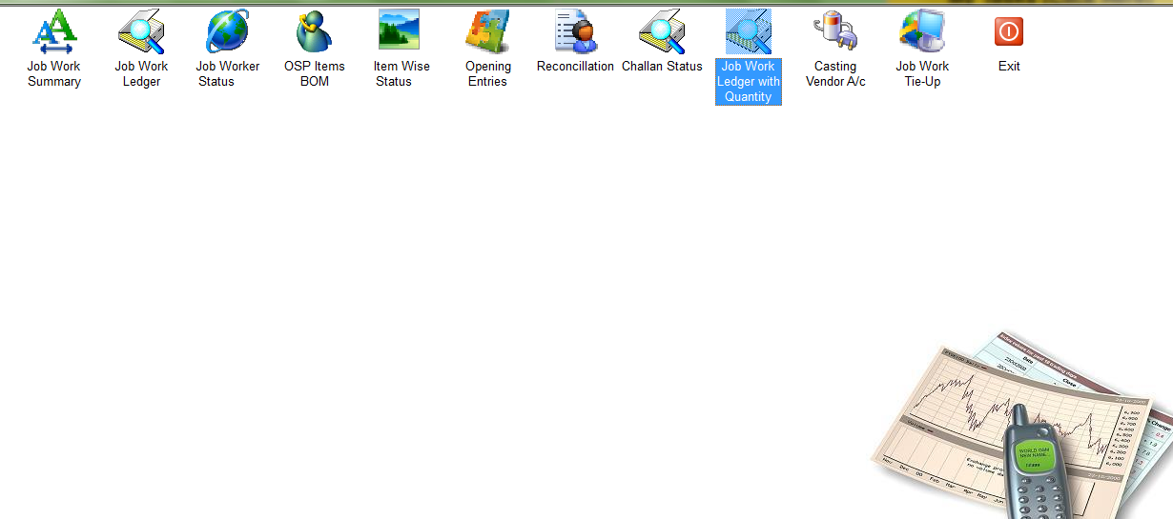
ClickJob Work ledger with quantity
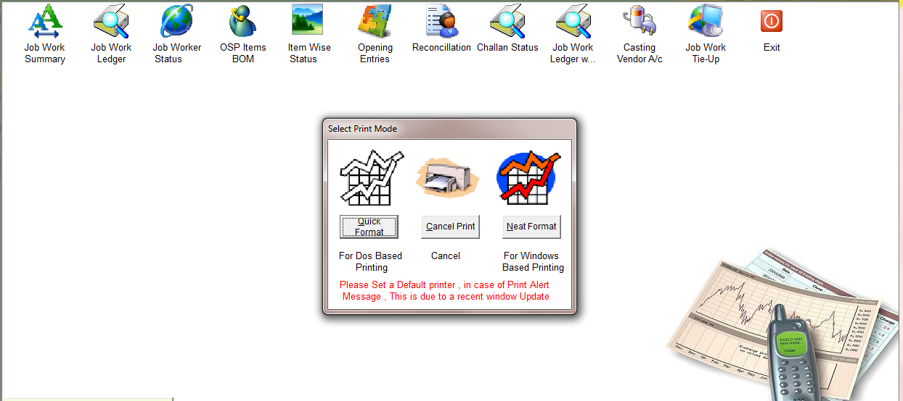
ClickNeat Format

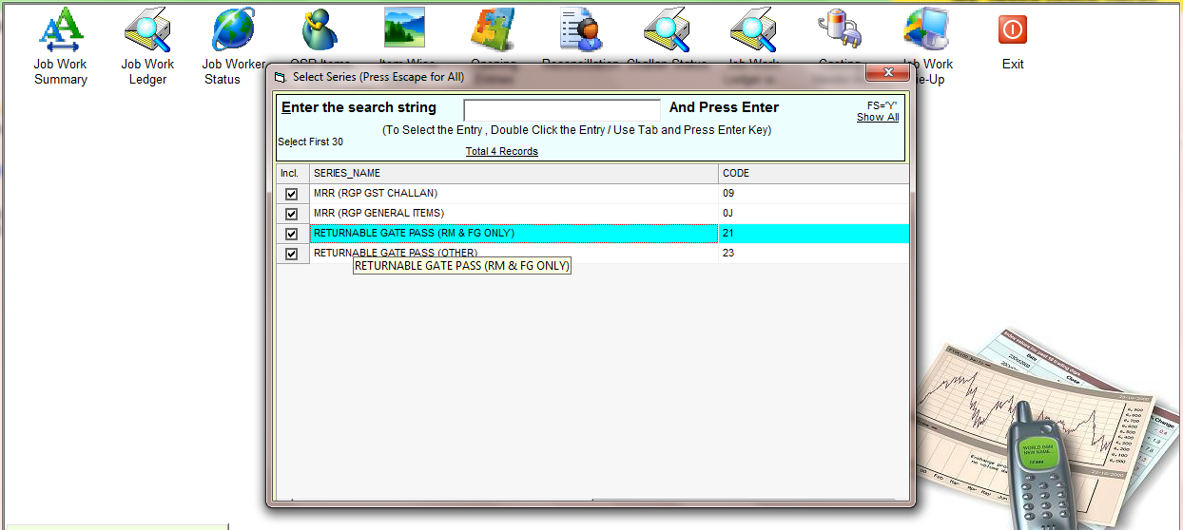
Select the types
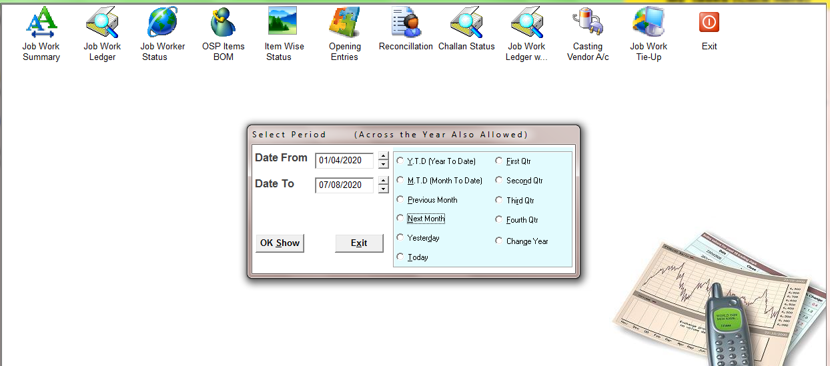
Select the time period
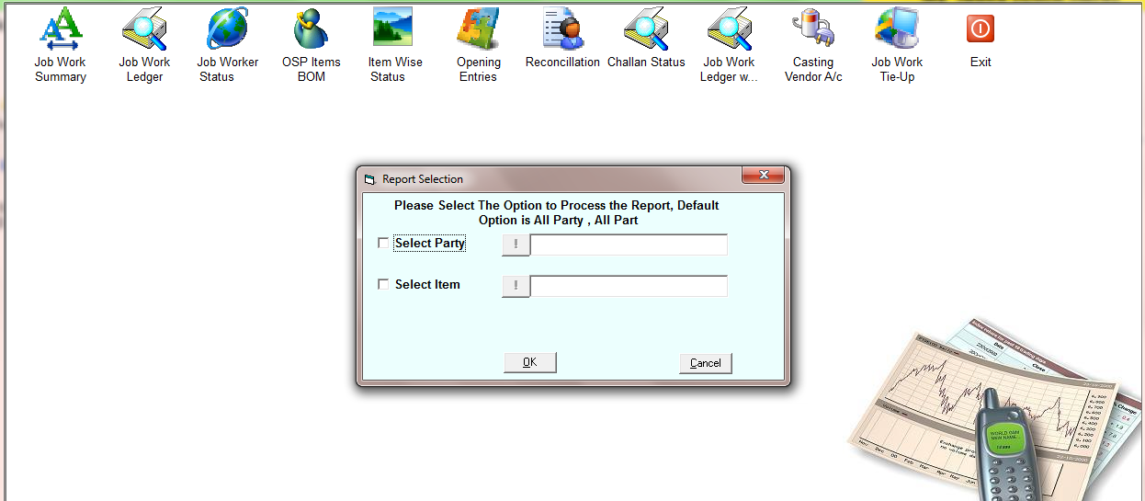
Select the party if you want to see for specific party report
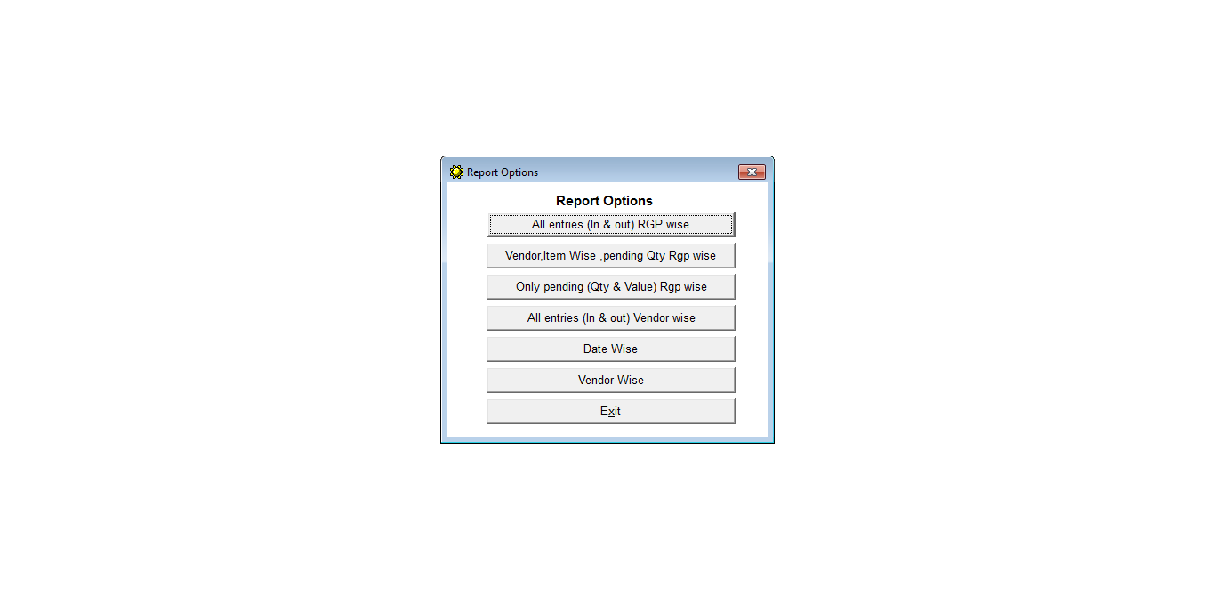
Select the option
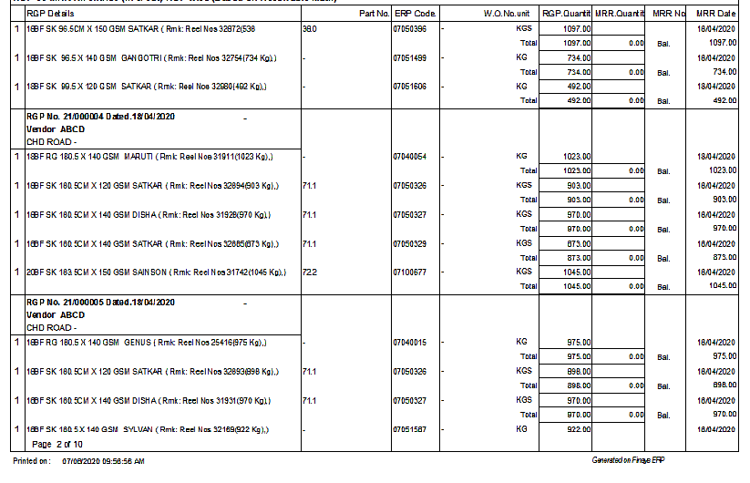
Report

