What report should we see for issue entry report with rate and value?
We have a report for issue entry report with rate and value
INVENTORY MANAGEMENTREPORTSCOST REPORTSDEPTT WISE ISSUE
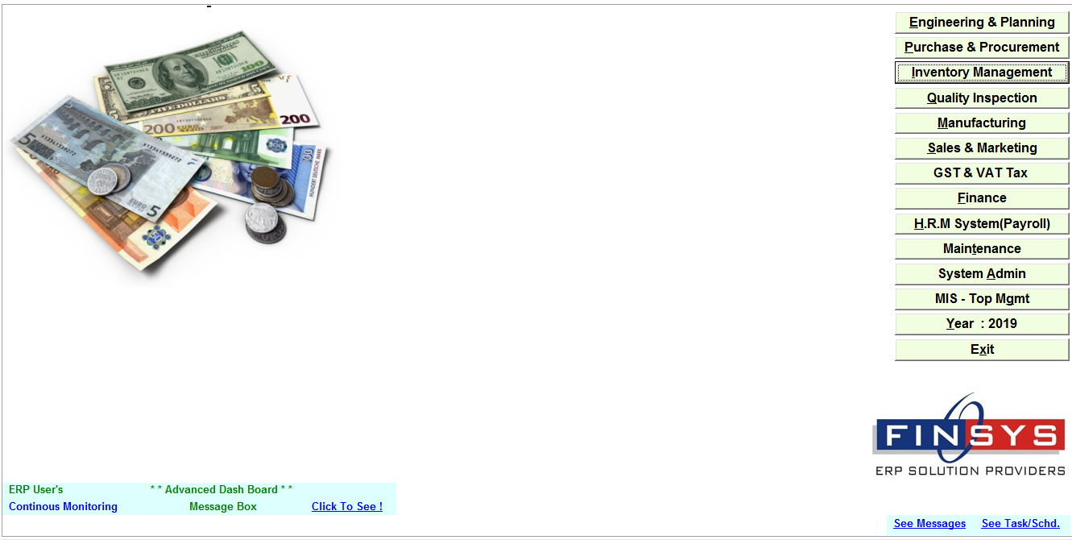
CLICK: - INVENTORY MANAGEMENT
CLICK: - REPORTS
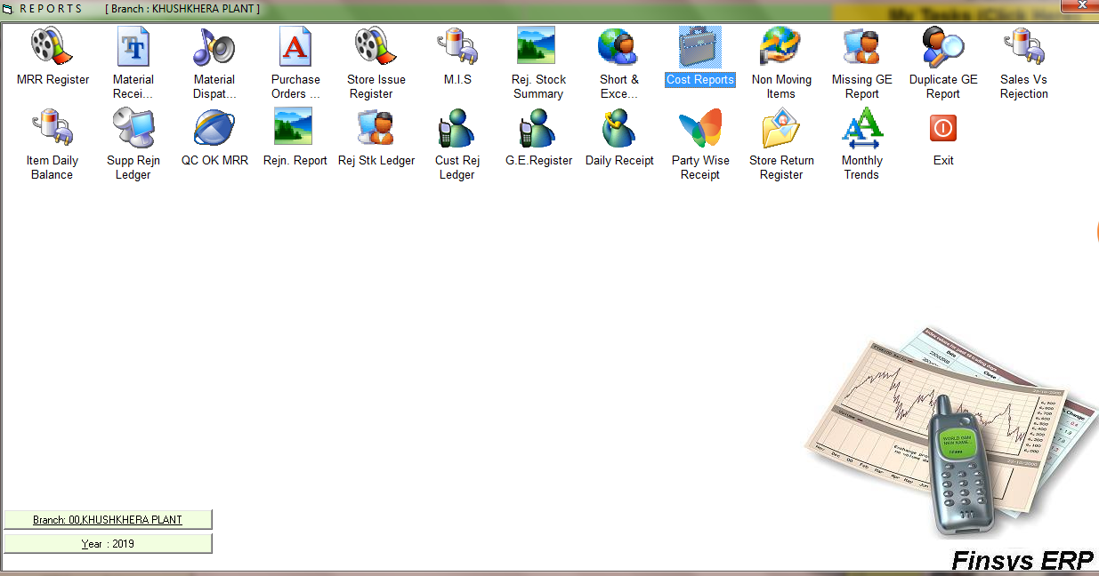
CLICK: - COST REPORTS
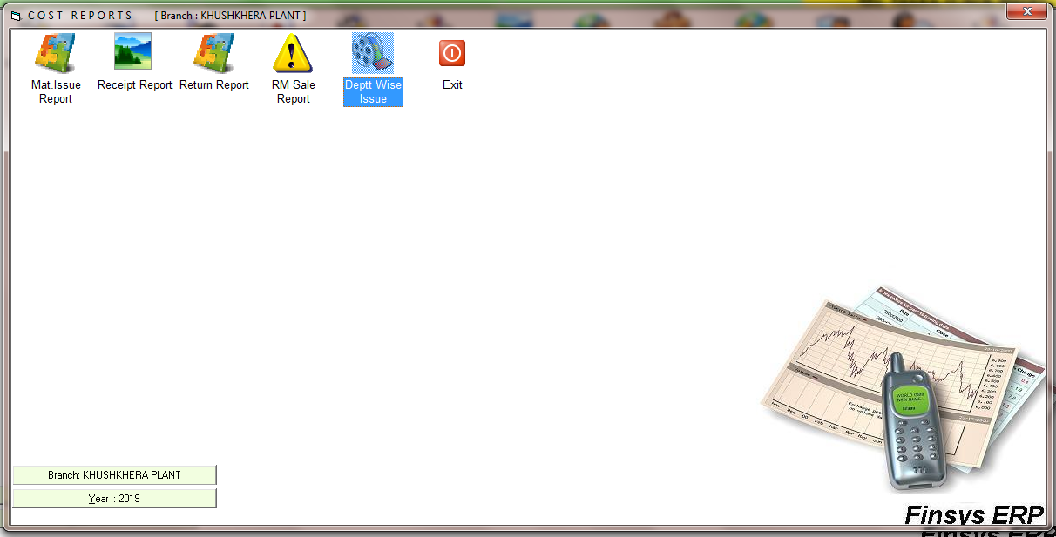
CLICK: - DEPTT WISE ISSUE
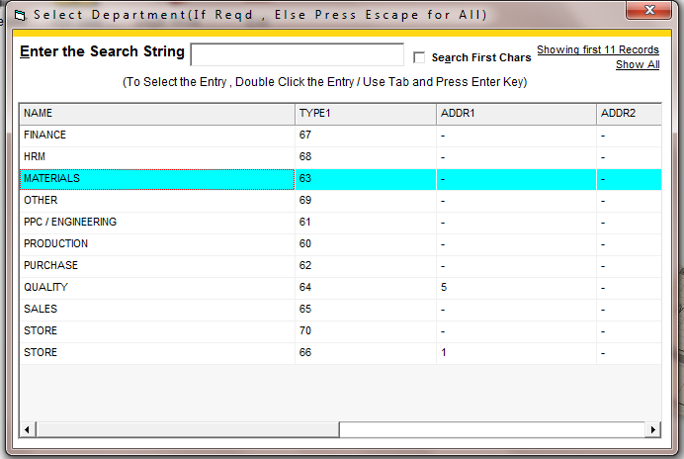
SLEECT THE DEPTT IF YOU WANT TO SEE REPORT FOR A SPECIFIC DEPTT
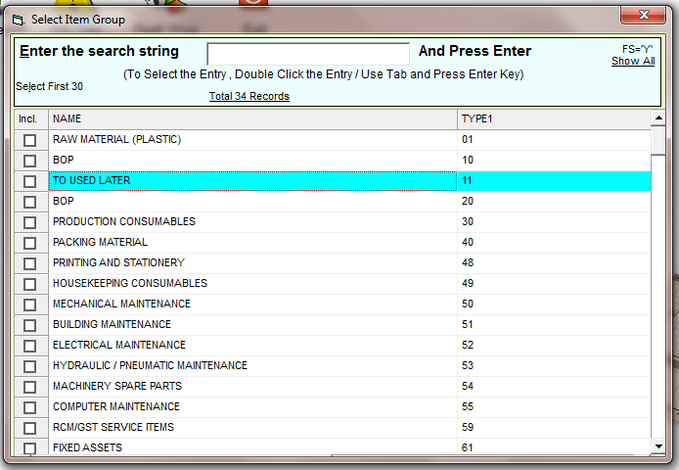
SLEECT THE ITEM GROUP IF YOU WANT TO SEE REPORT FOR A SPECIFIC GROUP
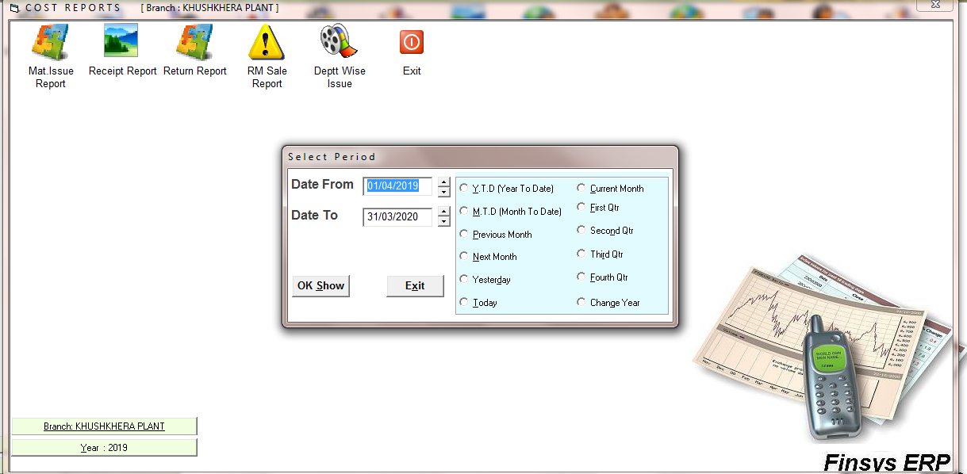
SELECT THE TIME PERIOD
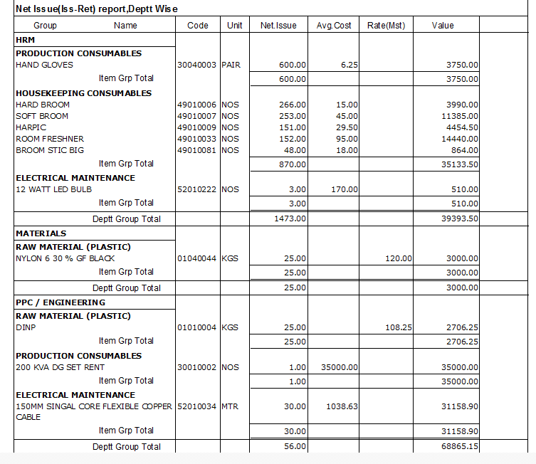
REPORT

