What report should we see for MRR Vs material received inspection report?
We have a report for MRR Vs material received inspection report
PURCHASE&PROCUREMENTPURCHASE MIS2nd TAB (Schedule related/TAT)TRACKING: TAT (MRR VS MRIR)
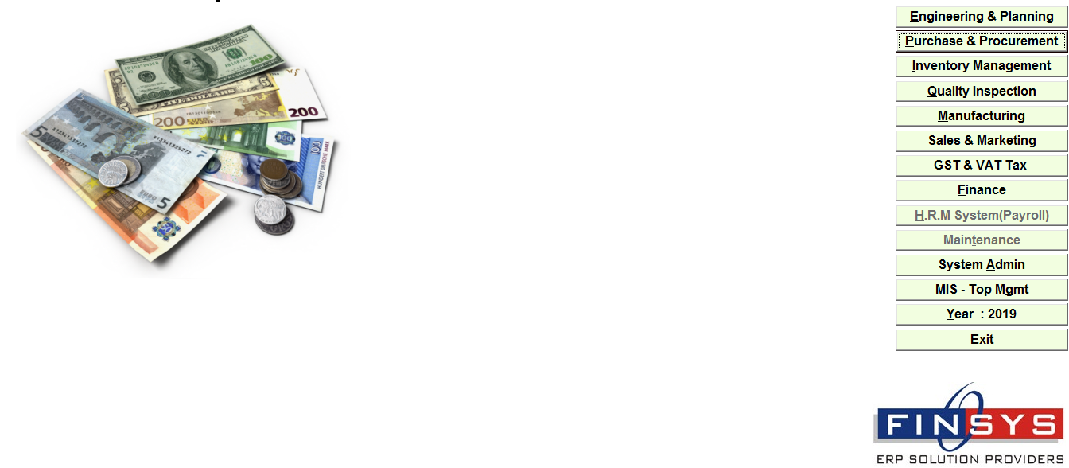
Click:- PURCHASE&PROCUREMENT
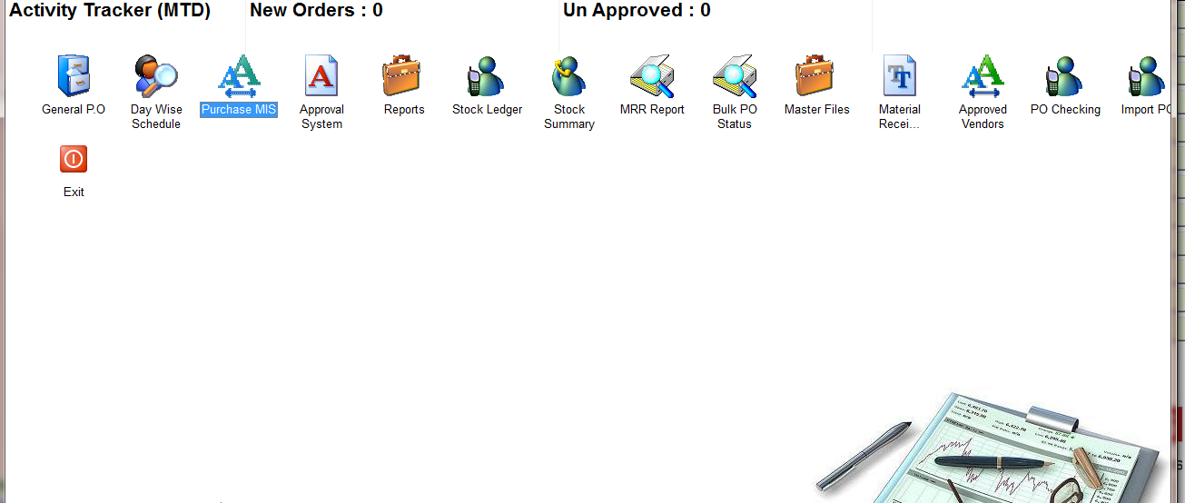
Click:- PURCHASE MIS
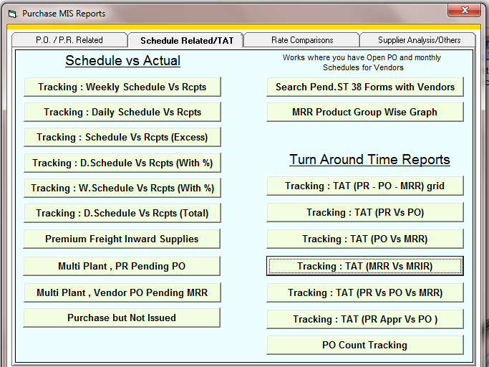
Click:- Tracking : TAT (MRR Vs MRIR)
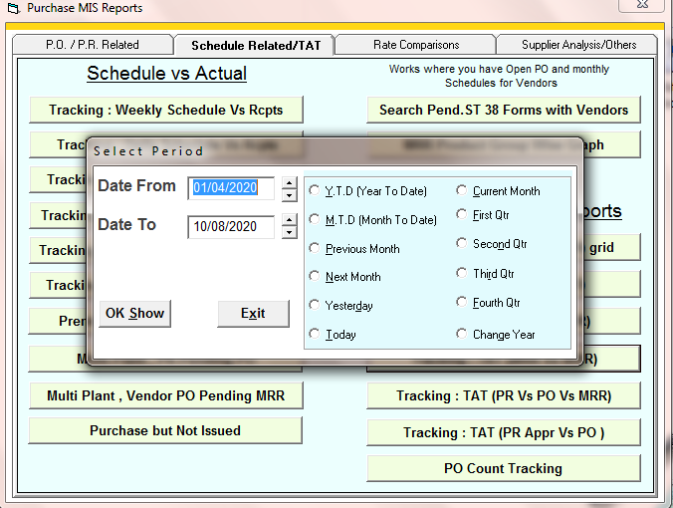
Enter the time period
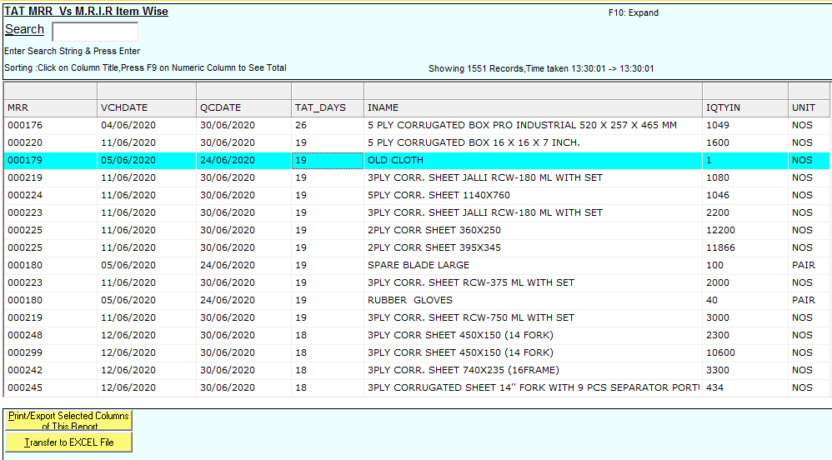
Report

