Can we see the summary of MRR register?
YES, we have MRR register
FINANCE>>MIS>>MRR REGISTER
MRR register method 2
FINANCE
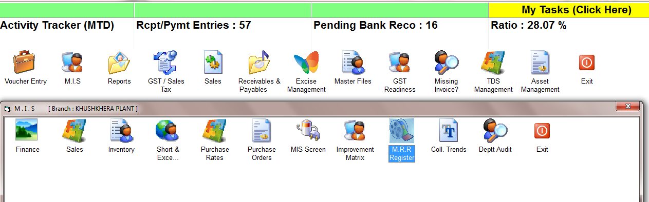

Finance MIS MRR Register
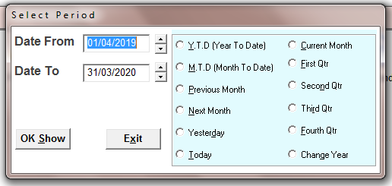
SELECT THE TIME PERIOD
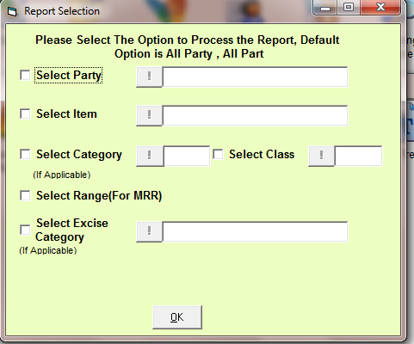
SELECT THE OPTIONS OR FOR ALL PRESS OK
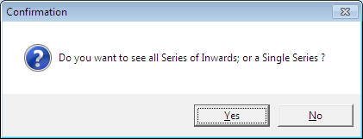
CHOOSE THE OPTION

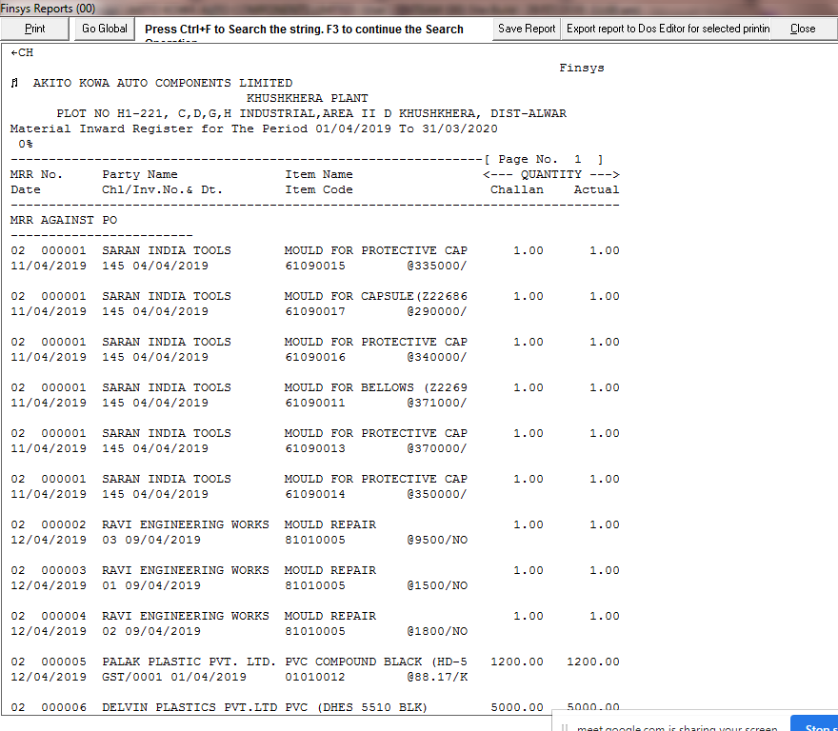

Summary based on selection

