How to update the opening ITEM Balances
from 31.3.2019 to new year 2019-20 ?

Notes and Frequently Asked Questions:
- The Finsys ERP allows you to work in multiple years.
- There is no need of any “Year Closure” , or immediate closure of books.
- You can continue doing entries in financial year 2018-19 as well as Fin year 2019-20, without any problems.
- Question = ITEM balances
  - Question If I pass additional say, 5 vouchers in Fin year 2018-19 , how will the closing balance of 31.3.2019 carried over to 1.4.2019 (as opening balances )
  - Answer: Just press “Update Posting” in next year. ( you can do this every few days) – Whenever you want.

Detailed steps are shown in the following screenshots:
Step 1 = Go into the FY 2019-20
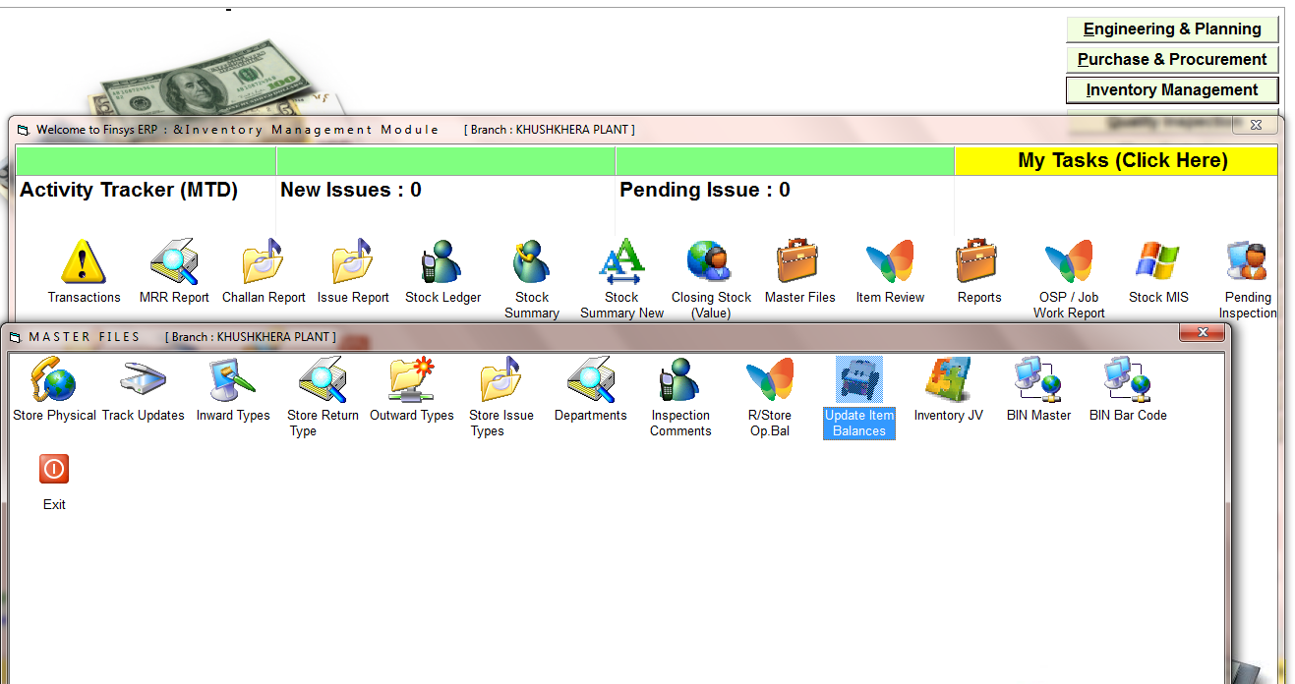
Step 2 = Go into Inventory >>> Master files
Press the button >>> Update Item Balances

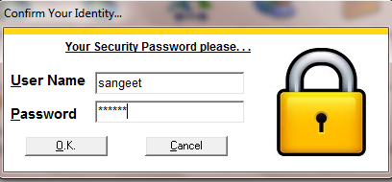

Give your password
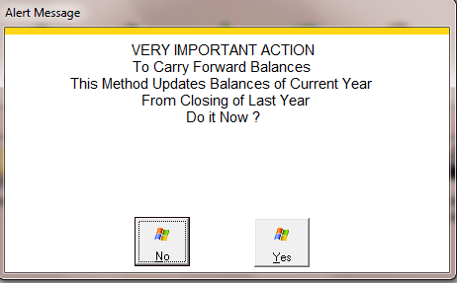

System will say,
“Should I update balances of current year (2019-20) from the closing of last year (31.3.2019)”
Do it now?

Say YES
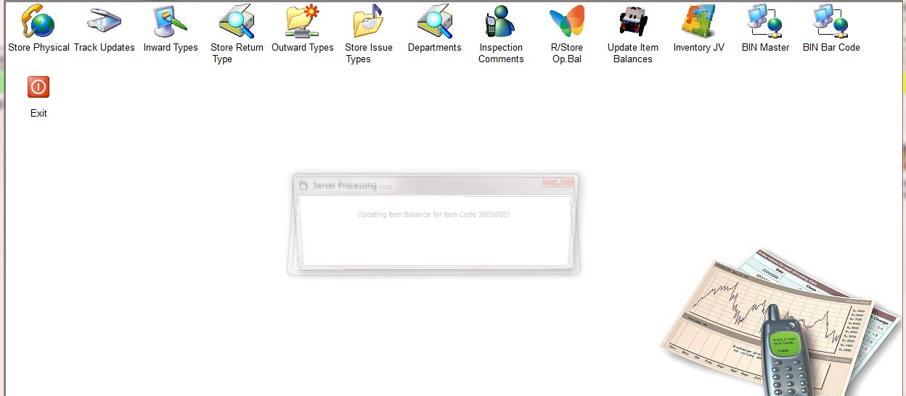

System will start updating as shown above
It will take about 2 to 6 minutes (depending on data size)
Please do not disturb the processing at this time

WAIT
WAIT
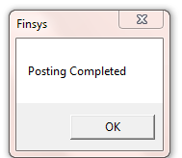

After those 2 to 6 minutes
In the end, it will say, “Posting Completed”
<< That is all >>

Yes, you can do this every few days…..

