How to see what Stores requests are pending?
We have a report Stores requests are pending
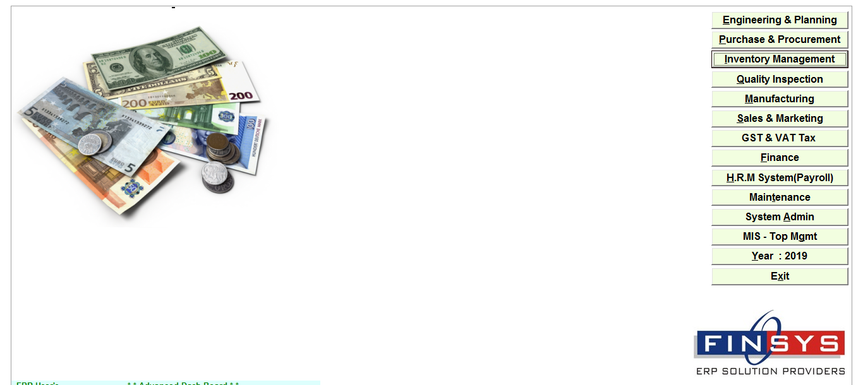
INVENTORY MANAGEMENT
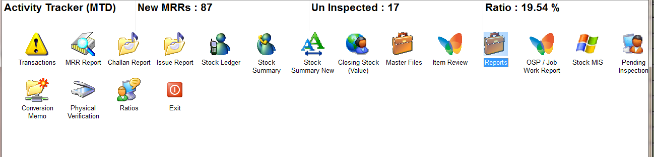
REPORTS
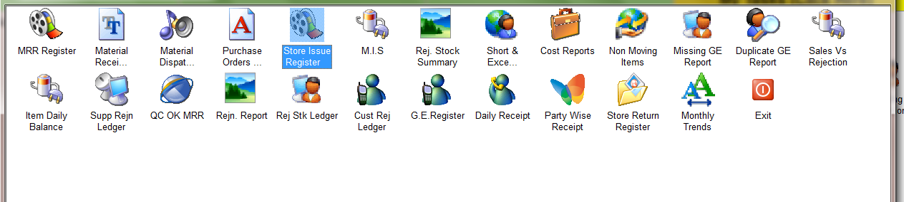
STORE ISSUE REGISTER
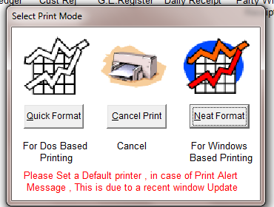
CHOOSE THE PRINT FORMAT
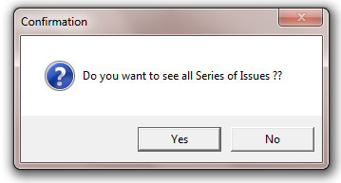
SELECT OPTION
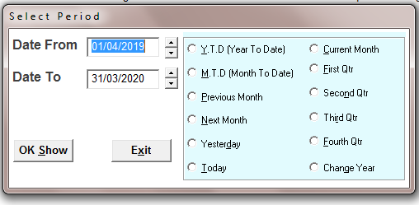
SELECT THE TIME PERIOD
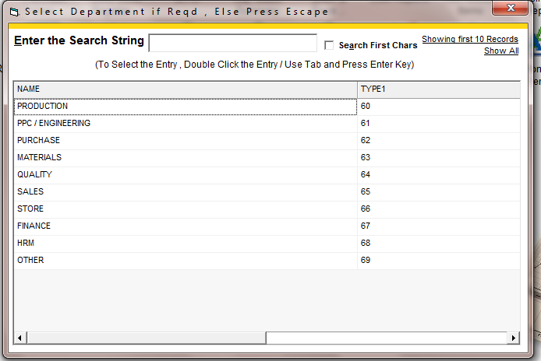
SELECT THE DEPARTMENT, PRESS Esc for all

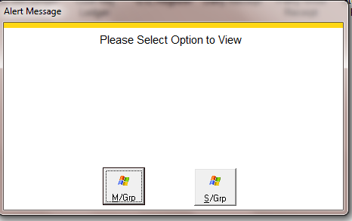
Select the option

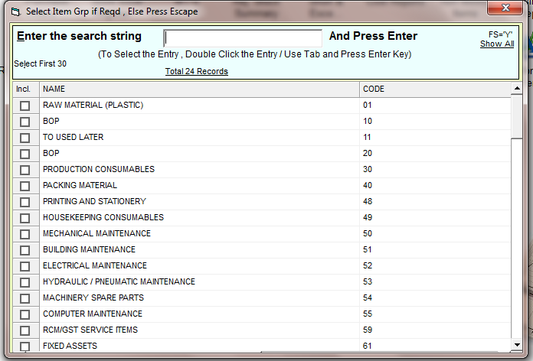
SELECT THE ITEM GROUP, PRESS Esc for all
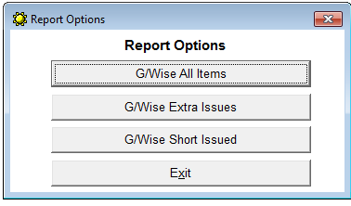
WE HAVE 3 OPTIONS FOR REPORT
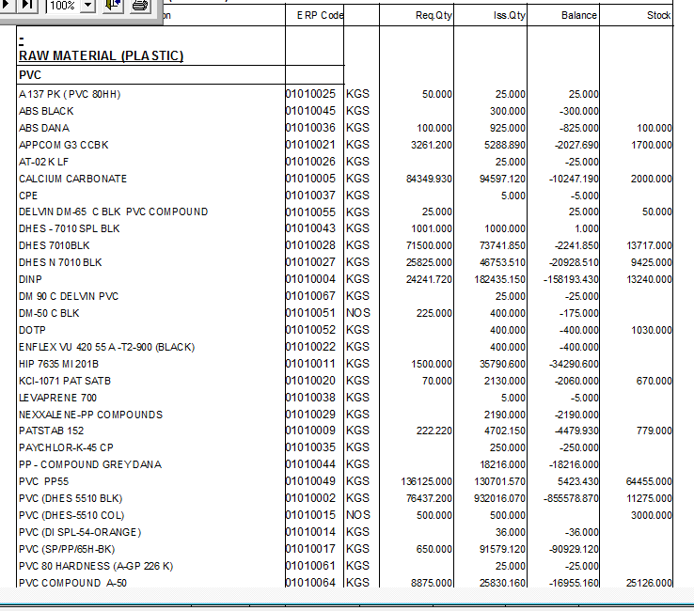
G/WISE ALL ITEMS
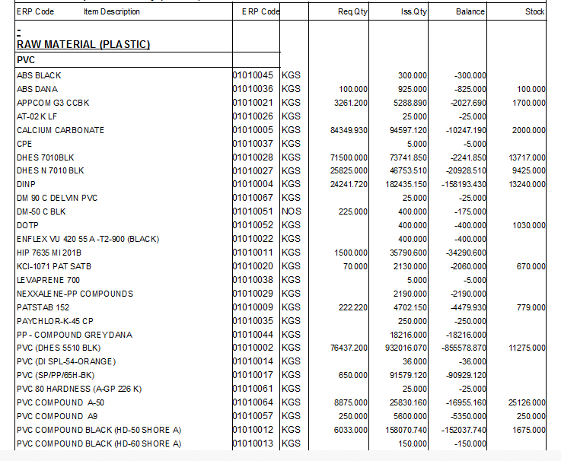
G/WISE EXTRA ISSUES
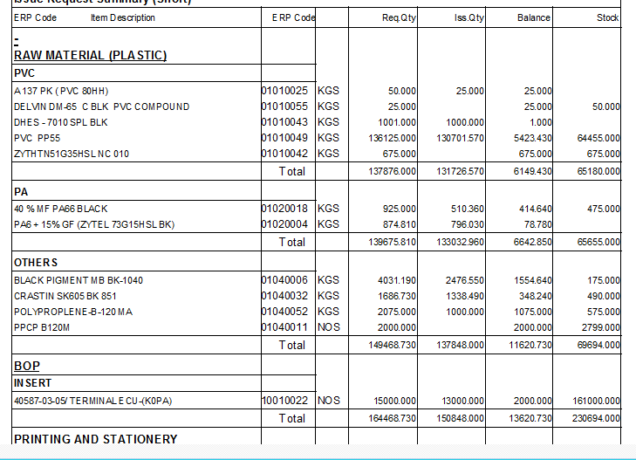
G/WISE SHORT ISSUED REPORT

