How to see the QC passed MRR deleted?
We have a report for QC passed MRR deleted.

Step 1 Go to system admin Reports ERP Tracking QC passed MRR deleted

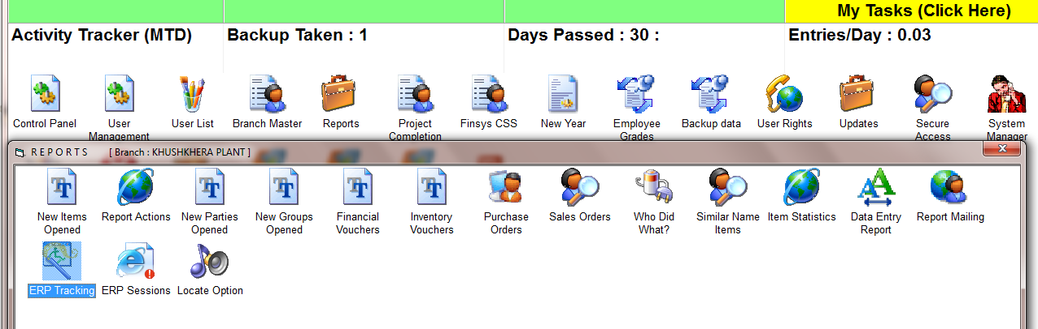

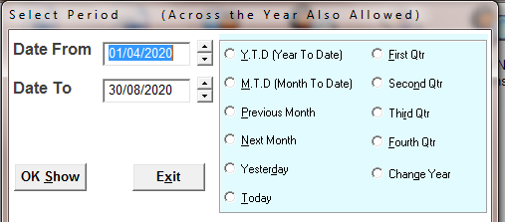
SELECT THE TIME PERIOD

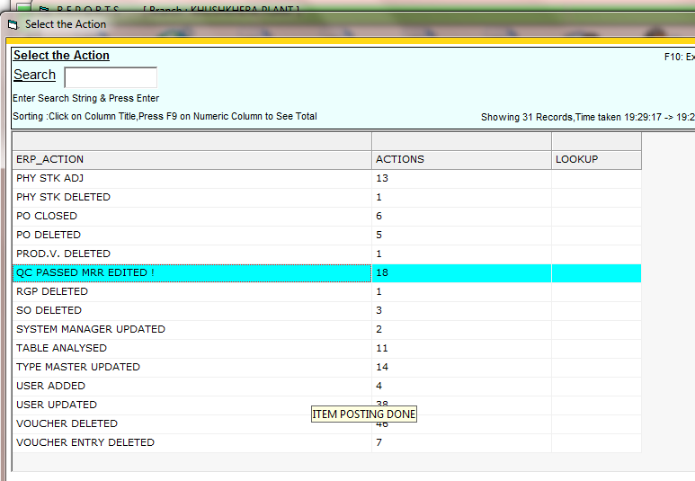
Shows that there are 18 such deletions.

Now press Enter / double click to see which 18 are these?

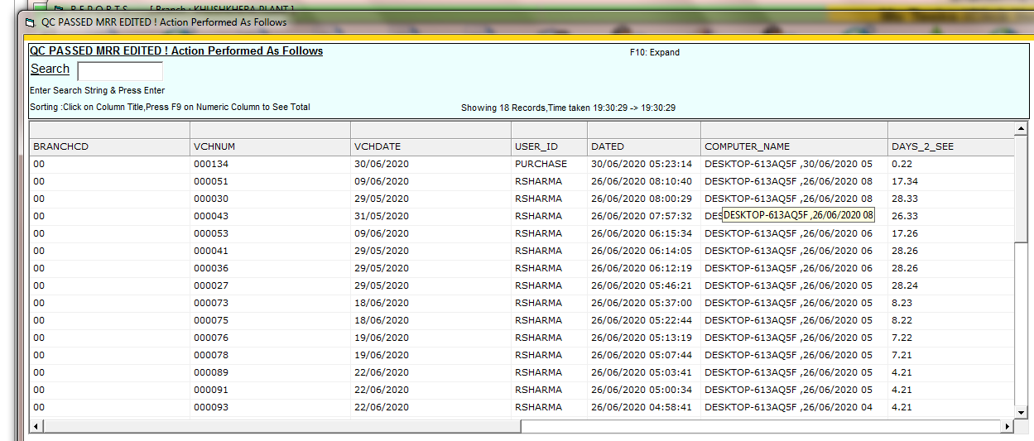

These are the 18 missing entries

System shows you,
- MRR entry no, and date
- Deleted by which user ( his user id )
- Deleted on date and time
- Deleted from which computer? At what date / time?

