How to see the Gate entry deleted?
We have a report for gate entry deleted.

Step 1 Go to system admin Reports ERP Tracking Gate entry deleted

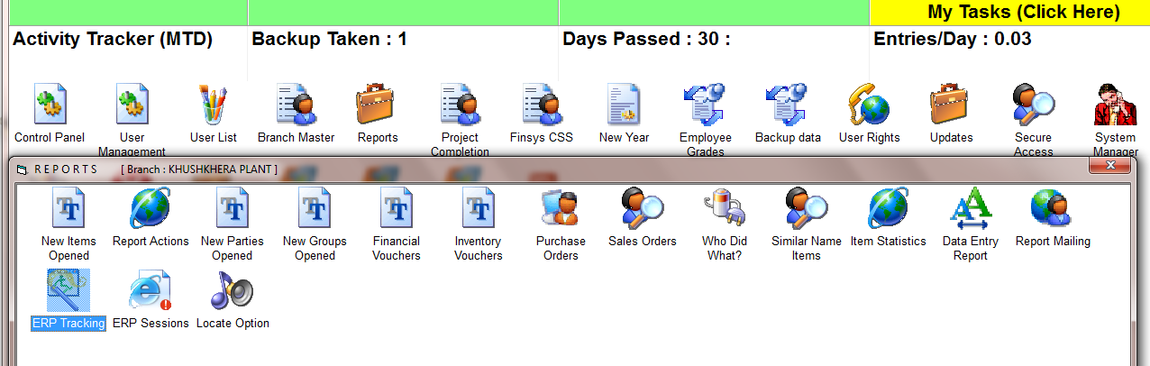

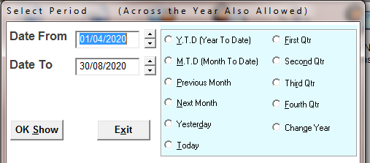
SELECT THE TIME PERIOD

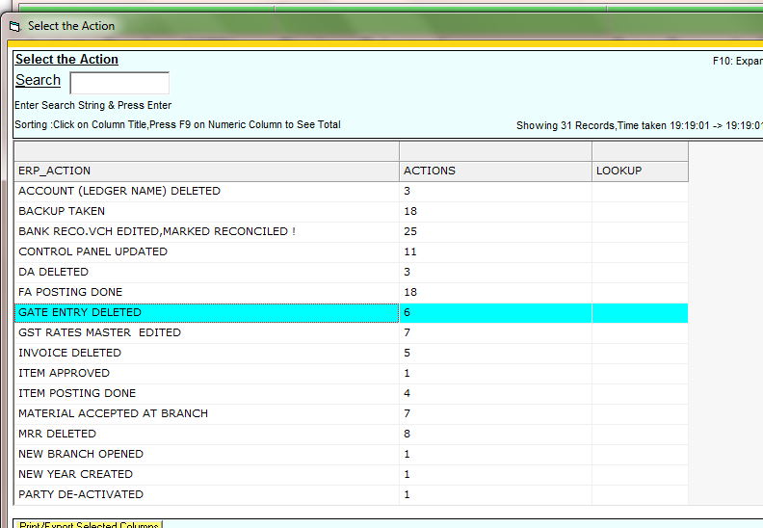
Shows that there are 6 such deletions.

Now press Enter / double click to see which 6 are these?

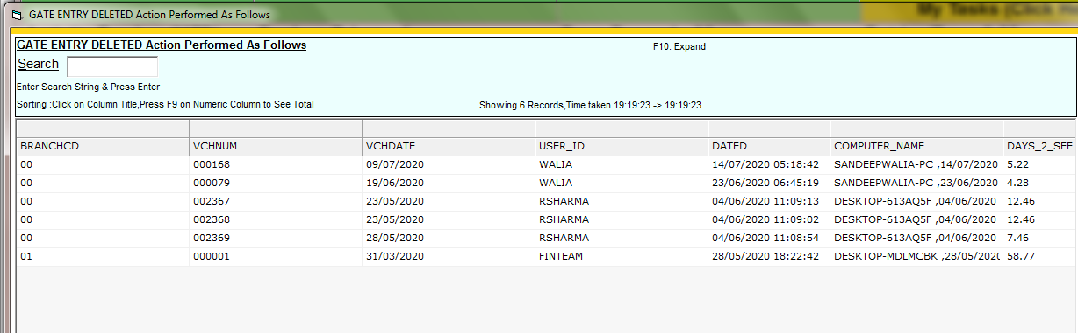

These are the 6 missing entries

System shows you ,
- Gate entry no, and date
- Deleted by which user ( his user id )
- Deleted on date and time
- Deleted from which computer? At what date / time?

