How can we use of PO checking in finsys?
Through PO checking, we can see here at which rate this item was purchased before that time.
PURCHASE&PROCUREMENT>>PO CHECKING
PURCHASE & PROCUREMENT
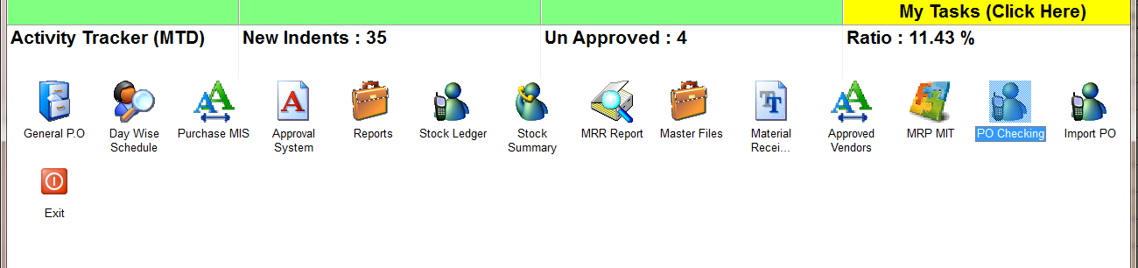
PO CHECKING THAN PRESS START
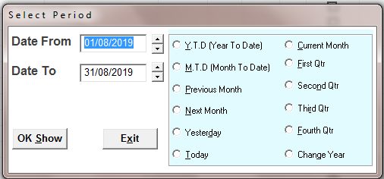
SELECT THE TIME PERIOD
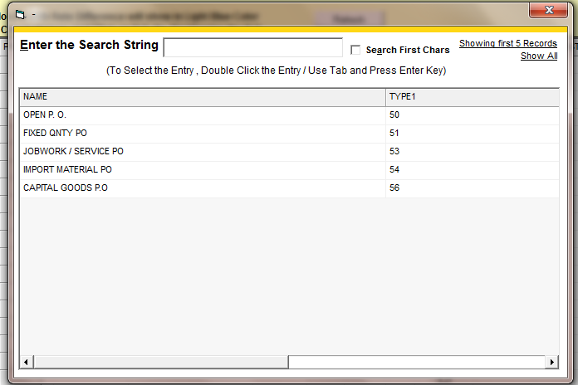
SELECT THE PO TYPE IF YOU WANT TO SEE REPORT FOR A SPECIFIC TYPE AND FOR ALL PRESS ESC
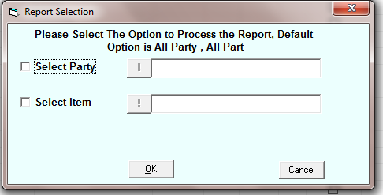
SELECT THE PARTY OR ITEM IF YOU WANT TO SEE REPORT FOR A SPECIFIC PARTY OR ITEM OR PRESS OK
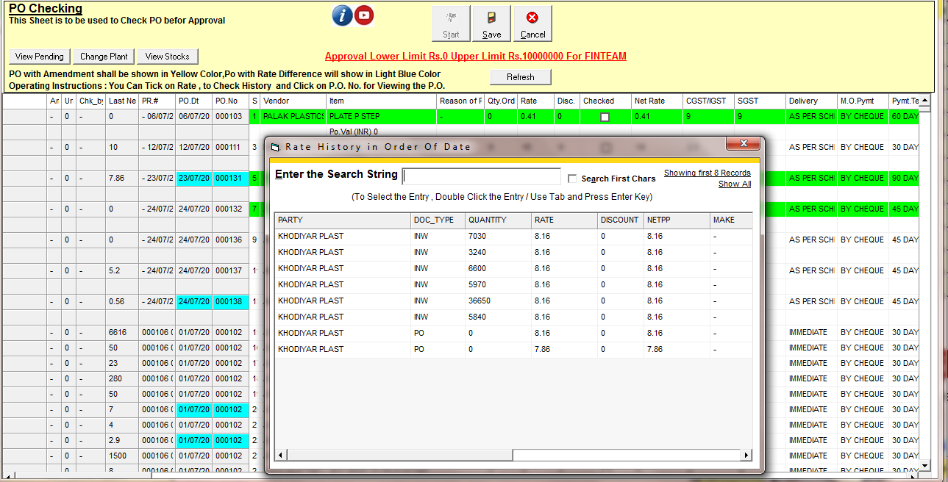
CLICK ON RATE THERE WILL BE SHOW which rate this item has been purchased AND click on PO number there will be open PO print
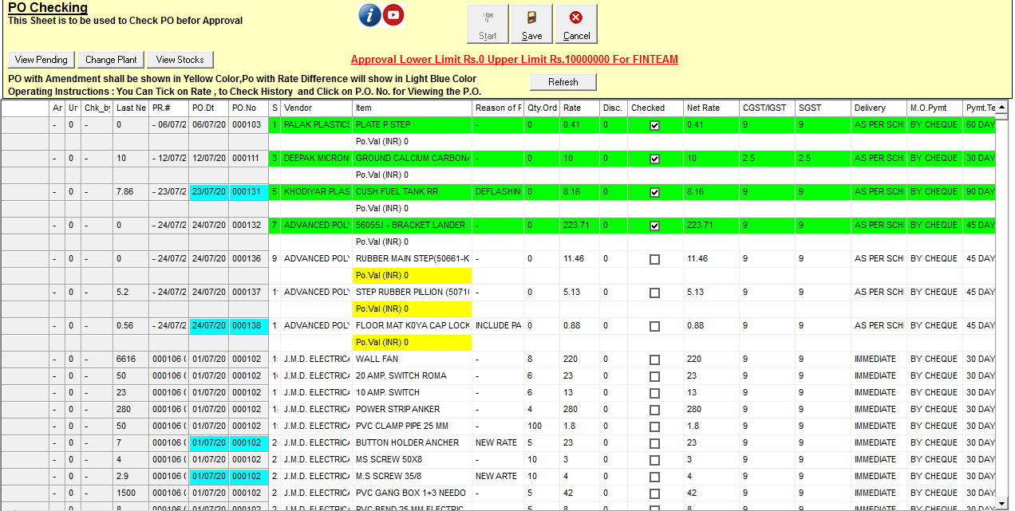
Tick the checkboxes
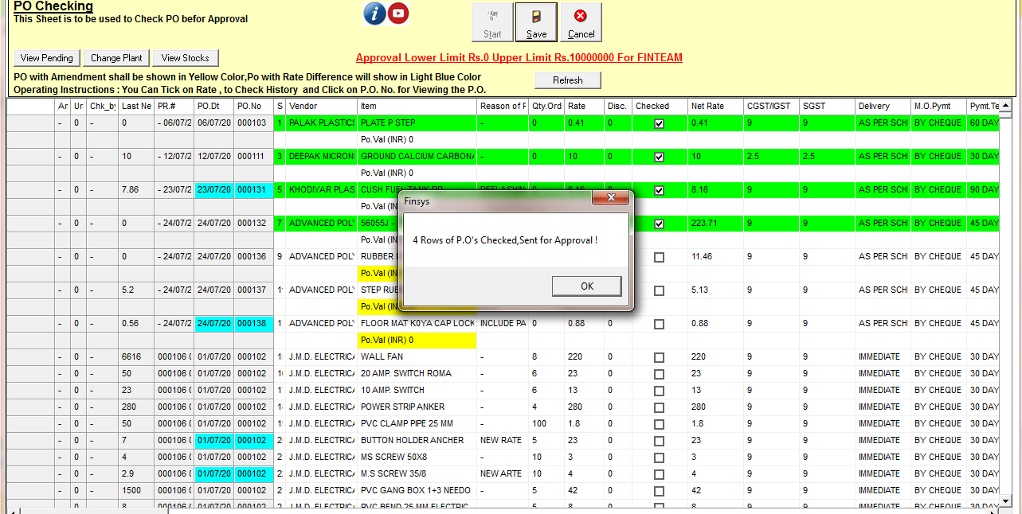
CLICK ON SAVE

