How can we use approved vendor in finsys
We have an option for approved vendor.
PURCHASE&PROCUREMENTAPPROVED VENDOR
Benefits: - If the vendor is approved then there will be no material purchase from any vendor, only if the material comes from the same vendor, then the management will be approved.
If the approved rate is there, then the person cannot enter the rate from himself, the same rate will be applied which will be approved.
CLICK:- PURCHASE&PROCUREMNET
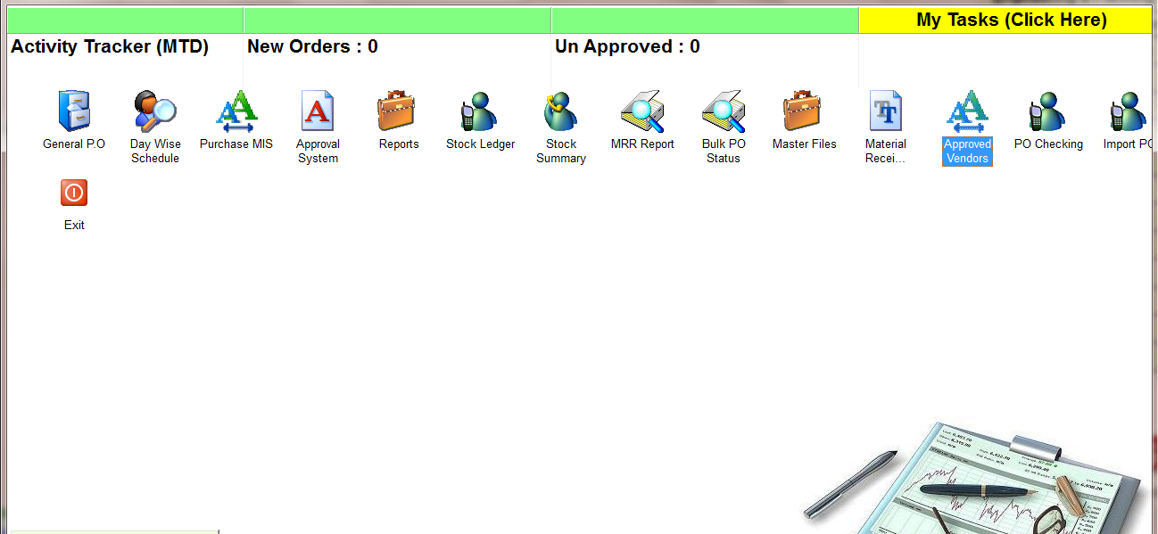
CLICK:- APPROVED VENDOR
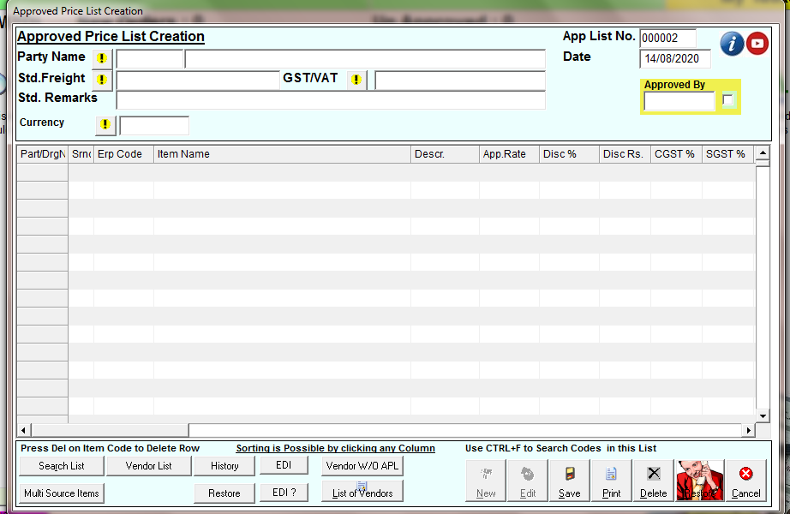
CLICK:- NEW BOTTUN
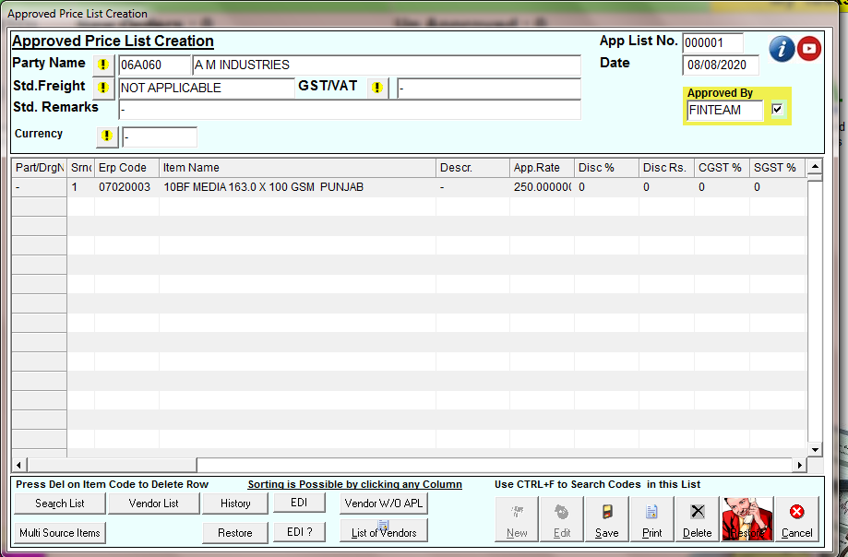
SELECT THE VENDOR NAME, ITEM NAME, AND PUT THE RATE OF ITEM, SELECT THE FREIGHT STD. IF YOU WANT TO ENTER AND CLICK ON CHECK BOX FOR APPROVAL THAN SAVE IT
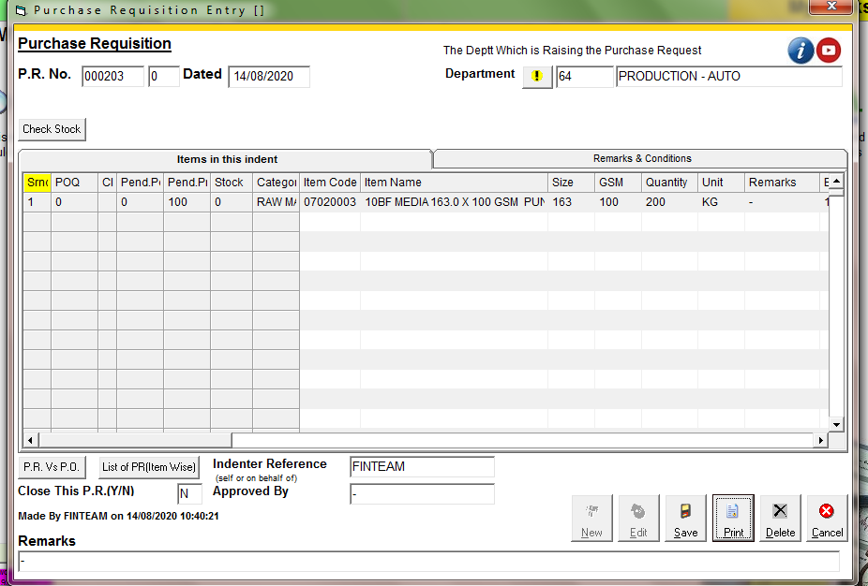
MAKE PR FOR APPROVED ITEM
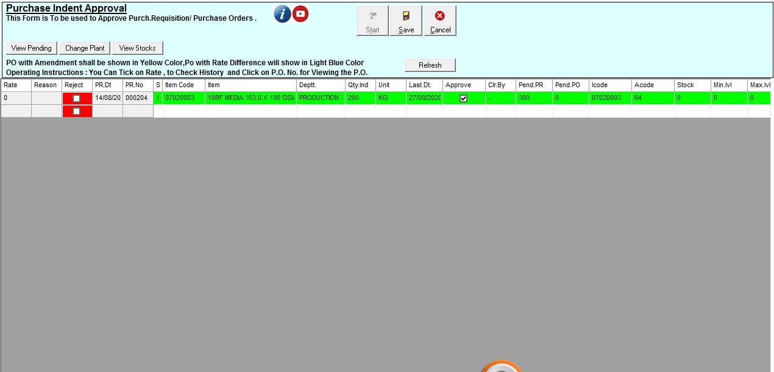
APPROVED THE PR
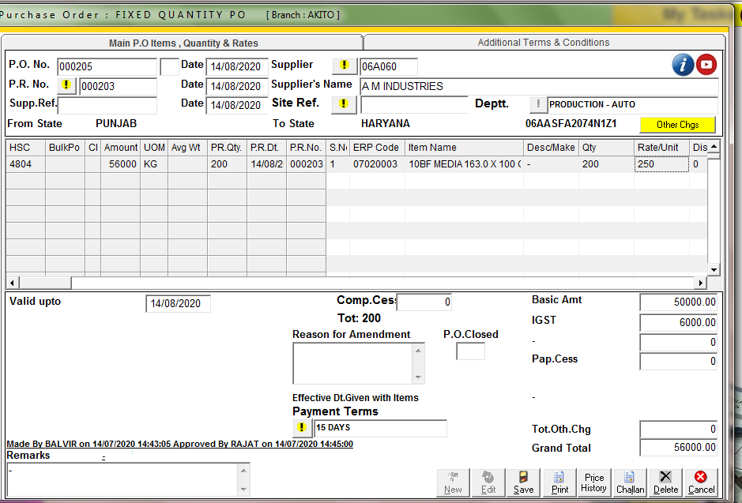
MAKE THE PO AND SELECT THE APPROVED VENDOR AND THE PR THEN SEE THE RATE WILL COME AUTOMETICALLY WHICH IS YOU APPROVED FOR THIS VENDOR AND SAVE IT
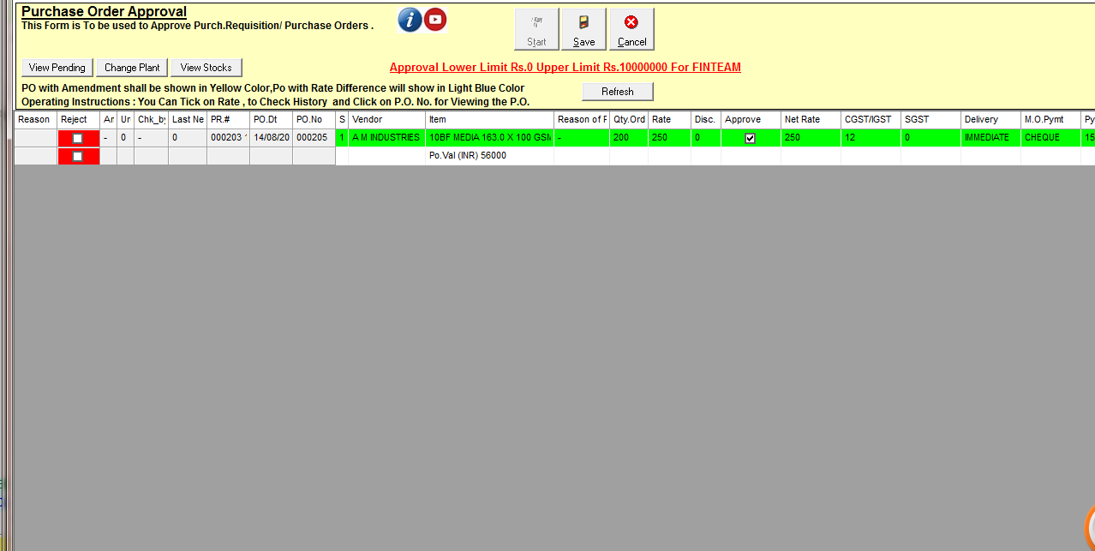
APPROVED THE PO

