How can we see report of Min level/Re-order level in finsys?
We have a report for Min level/Re-order level
PURCHASE&PROCUREMENTPURCHASE MISFIRST TAB (PR/PO RELATED)PURCHASE ESTIMATE OF MSL/ROL ITEMS
Click:- Purchase & procurement
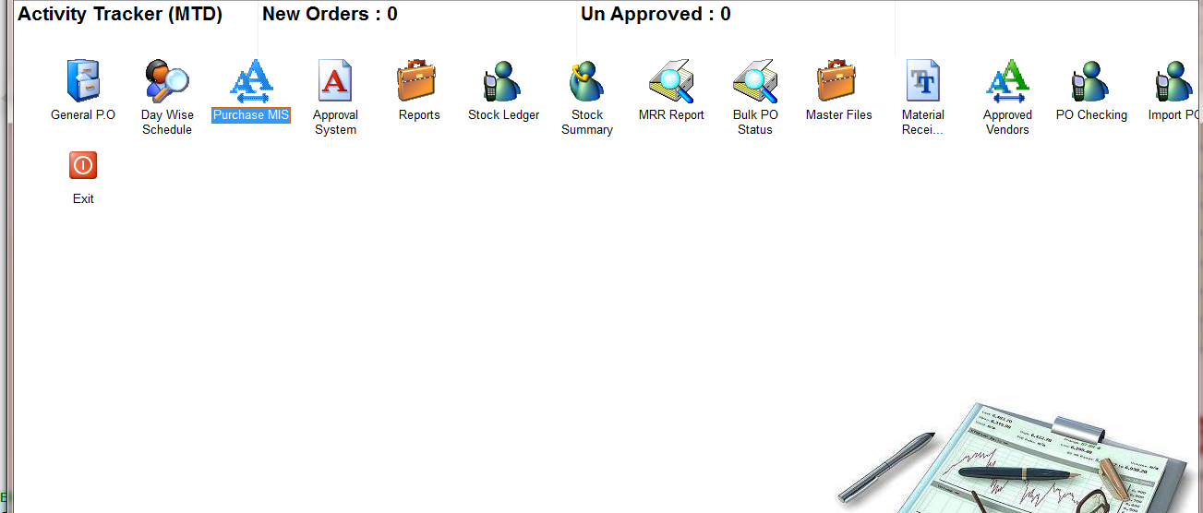
Click:- Purchase MIS
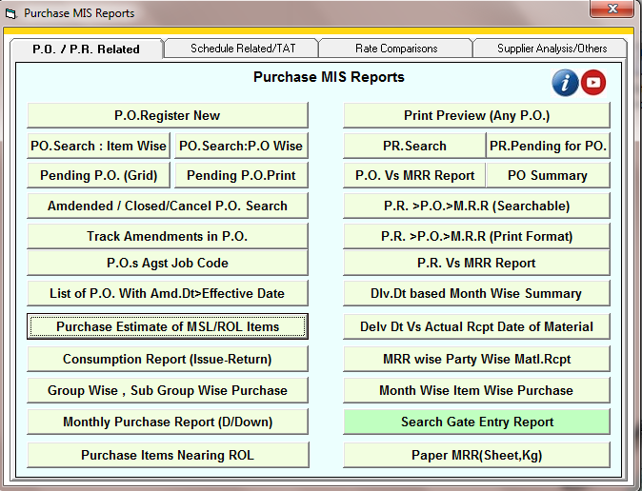
Click:- Purchase estimate of MSL/ROL items

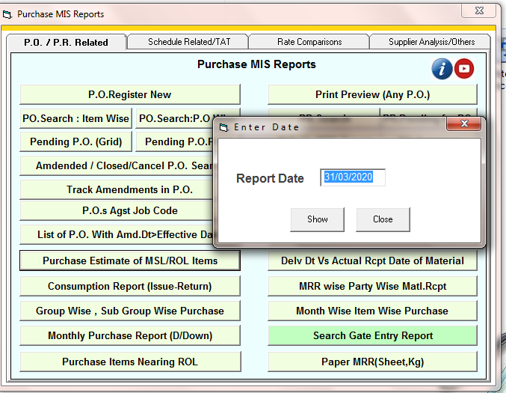
Enter the date

Select the option
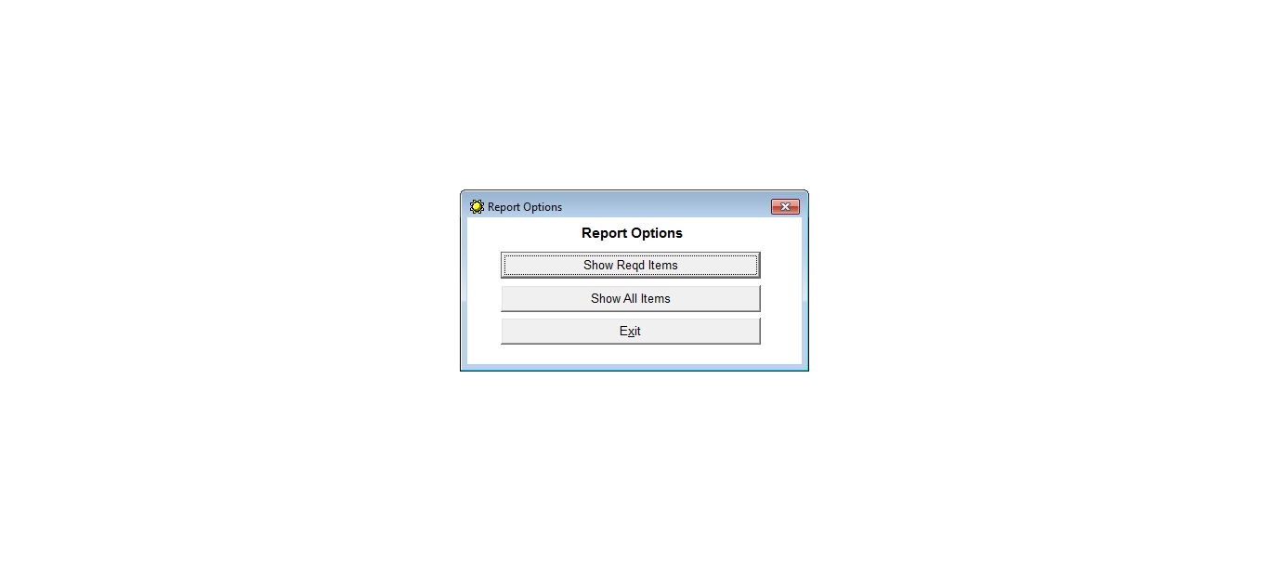
Select the option for item

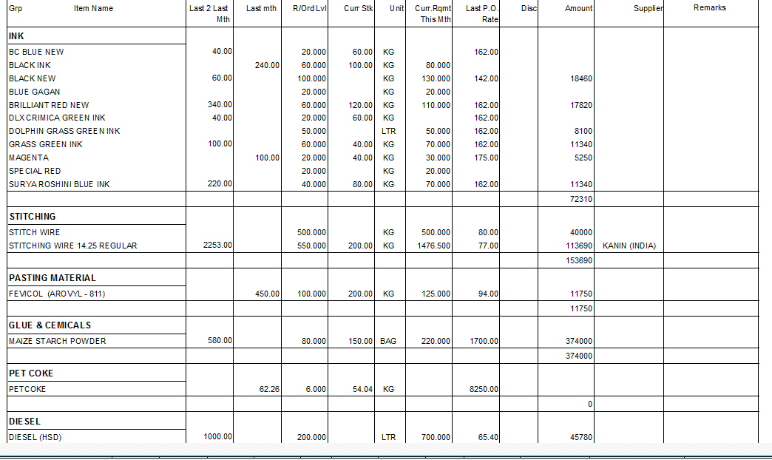
Re-order Report

