How can we see report for rejection material stock?
We have a report for rejection material stock.
INVENTORY MANAGEMENT>>REPORT>>REJ STK LEDGER
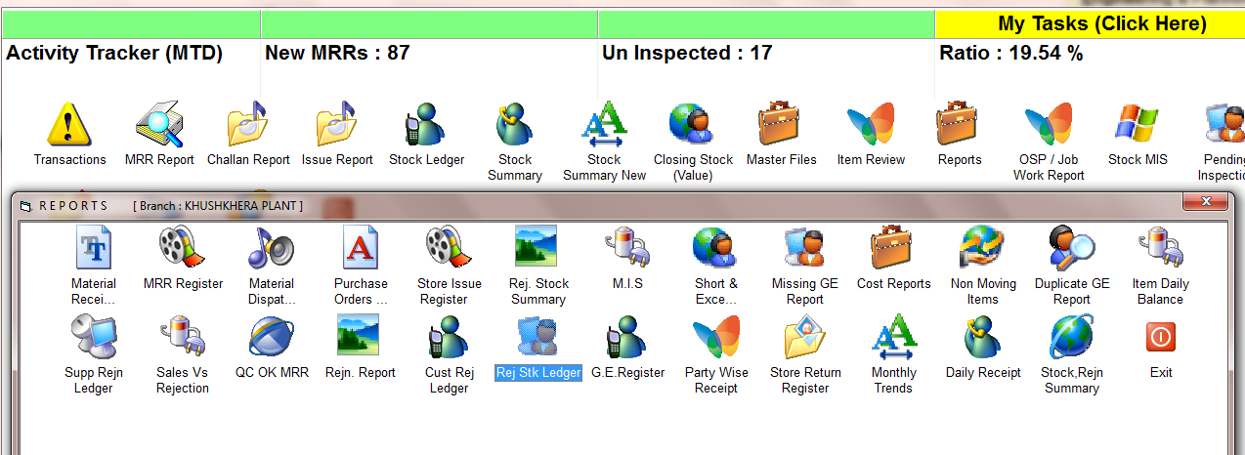
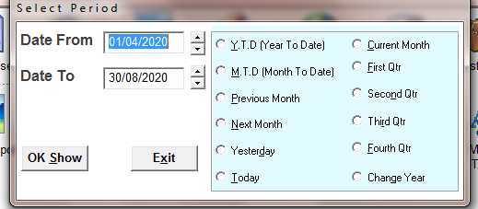
SELECT THE TIME PERIOD
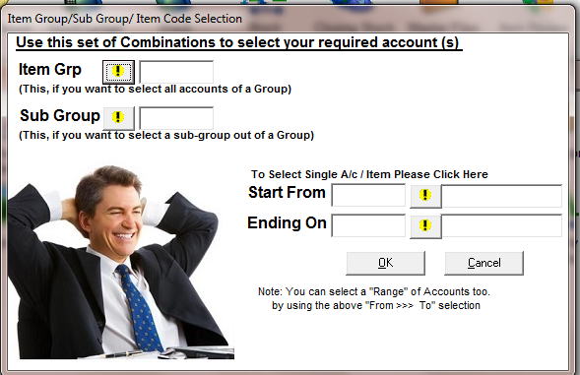
SELECT THE ITEM OR PRESS OK FOR ALL
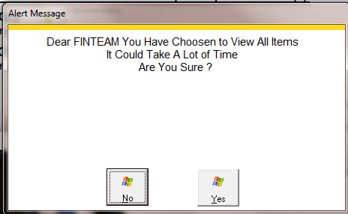
PRESS YES FOR ALL
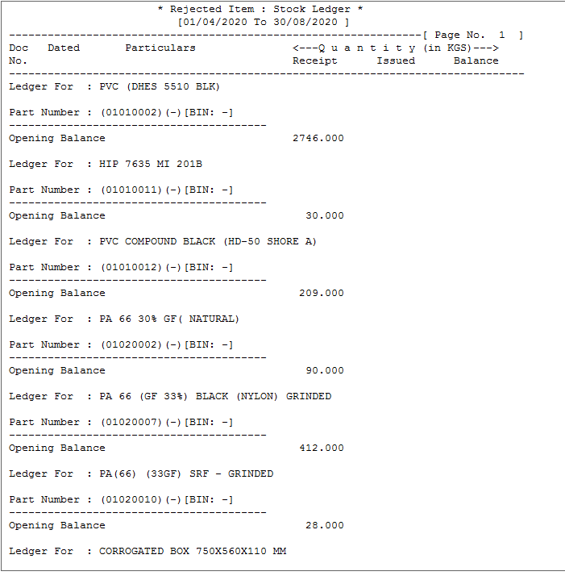
REJECTION STOCK REPORT

