How can we see party wise purchase report?
We have a report for party wise purchase
PURCHASE&PROCUREMENTREPORTSPARTY WISE PURCHASE
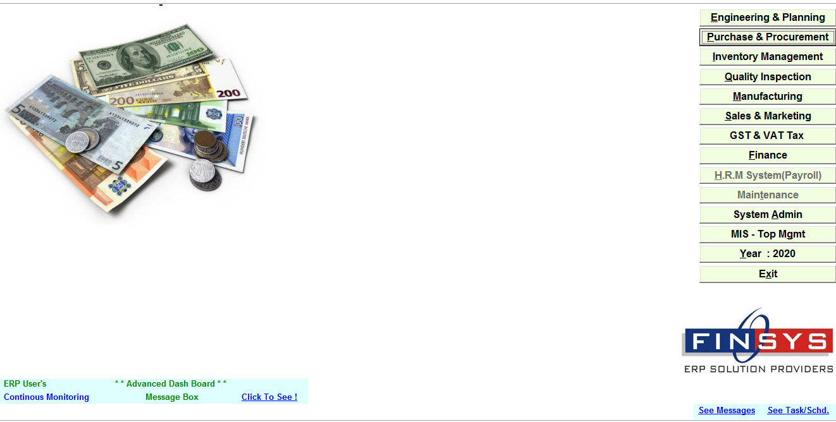
CLICK: - PURCHASE & PROCUREMENT
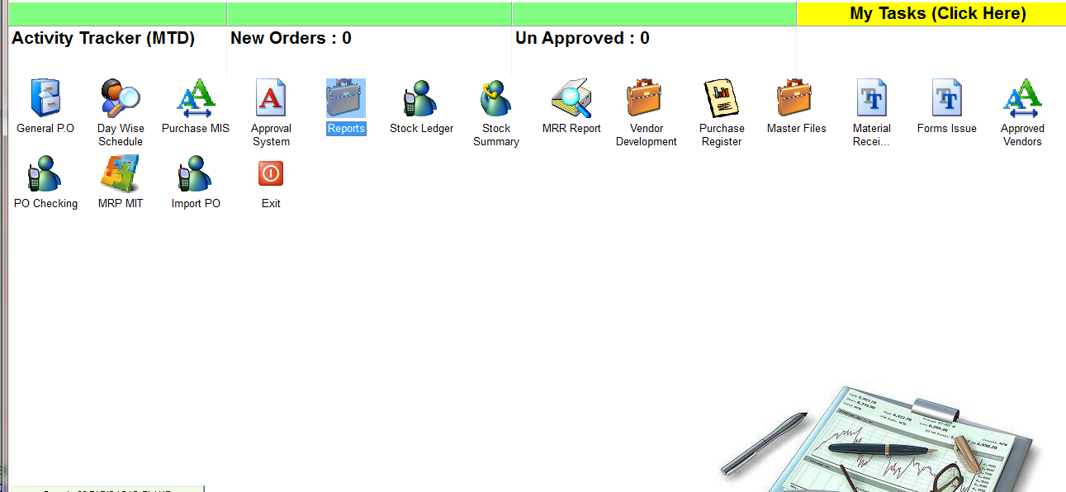
CLICK: - REPORTS
CLICK: - PART WISE PURCHASE
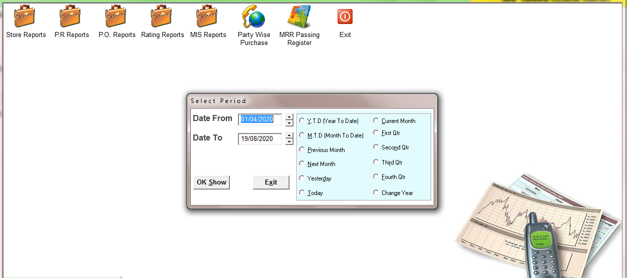
SELECT THE TME PERIOD
TY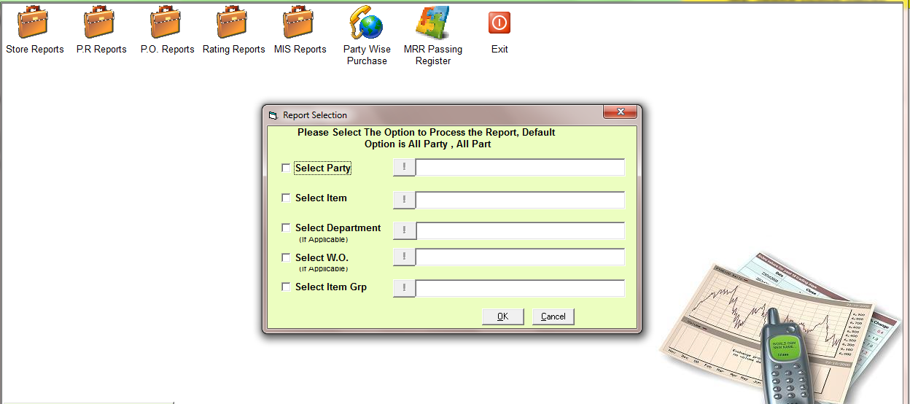
SELECT THE OPTIONS IF YOU WANT TO SEE REPORT FOR A SPRECIFIC PARTY, ITEM etc. or CLICK OK FOR ALL
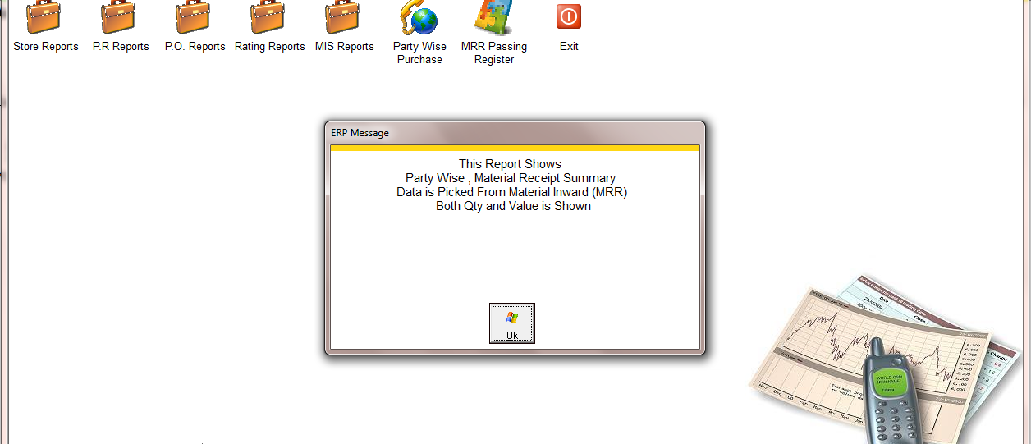
CLICK: - OK
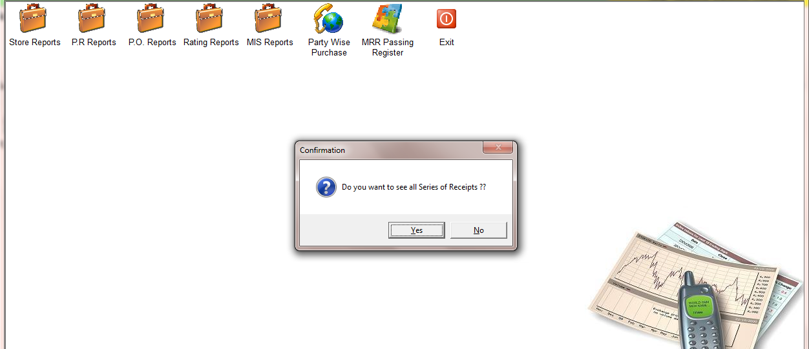
SELECT THE OPTION
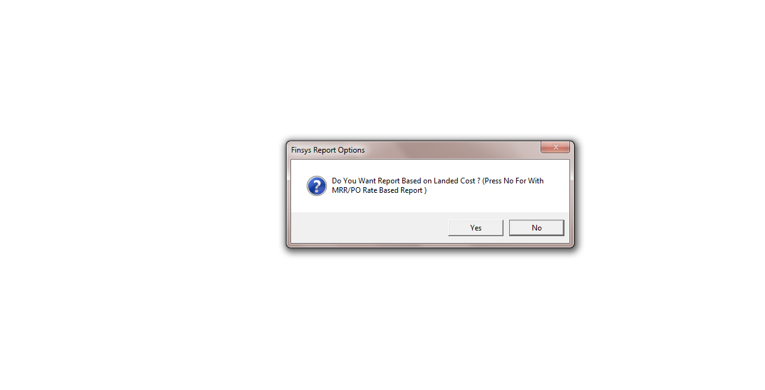
SELECT THE OPTION
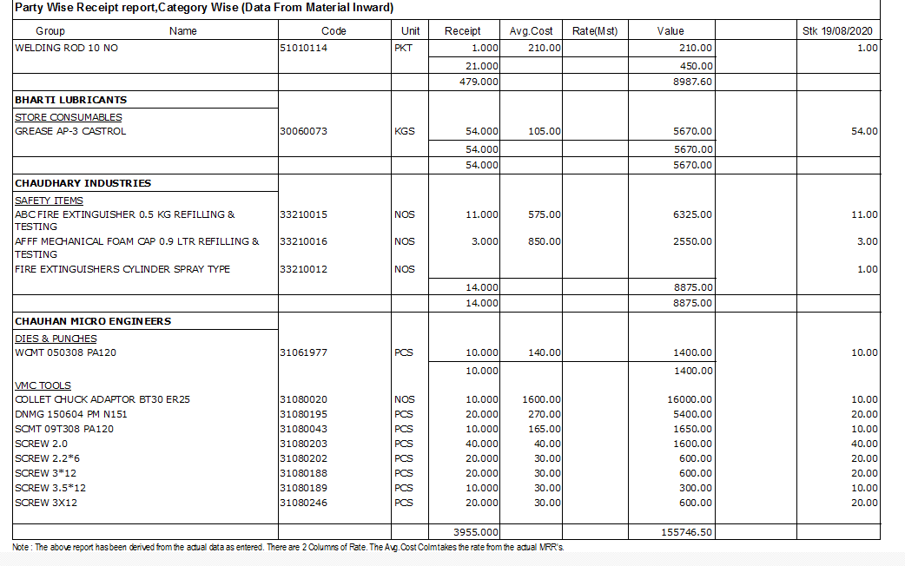
REPORT

