How can we see non moving items report?
We have a report for non moving items report
INVENTORY MANAGEMENT
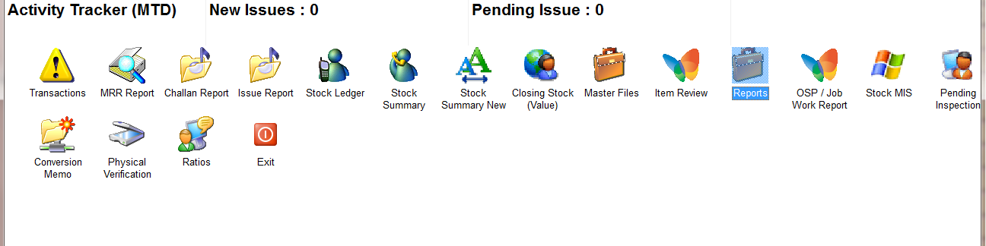
REPORTS
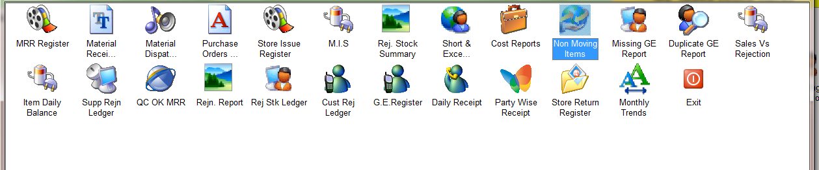
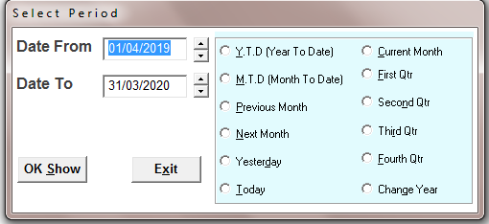
SELECT THE TIME PERIOD
ENTER THE NO. OF DAYS
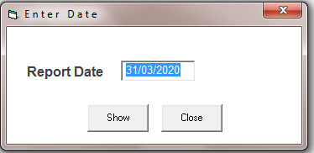
ENTER THE DATE
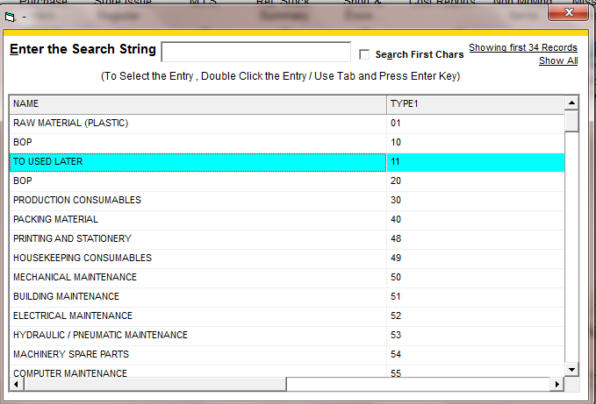
SELECT A ITEM GROUP FOR A SPECIFIC GROUP REPORT
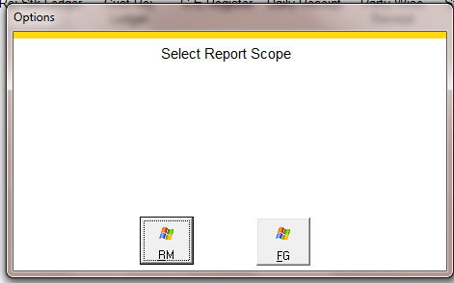
SELECT OPTION FOR RM /FG
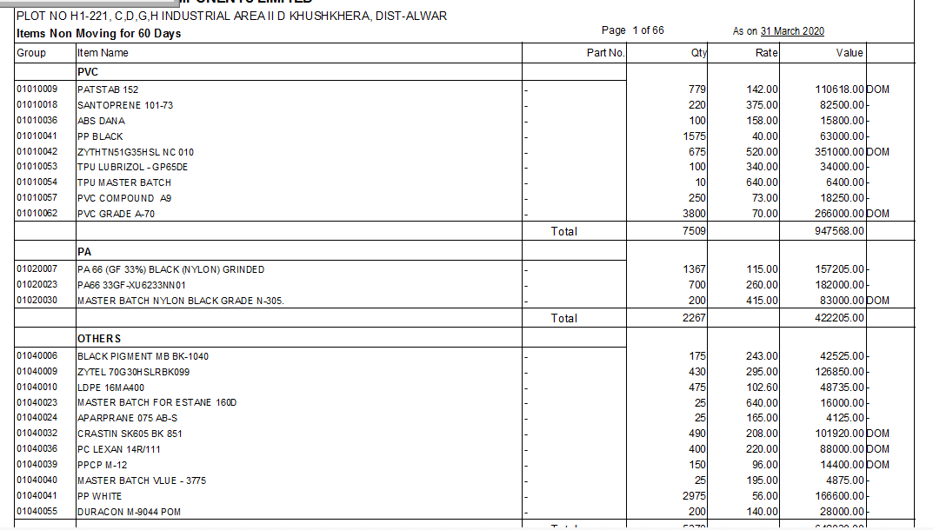
REPORT

