How can we see PO item with rate increase/decrease?
We have a report for PO item with rate increase/decrease
PURCHASE&PROCUREMENTPURCHASE MIS3RD TAB (RATE COMPARISON)PO ITEM WITH RATE INCREASE/DECREASE
Click:- PURCHASE&PROCUREMENT
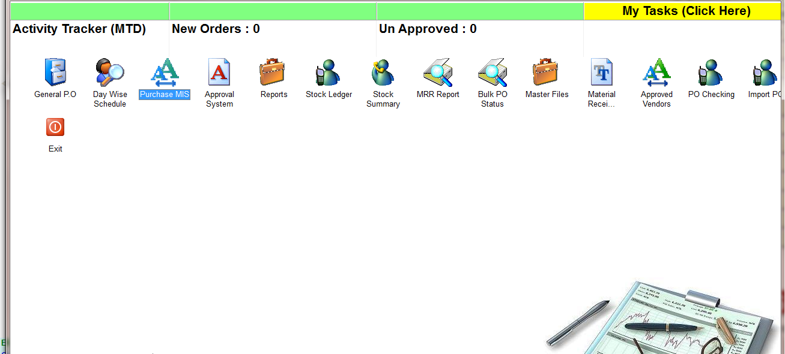
Click:- PURCHASE MIS
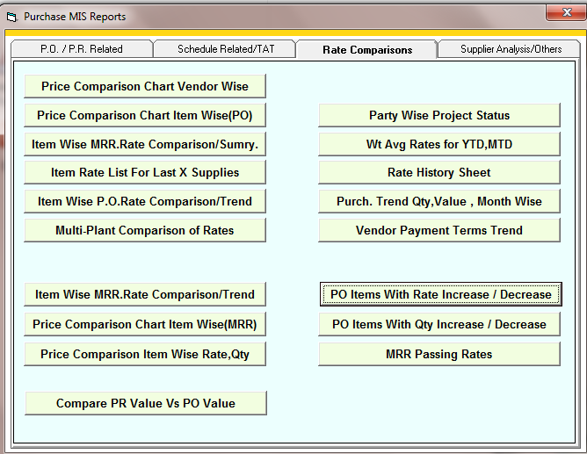
CLICK:- PO ITEM WITH RATE INCREASE/DECREASE
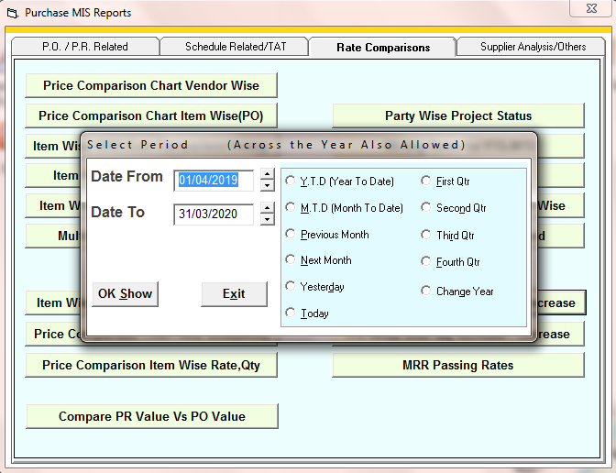
SELECT THE TIME PERIOD
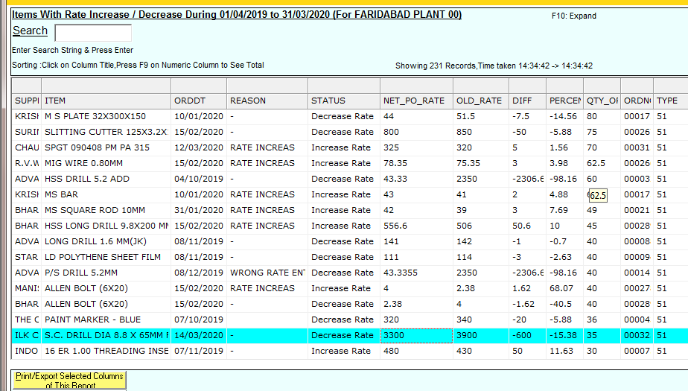
REPORT

