How can we see MRR with rejection report?
We have report for MRR with rejection report
INVENTORY MANAGEMENT
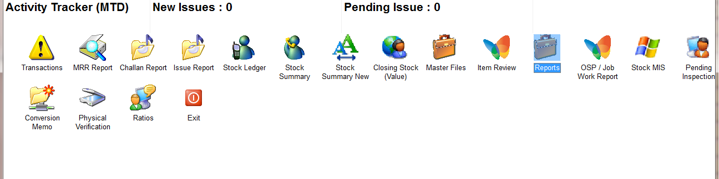
REPORTS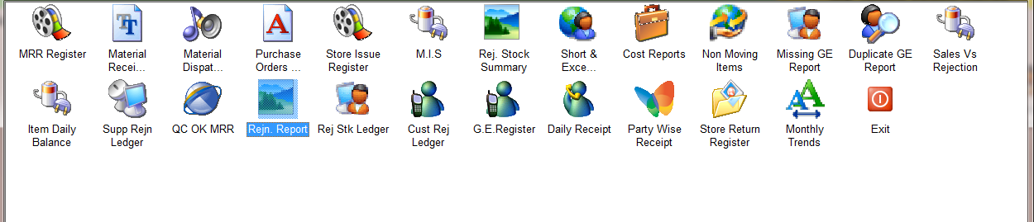
REJN REPORT
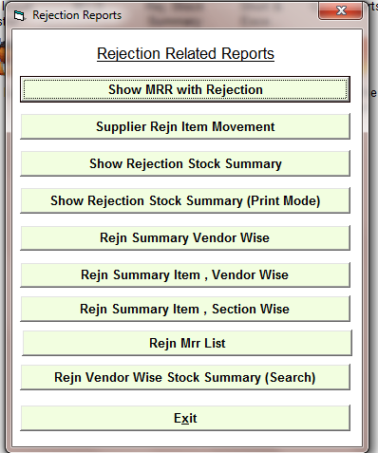
SHOW MRR WITH REJECTION

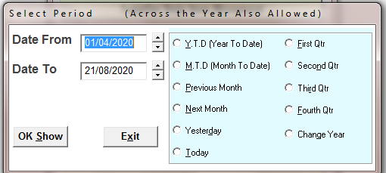
SELECT TIME PERIOD
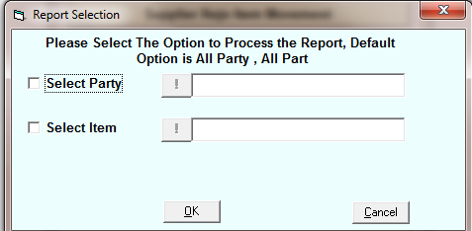
SELECT PARTY OR ITEM FOR SPECIFIC SELECTED PARTY OR ITEM REPORT
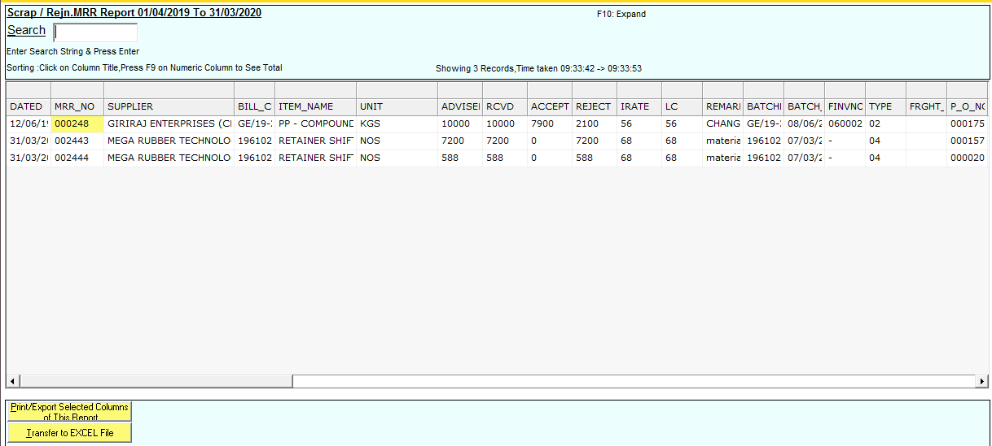
REPORT

