How can we see MRR pending for P.V Data/report?
We have a report MRR pending for P.V Data/report
PURCHASE & PROCUREMENT
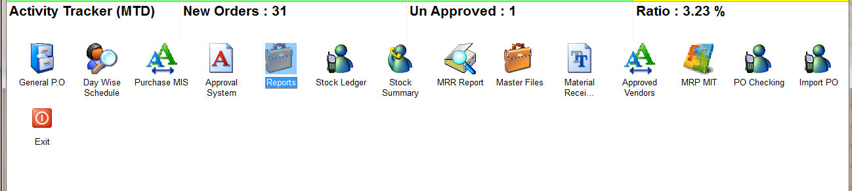
REPORTS
MRR PASSING REGISTER
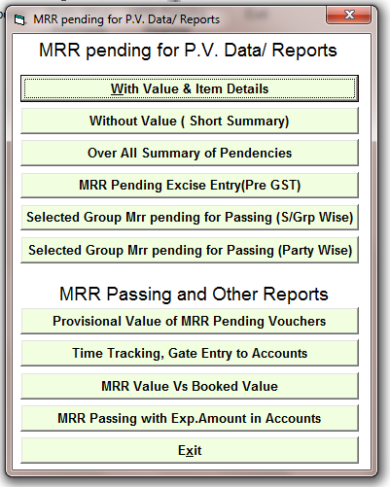
MRR PENDING FOR P.V DATA/REPORT WITH VALUE&DERAILS. HERE IS MANY OPTIONS FOR THIS REPORT

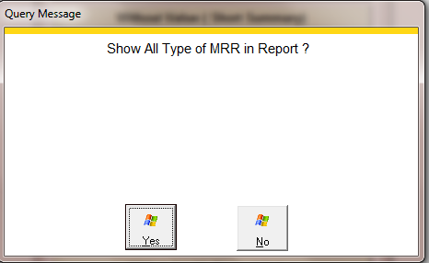
SELECT THE OPTION
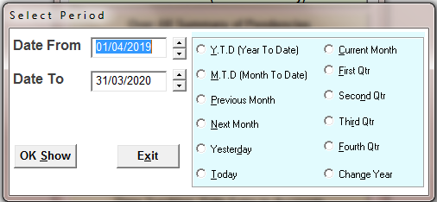
SELECT THE TIME PERIOD
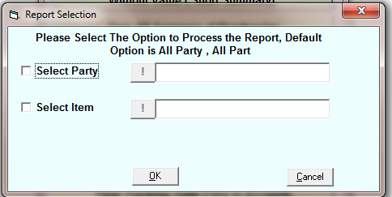
SELECT THE SPECIFIC PARTY OR ITEM IF YOU WANT TO SEE REPORT FOR A SINGLE PARTY OR ITEM
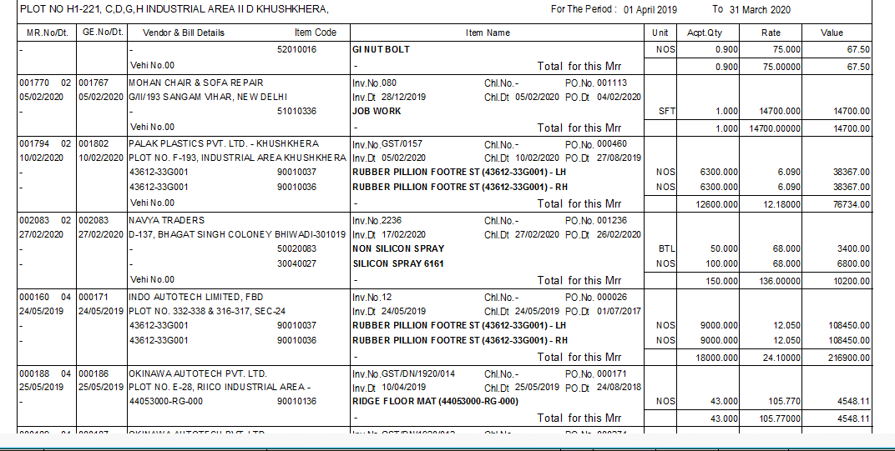
REPORT

