How can we monthly purchase report of total value?
We have a report for monthly purchase item wise, groups wise.
PURCHASE&PROCUREMENT>>REPORTS>>MIS REPORTS>>MONTHLY PURCHASE
We can see here how much an item was purchased in this month and what was the maximum rate and minimum rate and what is the average cost

PURCHASE&PROCUREMENT
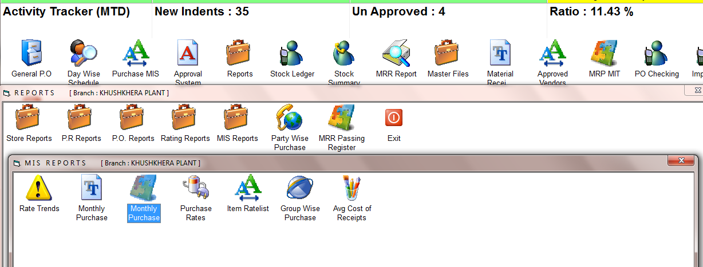
PURCHASE&PROCUREMENT>>REPORTS>>MIS REPORTS>>MONTHLY PURCHASE
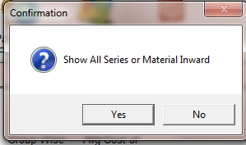
SELECT THE OPTION
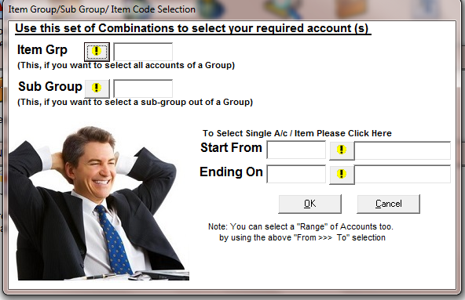
SELECT THE ITEM FOR SPECIFIC ITEM REPORT
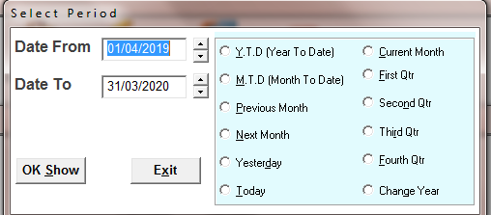
SELECT THE TIME PERIOD
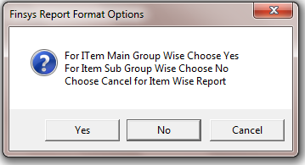
SELECT THE OPTION
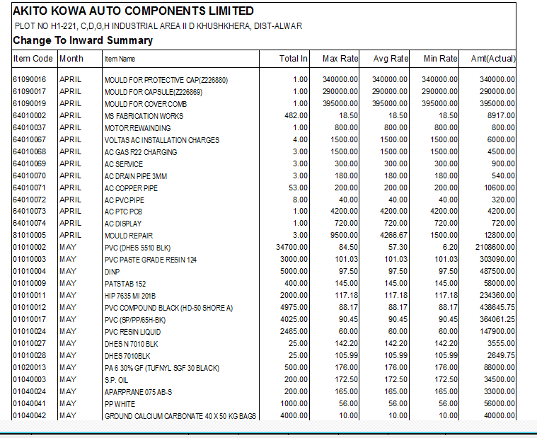
REPORT
Total qty of item in month, max rate, Avg rate, min rate and actual amount

