How can we get the report for PR pending PO of multi plants?
We have a report for PR pending PO of multi plants.
PURCHASE&PROCUREMENTPURCHASE MIS2nd TAB (Schedule related/TAT)MULTI PLANT: PR PENDING PO
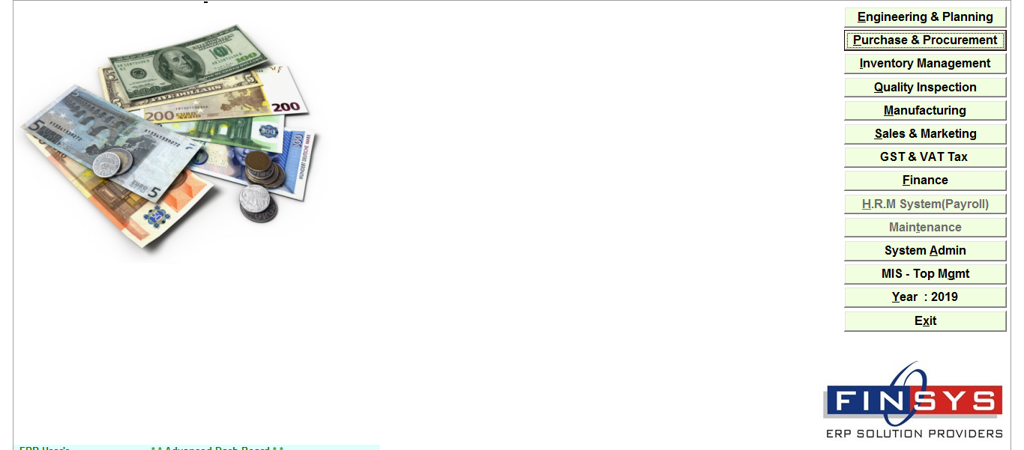
Click:- Purchase & procurement
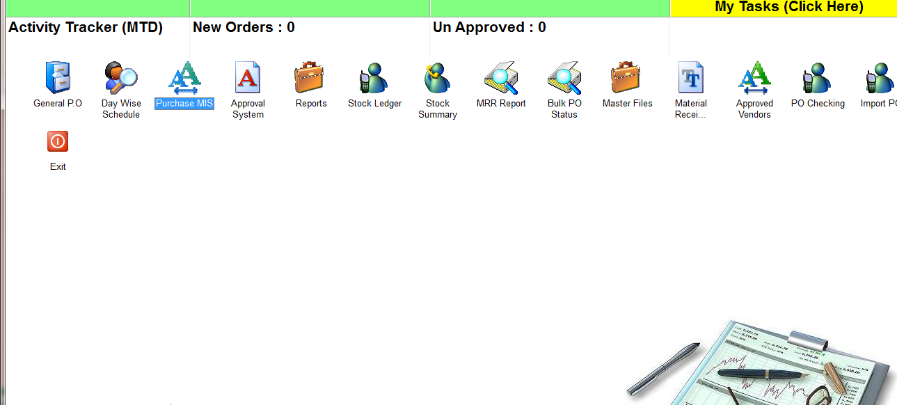
Click:- Purchase MIS
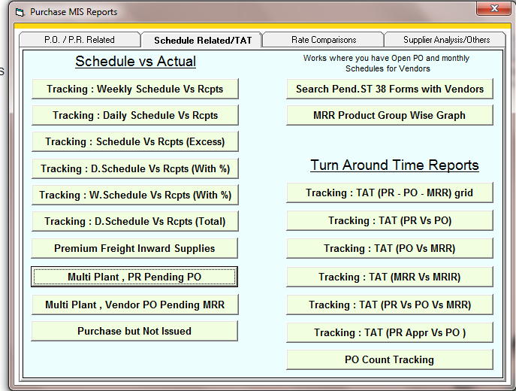
Click:- Multi Plant, PR pending PO
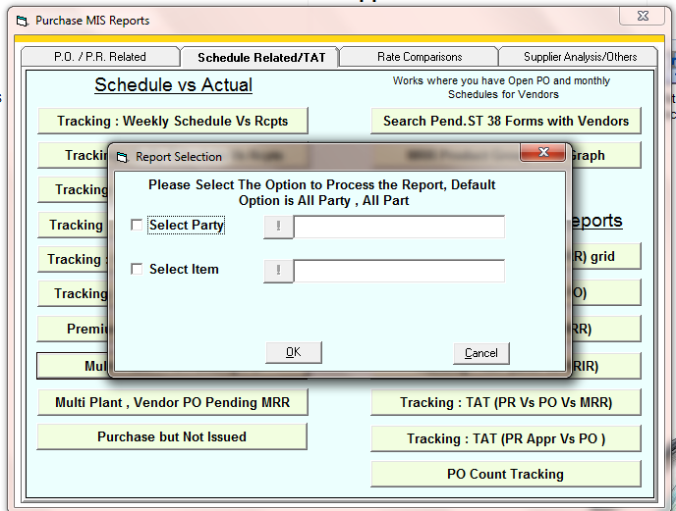
Select the party or item if you want to specific report of a item or party
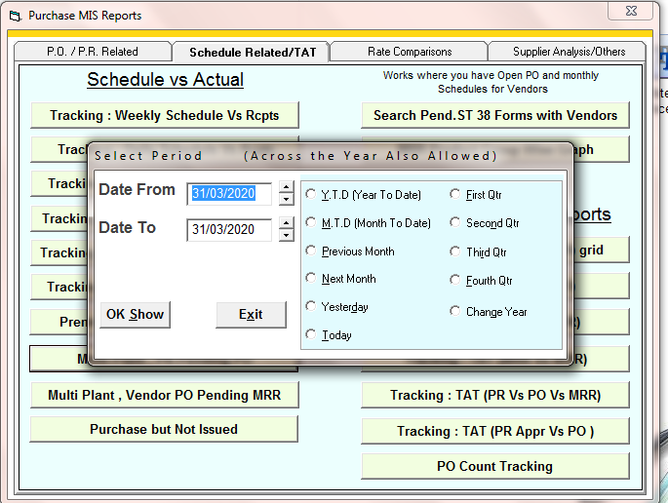
Enter the time period
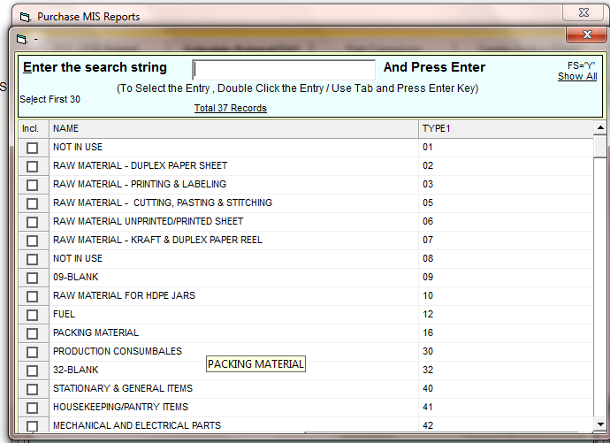
Select the item main group if you want to see report for specific group otherwise press ESC

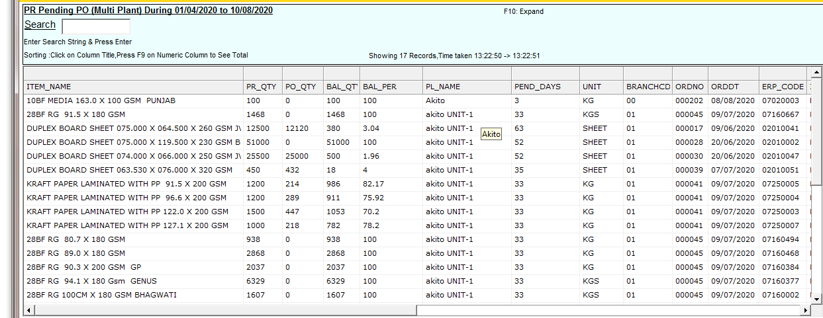
REPORT

