How can we get report for rate comparison of multi-plant?
We have a report for rate comparison of multi-plant
PURCHASE&PROCUREMENTPURCHASE MIS3RD TAB (RATE COMPARISON)MULTI PLANTS COMPARISON OF RATES
Click:- PURCHASE&PROCUREMENT
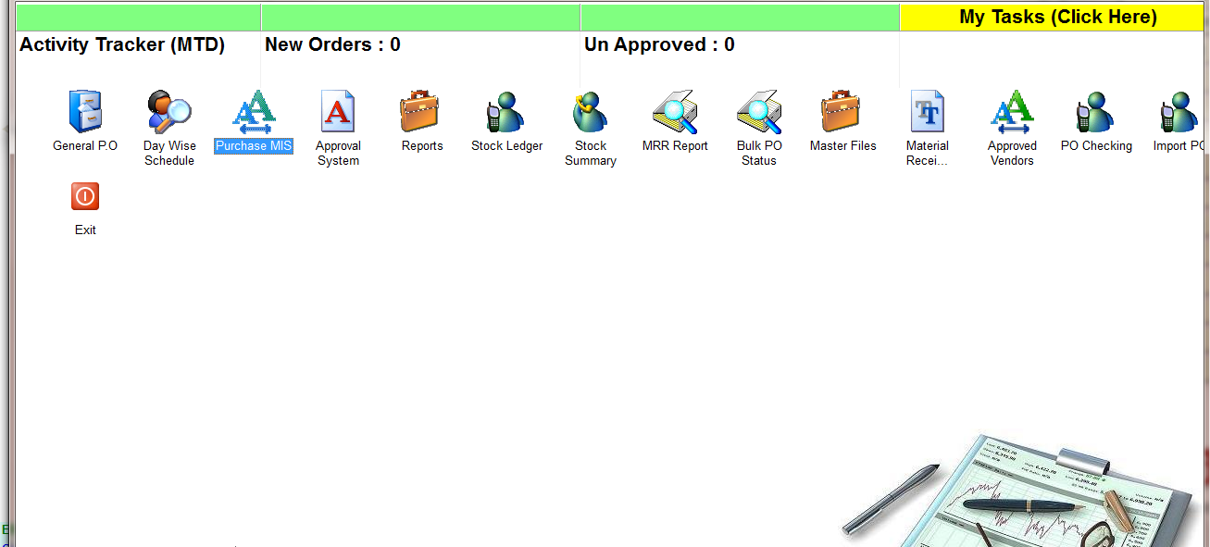
Click:- PURCHASE MIS
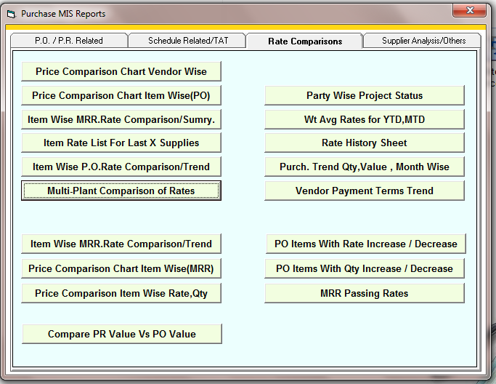
Click:- Multi plant comparison of rates
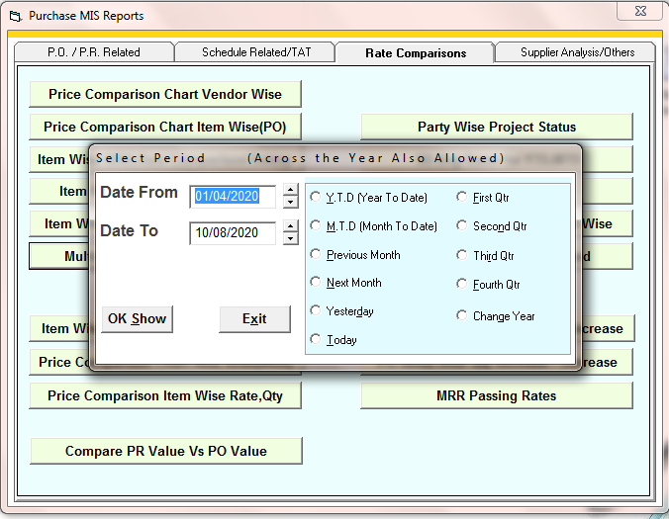
Enter the time period
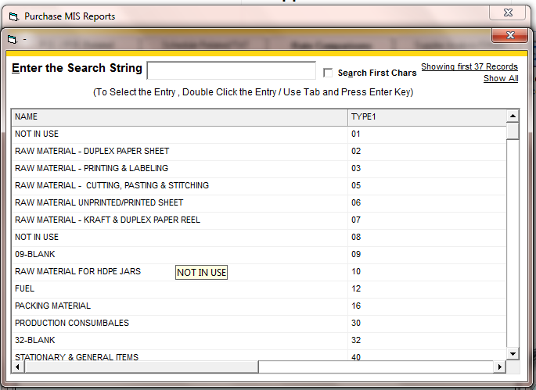
Select the item main group if you want to see report for specific group otherwise press ESC
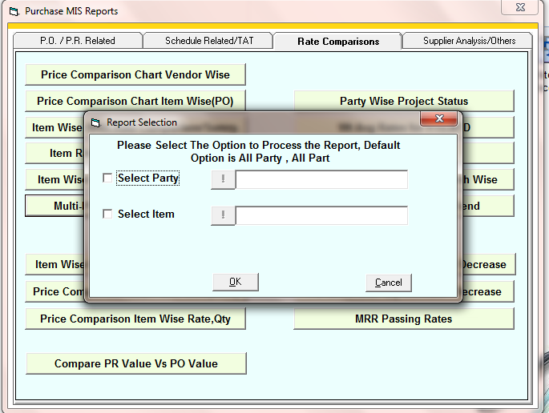
Select the party or item if you want to specific report of a item or party
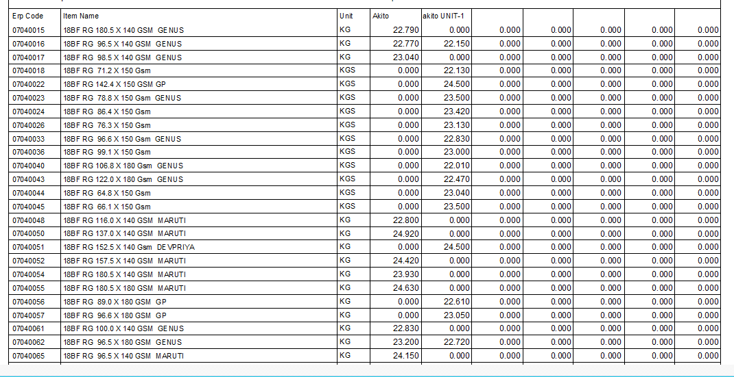
Report

