How can we create and link of bin with item and show in stock report?
We have options for create and link of bin with item and show in stock report
ENGINEERING & PLANNING
BIN MASTER FOR CREATE NEW BIN
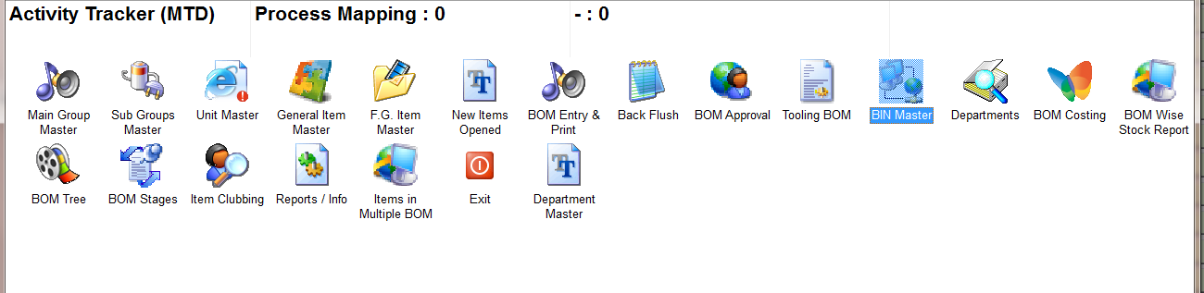
CLICK ON NEW AND CREATE NEW BIN ENTRY AND SAVE
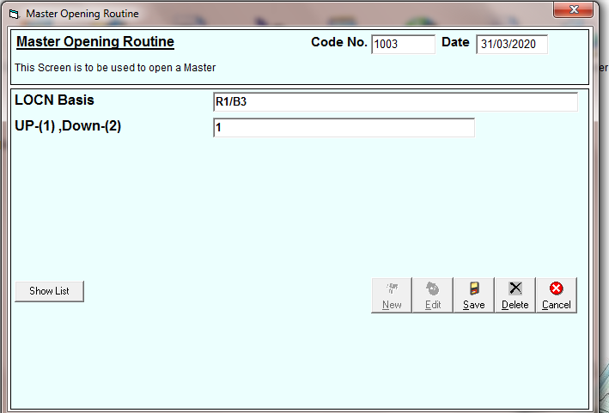
CLICK ON EDIT FOR UPDATE BIN ENTRY AND FOR SEE CREATED ENTRIES
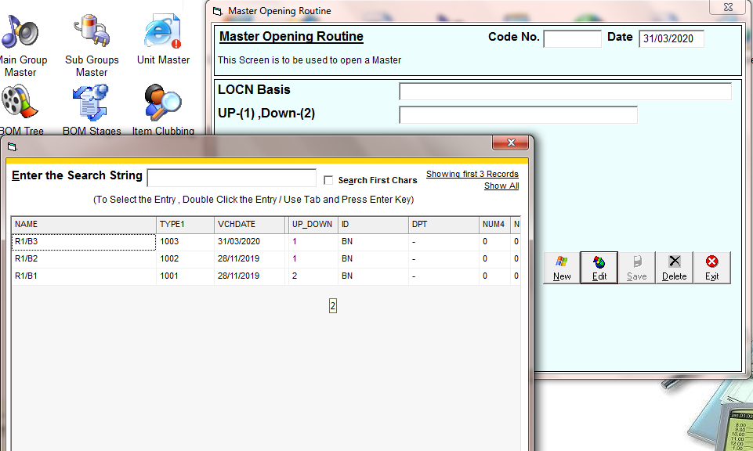
NOW: - LINK BIN WITH ITEM IN ITEM MASTER
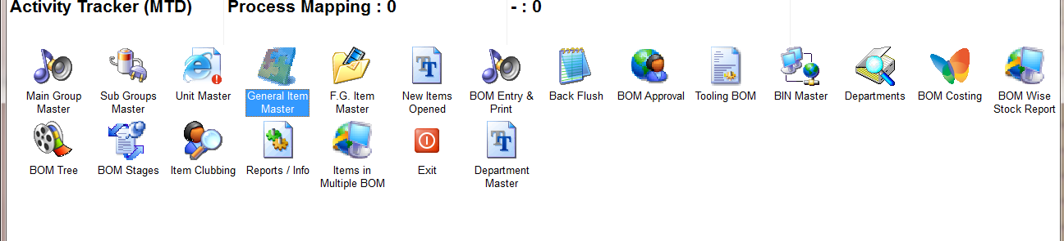
CREATE ITEM AND CLICK ON BIN NO. AND LINK THE BIN
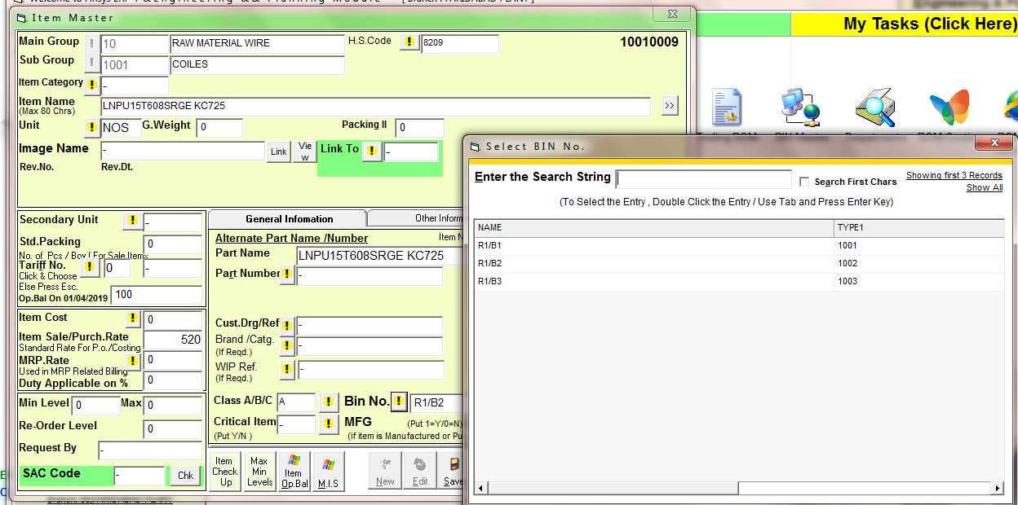
CLICK INVENTORY FOR SEE STOCK REPORTS WITH BIN
STOCK SUMMARY
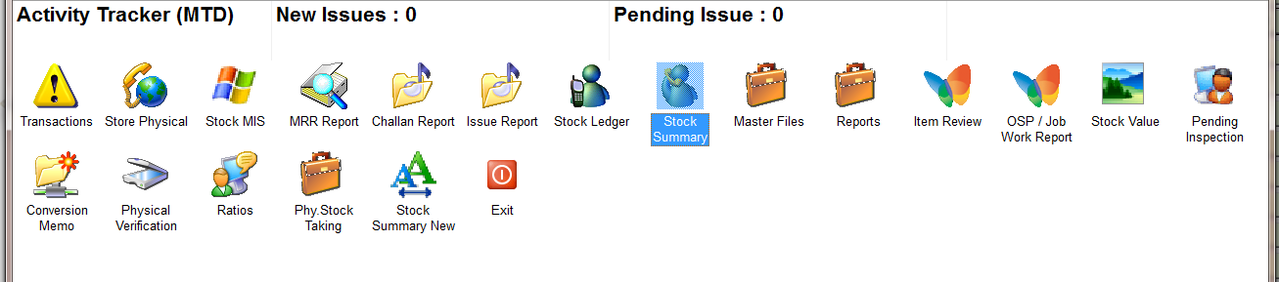
STOCK SUMMARY REPORT LOCATION COMES IN LAST COLUMN
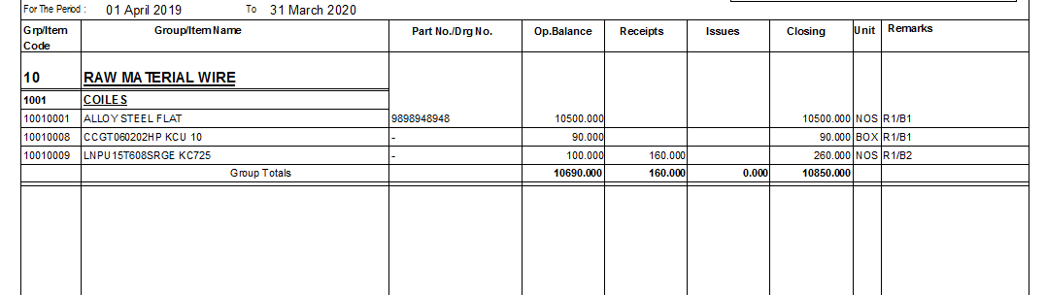
STOCK LADGER
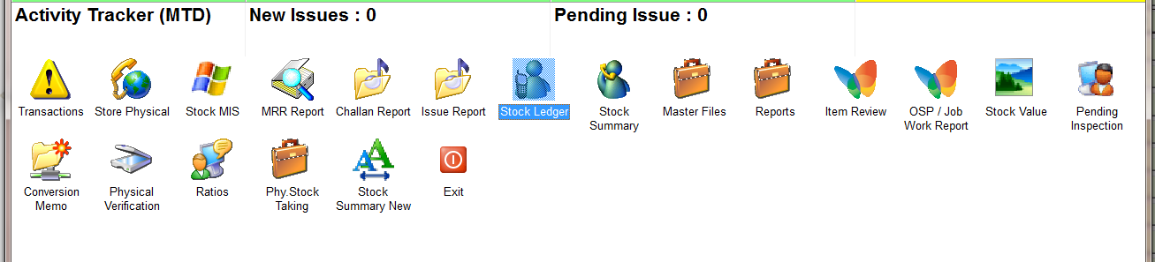
STCK LEDGER REPORT
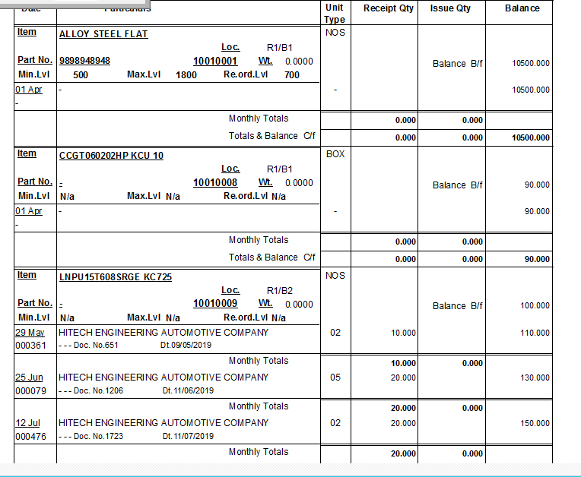
LOCATION COMES IN LEDGER

