Can we see such a report in which it is found that the PO is made against of PR and MRR is made against of PO?
Yes, we have a report for that
PURCHASR& PROCUREMENT>>PURCHASE MIS>>PR>>PO>>MRR (SEARCHABLE)
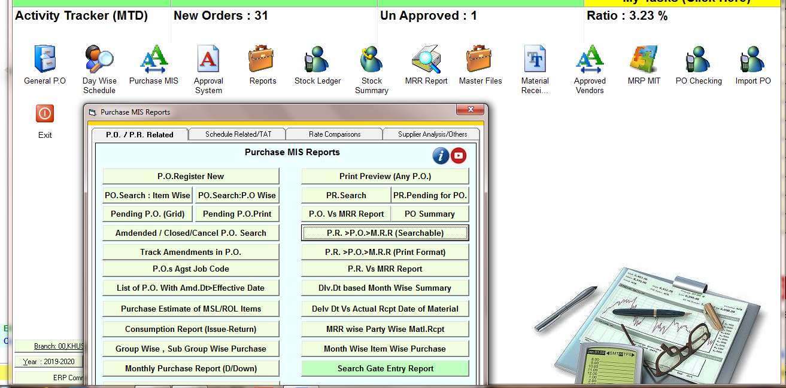

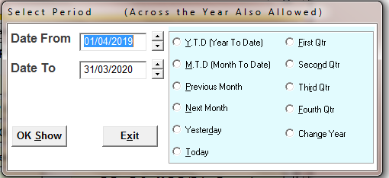
SELECT THE TIME PERIOD
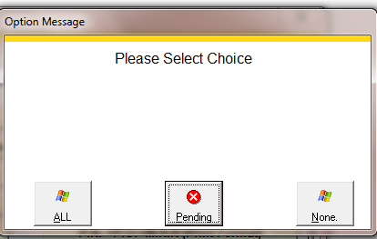
CHOOSE THE OPTION I PRESS PENDING
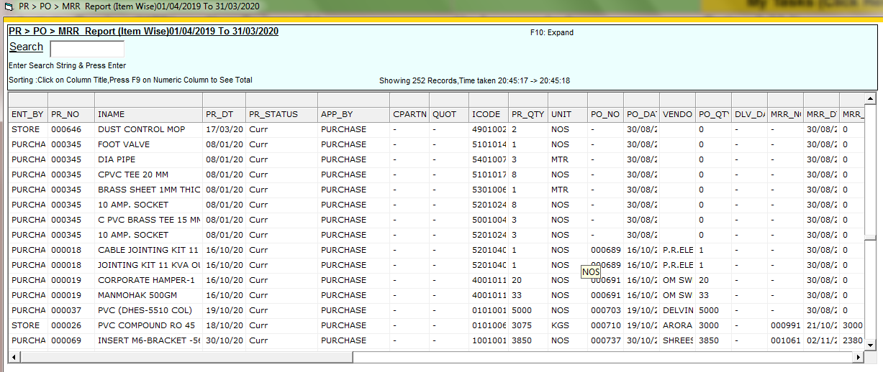
RPEORT>> HERE IS SHOWING PR IS MADE BUT THE PO IS PENDING AND PO IS MADE BUT MRR IS PENDING

