Can we see report in finsys for time tracking Gate entry to Accounts?
Yes, we have a report for time tracking Gate entry to Accounts
PURCHASE & PROCUREMENT
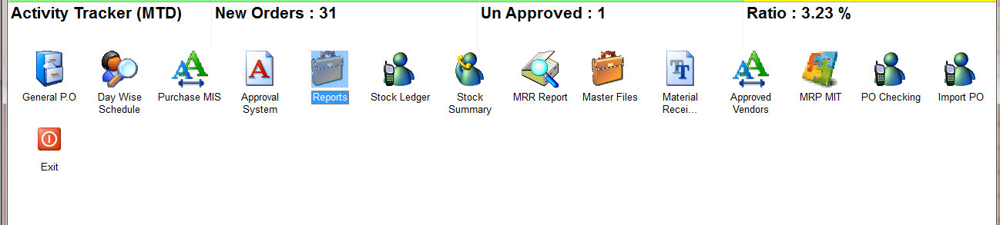
REPORTS
MRR PASSING REGISTER
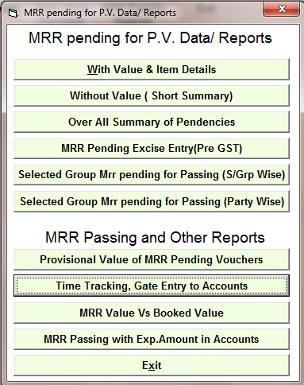
TIME TRACKING, GATE ENTRY TO ACCOUNTS
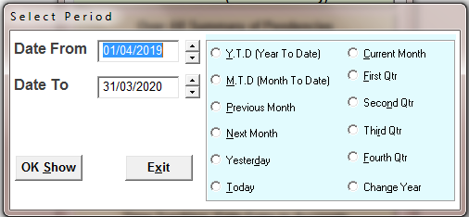
SELECT THE TIME PERIOD
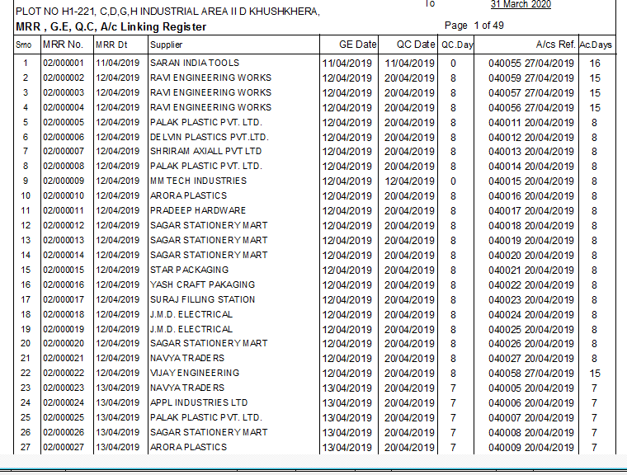
REPORT, here is showing no. of days for QC and AC entry

