Can we see monthly PO rates report?
YES, we have a report for monthly PO rates
PURCHASE&PROCUREMENT>>REPORT>>PO REPORTS>>MONTHLY PO RATES
Here we can see the month wise item rate increase or decrease
PURCHASE&PROCUREMENT
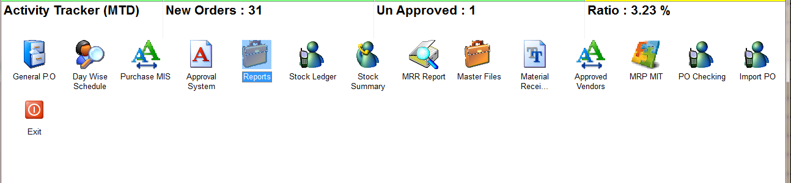
REPORTS
PO REPORTS
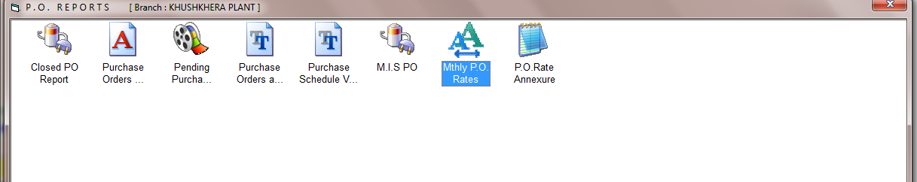
MTHLY PO RATES
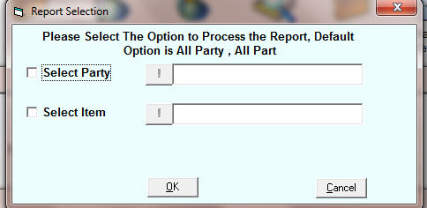
SELECT THE OPTIONS IF YOU WANT TO SEE A SPECIFIC RECORD
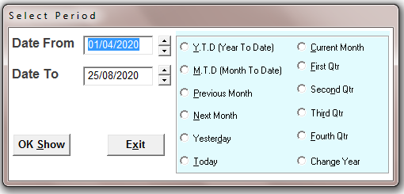
SELECT THE TIME PERIOD
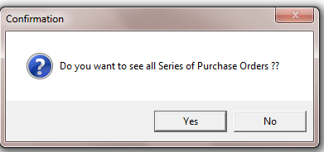
SELECT THE OPTION
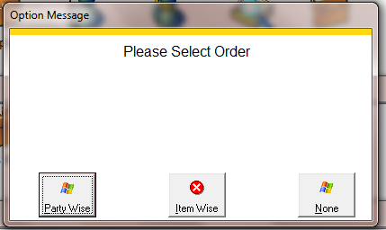
HERE IS 2 OPTIONS TO VIEW REPORT PARTY WISE, and ITEM WISE
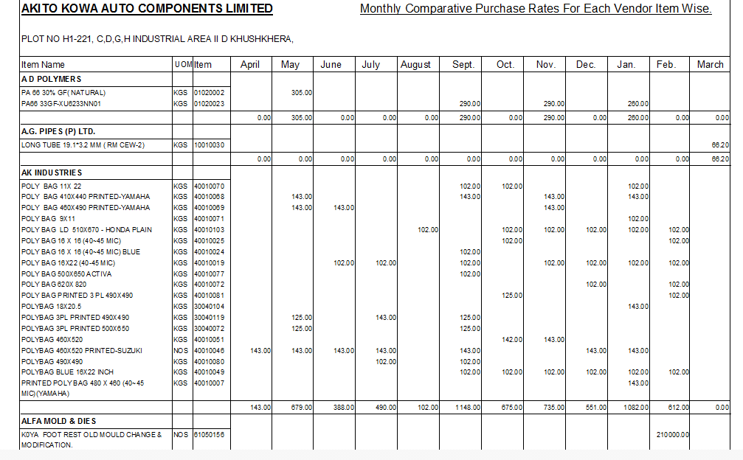
PARTY WISE REPORT

