Can we see Finished Goods closing stock with value report?
Yes. We have a report for Finished Goods closing stock with value
INVENTORY MANAGEMENTSTOCK VALUEFINISHED GOOS CLOSING STOCK WITH VALUE
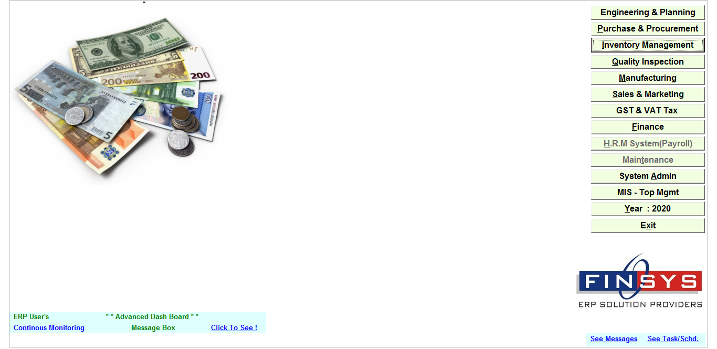
Click Inventory Module
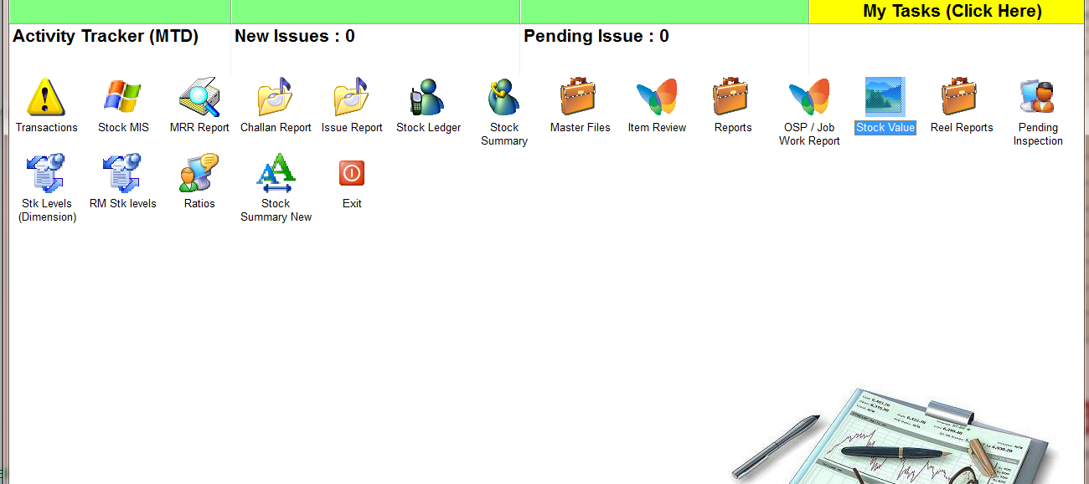
ClickStock Value
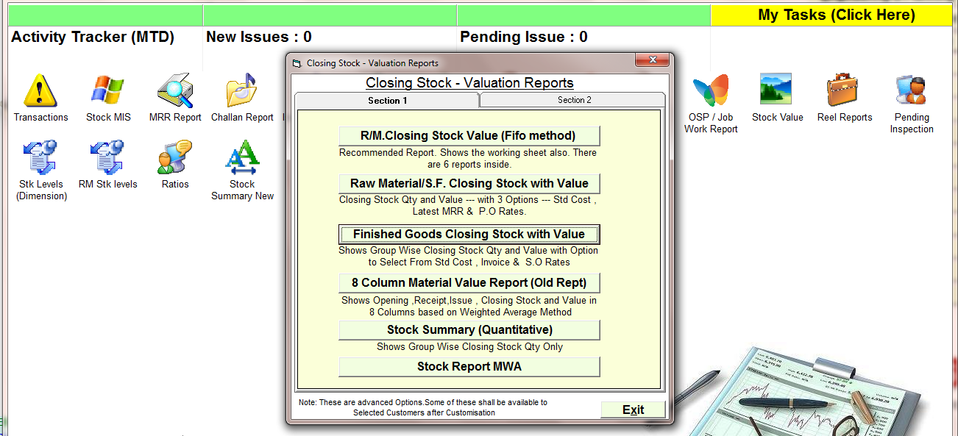
ClickOn the Finished Goods closing stock with value report
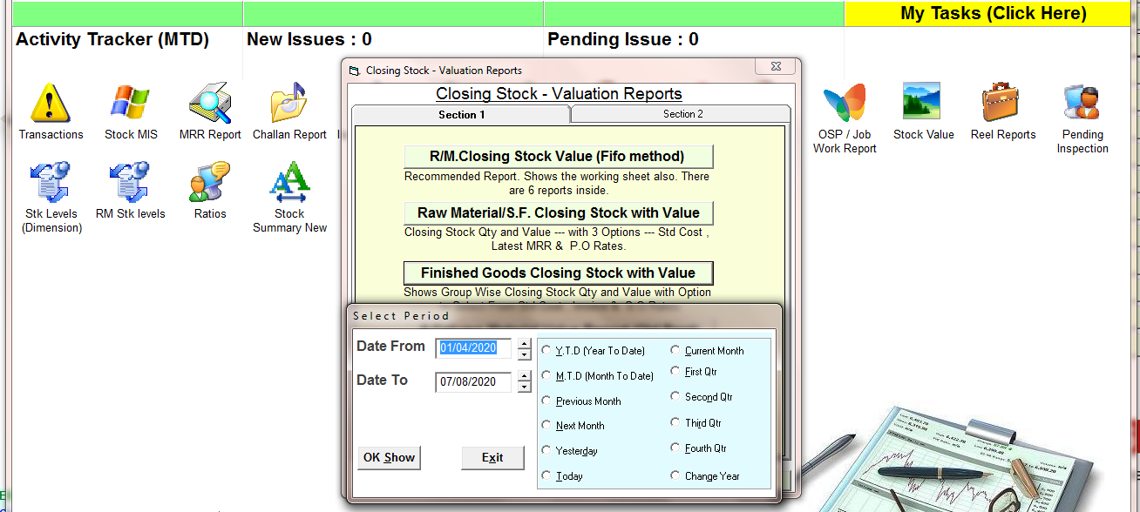
Select the time period
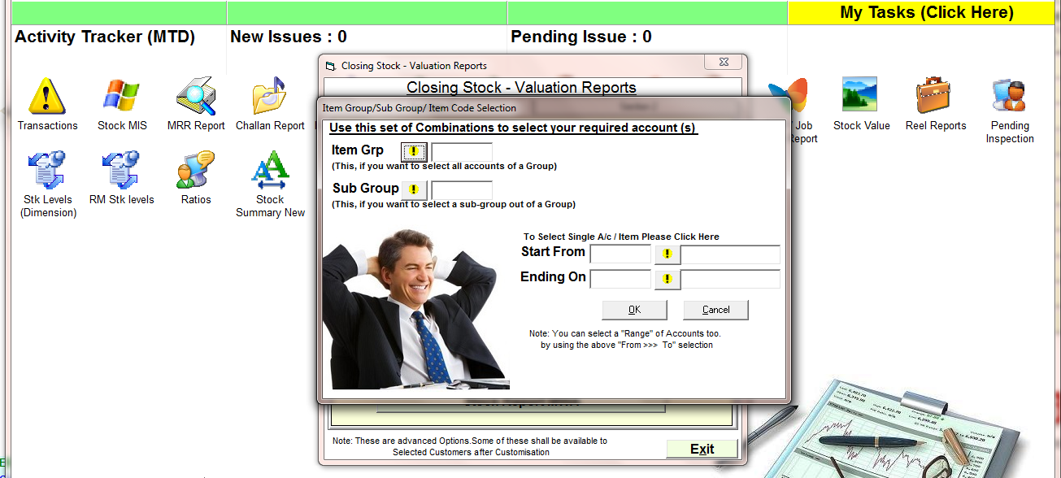
Select the item code if you want to see report for specific item
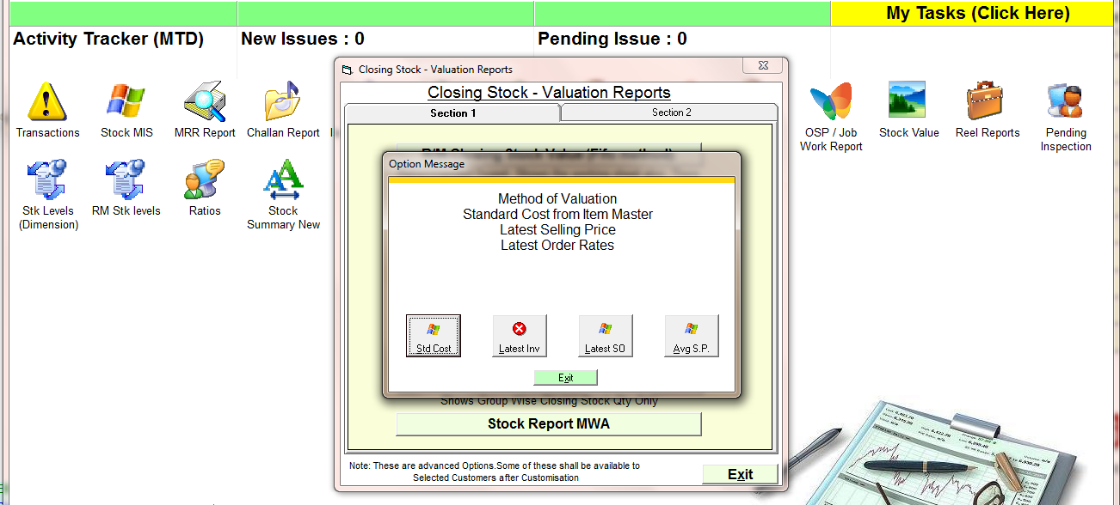
Select the method
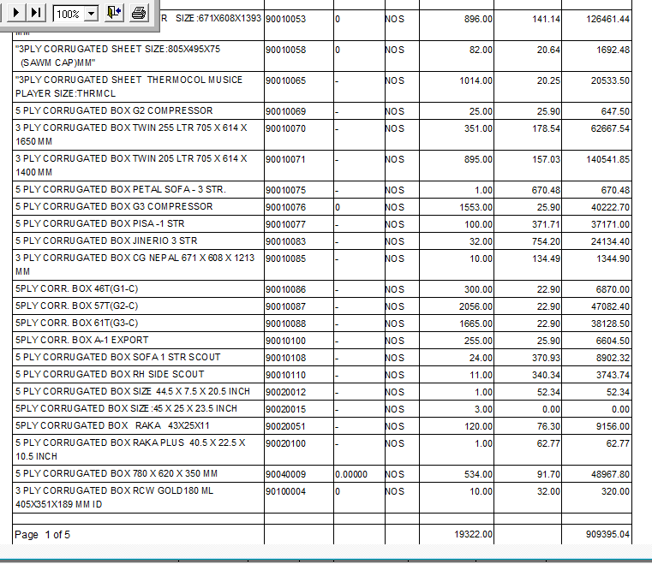
Report

