Can we get the report of vendor late material receipt?
Yes, we have a report for vendor late material receipt
PURCHASE&PROCUREMENTPURCHASE MIS4TH TAB (SUPPLIER ANALYSIS/OTHER)VENDOR : LATE MATERIAL RECEIPT
Click:- PURCHASE&PROCUREMENT
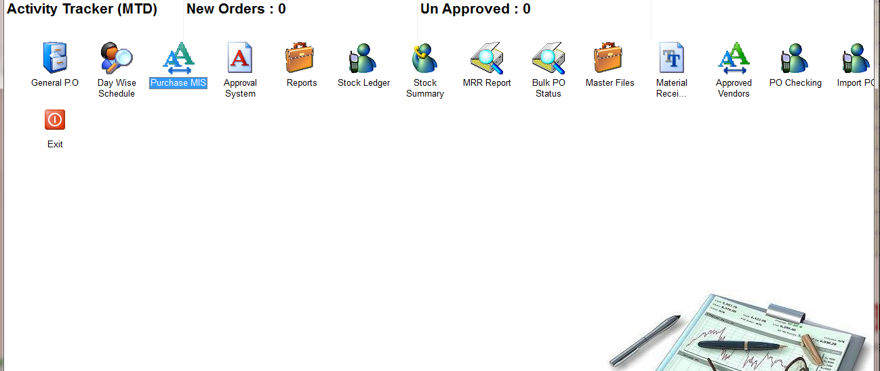
Click:- PURCHASE MIS
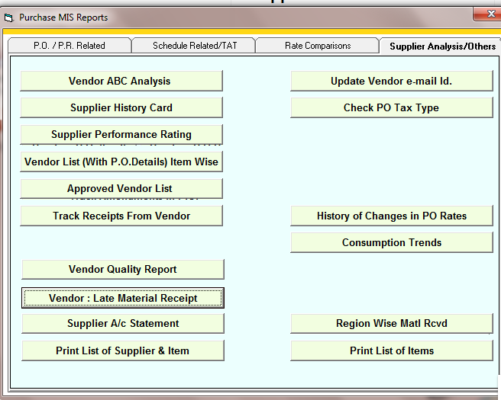
Click: Vendor: Late Material Receipt
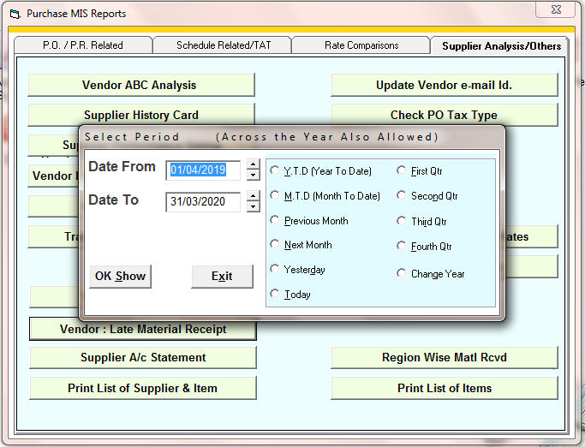
Select the time period
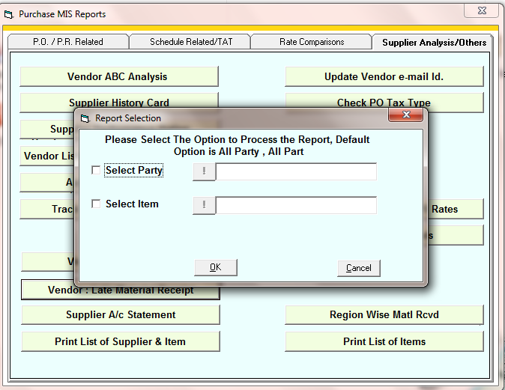
Select the party or item if you want to see report of specific a item or party
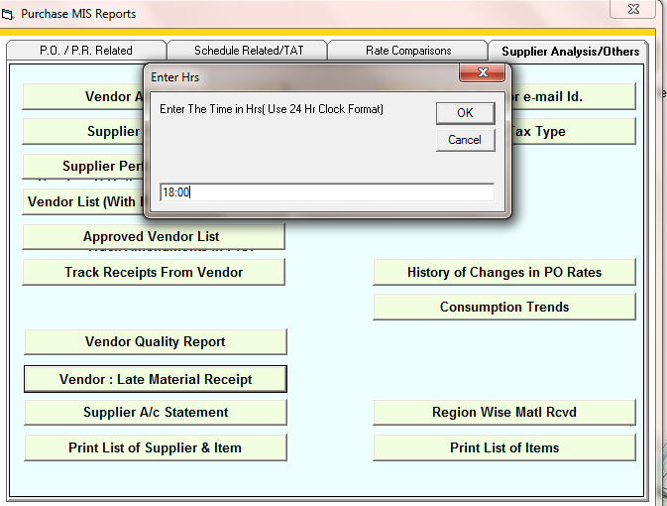
Enter the last hour time of the day in company
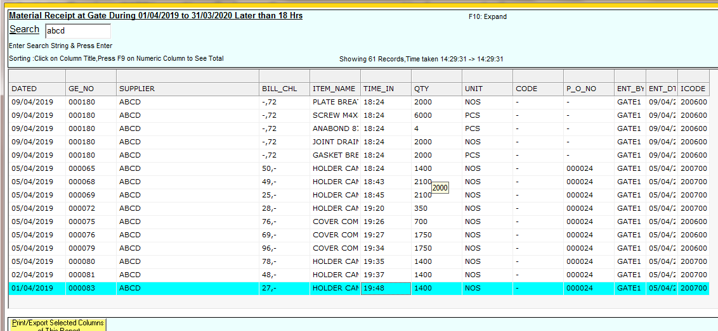
Report

