Can we get the report of list of approved vendor?
YES, we have a report for list of approved vendor
PURCHASE&PROCUREMENTPURCHASE MIS4TH TAB (SUPPLIER ANALYSIS/OTHER)APPROVED VENDOR LIST
Click:- PURCHASE&PROCUREMENT
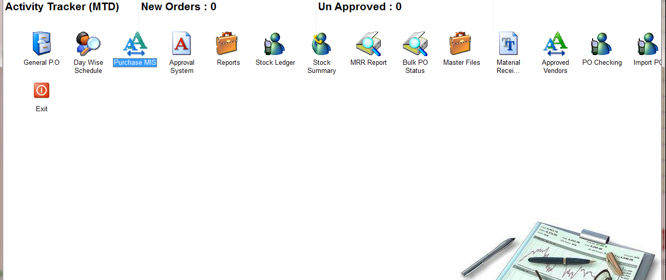
Click:- PURCHASE MIS
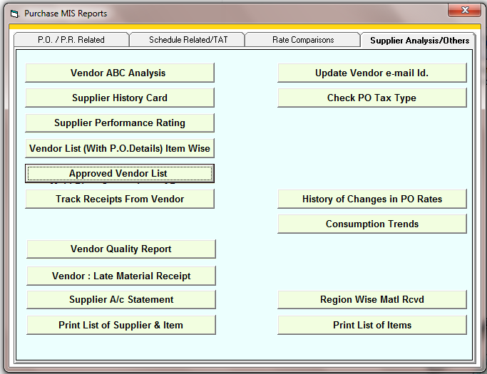
Click:- Approved Vendor List
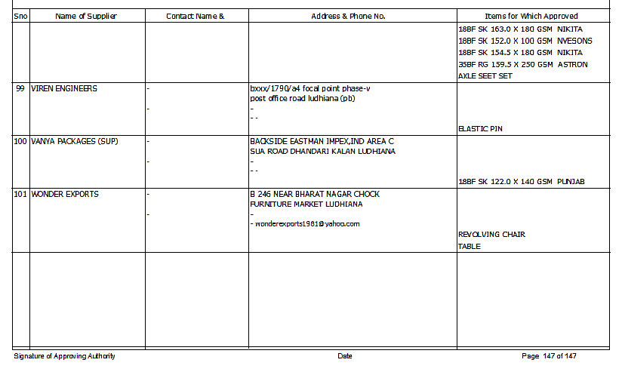
Report

