Can we get the report for average cost of receipt?
YES, we can see report for average cost of receipt.
PURCHASE&PROCUREMENT>>REPORTS>>MIS REPORTS>>AVG COST OF RECEIPTS
In this report we can get the average cost of items for selected time period.
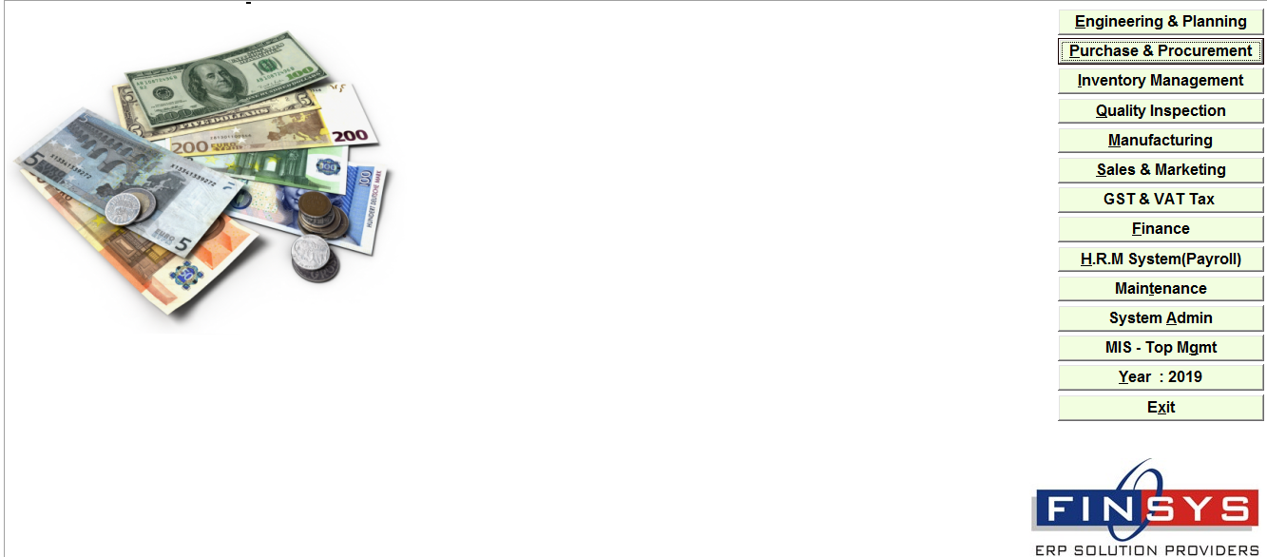
PURCHASE&PROCUREMENT
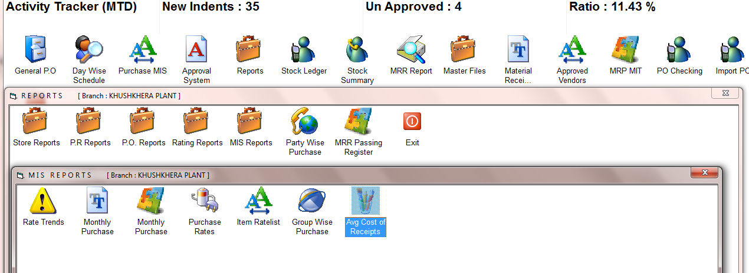
PURCHASE&PROCUREMENT>>REPORTS>>MIS REPORTS>>AVG COST OF RECEIPTS

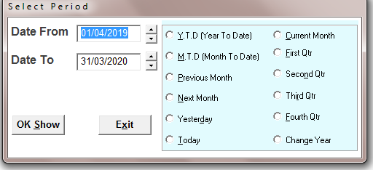
SELECT THE TIME PERIOD
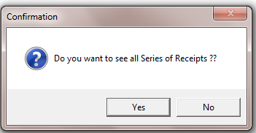
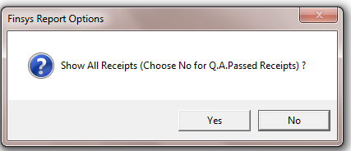
SELECT THE OPTION
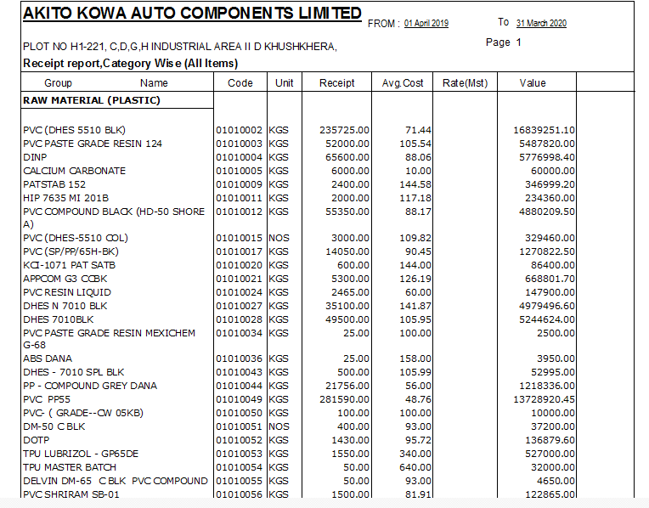
REPORT=In the receipt column showing the quantity as per selected time period and average cost in avg cost column and value

