Can we get the consumption report of items?
YES, we have a report for consumption report of items
PURCHASE&PROCUREMENTPURCHASE MISFIRST TAB (PR/PO RELATED) CONSUMPTION REPORT (ISSUE-RETURN)
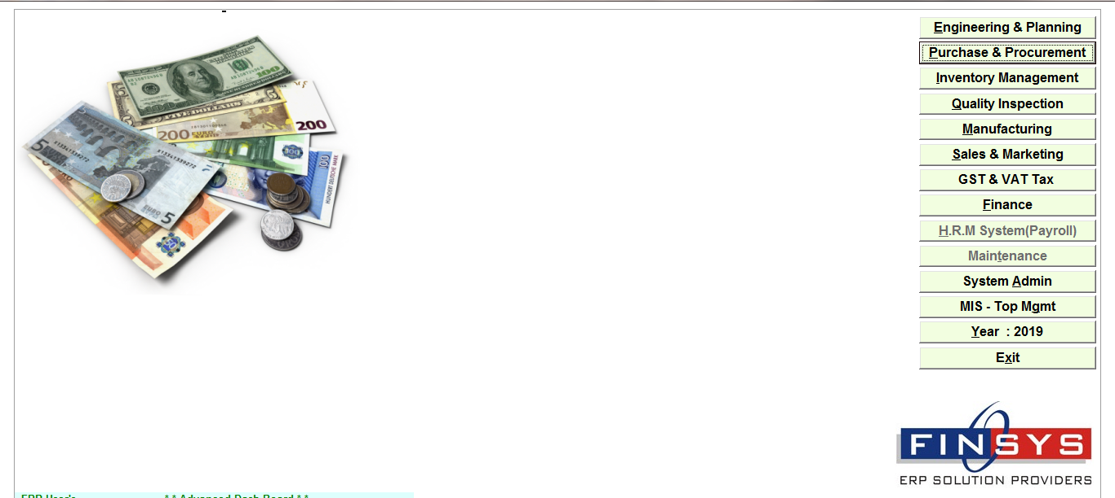
Click:- Purchase & procurement
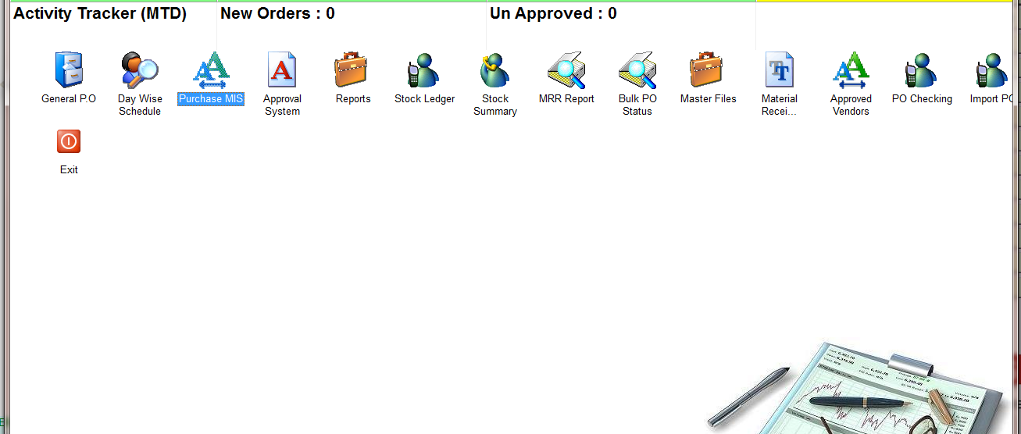
Click:- Purchase MIS
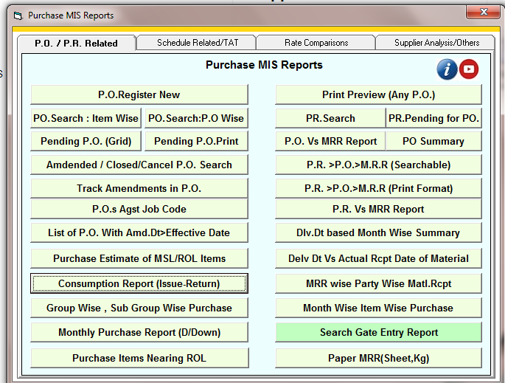
Click:- Consumption report (issue-return)
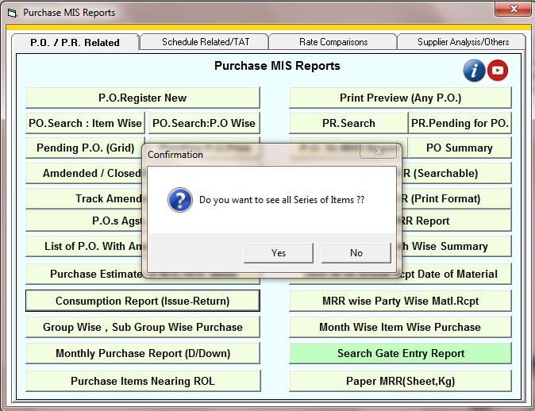
Select the option
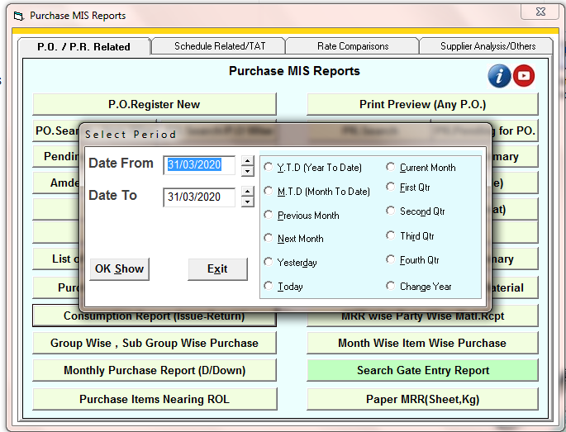
Enter the time period
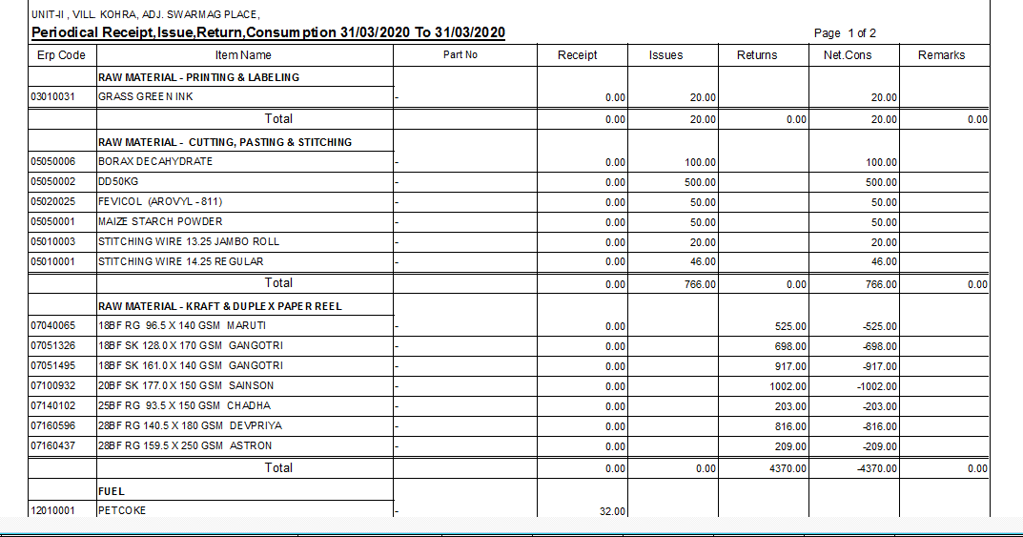
Report of all items

