Can we get report of item purchase but not issued?
YES, WE HAVE A REPORT FOR ITEM PURCHASE BUT NOT ISSUED
PURCHASE&PROCUREMENTPURCHASE MIS2nd TAB (Schedule related/TAT)PURCHASE BUT NOT ISSUED
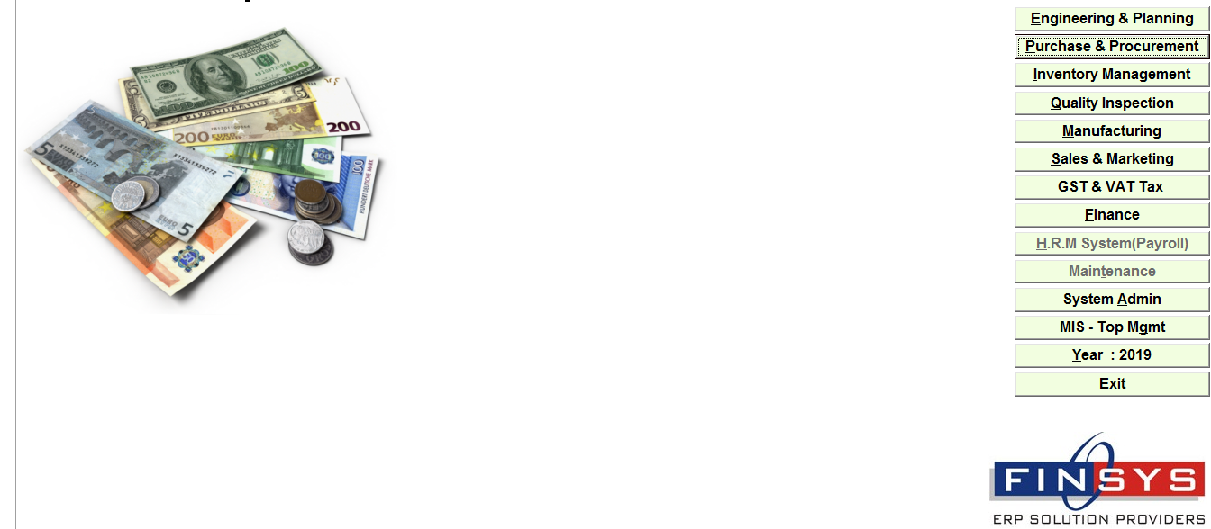
Click:- PURCHASE&PROCUREMENT
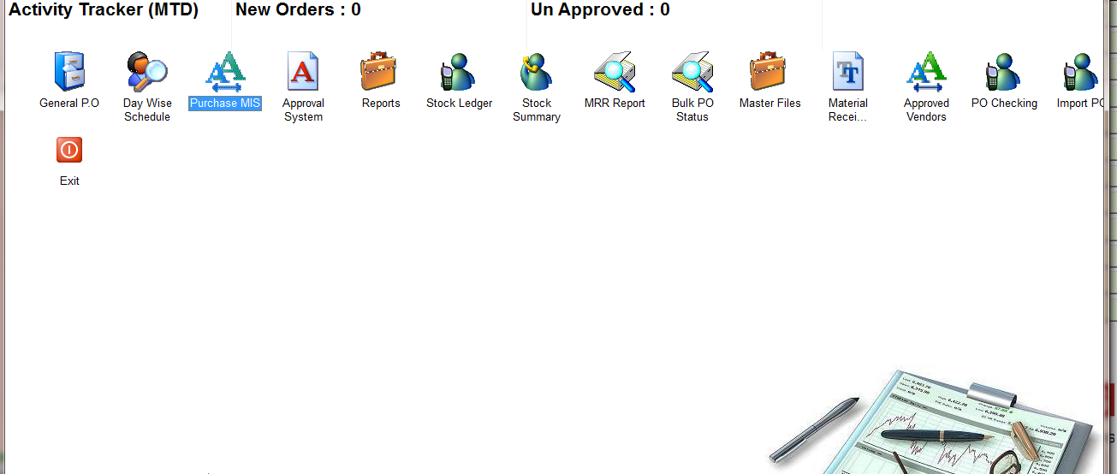
Click:- PURCHASE MIS
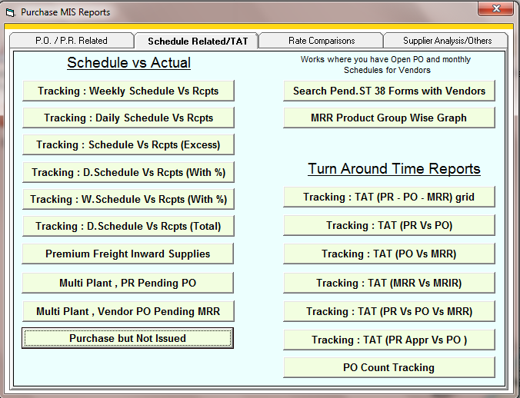
CLICK: PURCHASE BUT NOT ISSUED
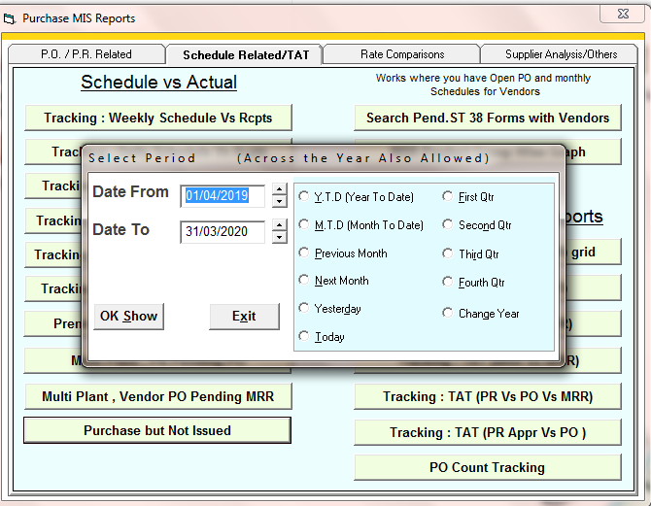
SELECT THE TIME PERIOD
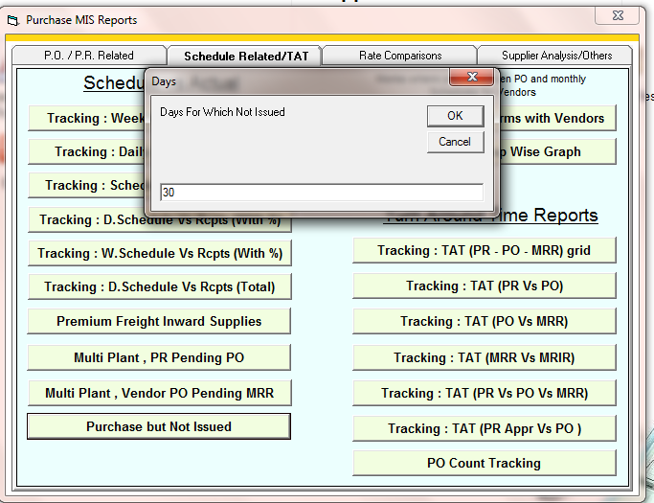
CLICK: ENTER THE DAYS

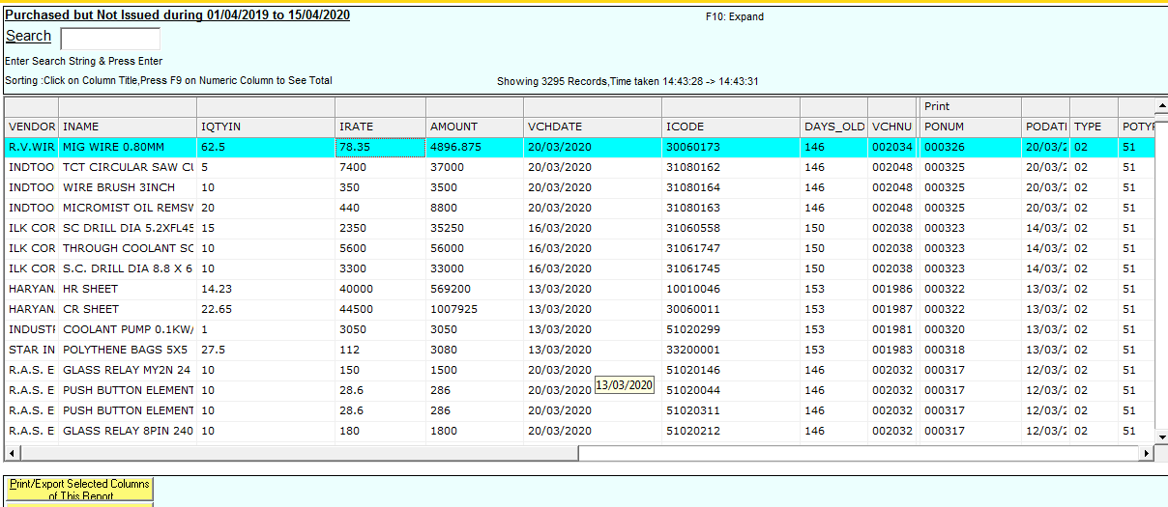
REPORT

