How can we reduce TCS% rate in finsys?
We can reduce TCS% with system&admin module

System&ModuleControl PanelD38 e.g. 0.75

Click:- System & admin module

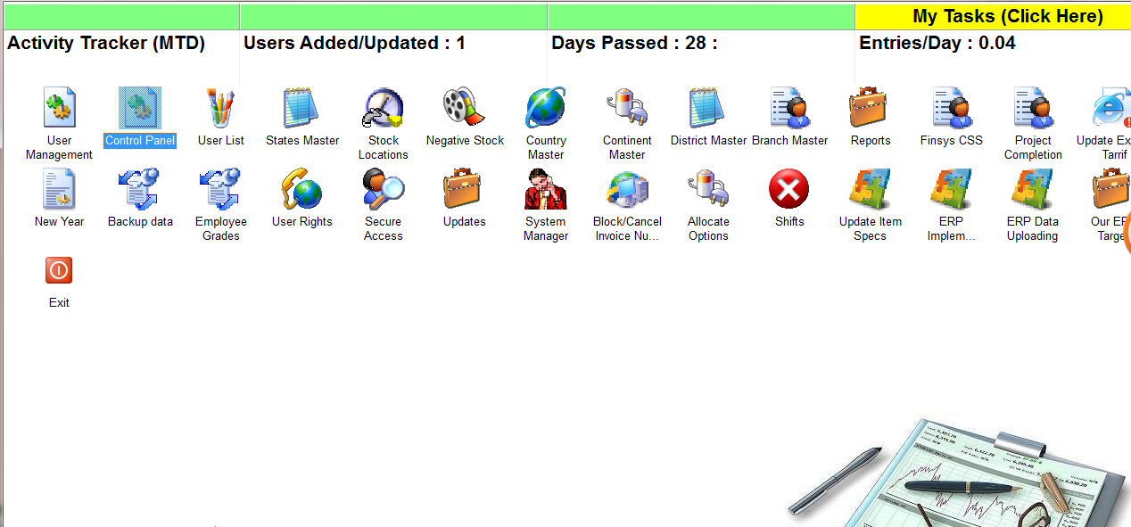
Click:- Control panel
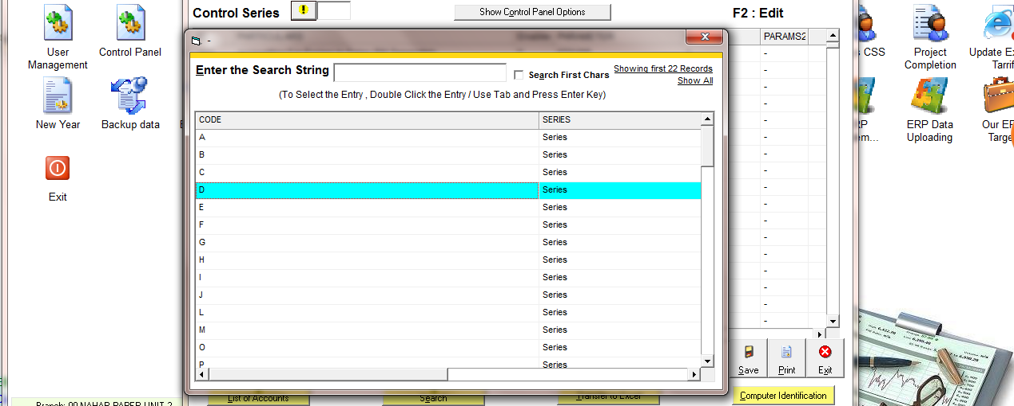
Click:- Control series and select the D series
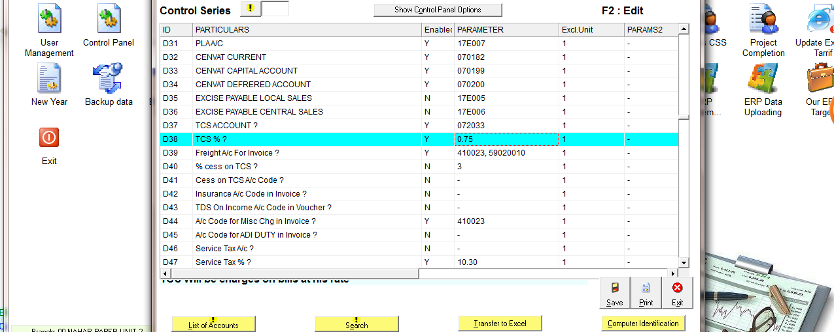
Scroll and go to D38 series and change the rate

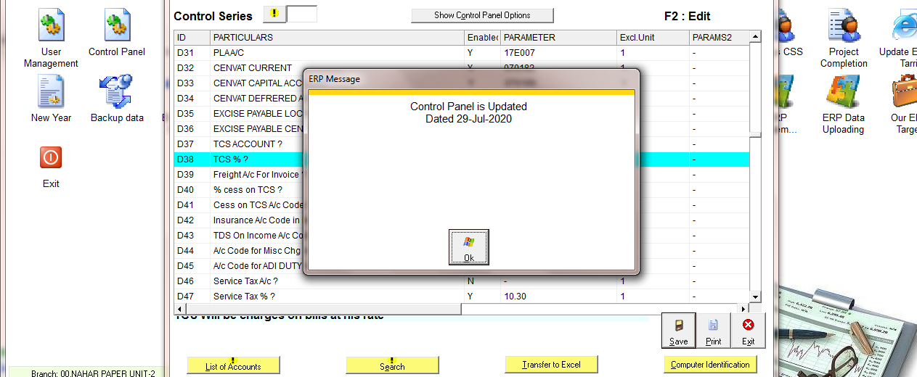
Click:- Save

