What report should we see for goods material received with PO?
We have a report for goods material received with PO in:
Purchase & procurement module reports PO ReportPurchase order and good received.

Click:- purchase & procurement module
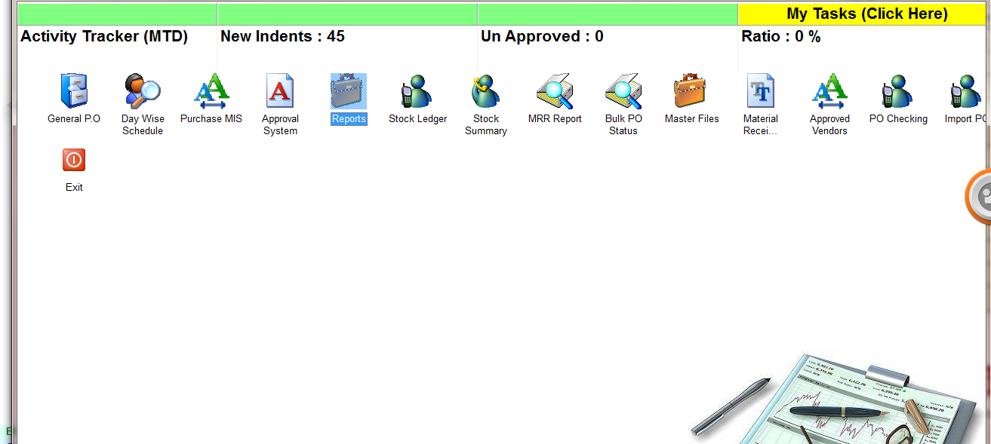
Click:- Report
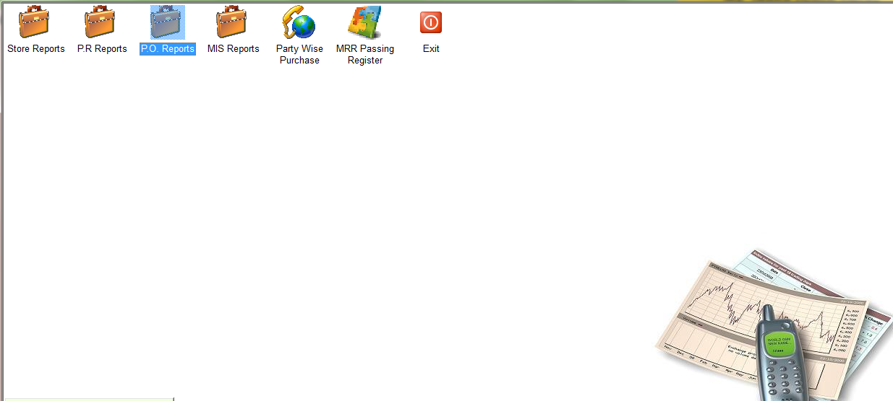
Click:- PO Reports
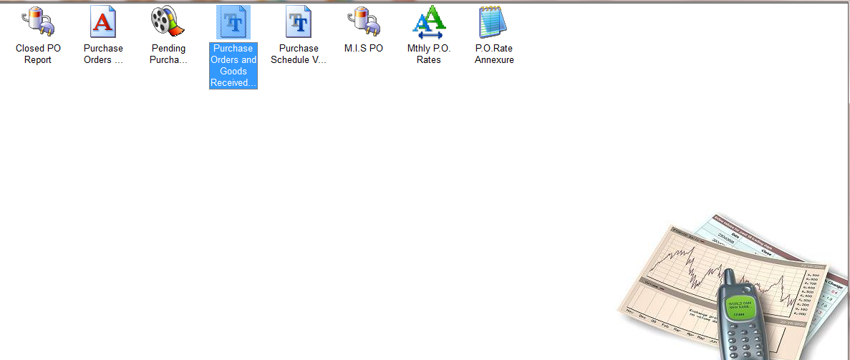
Click:- Purchase order and good received
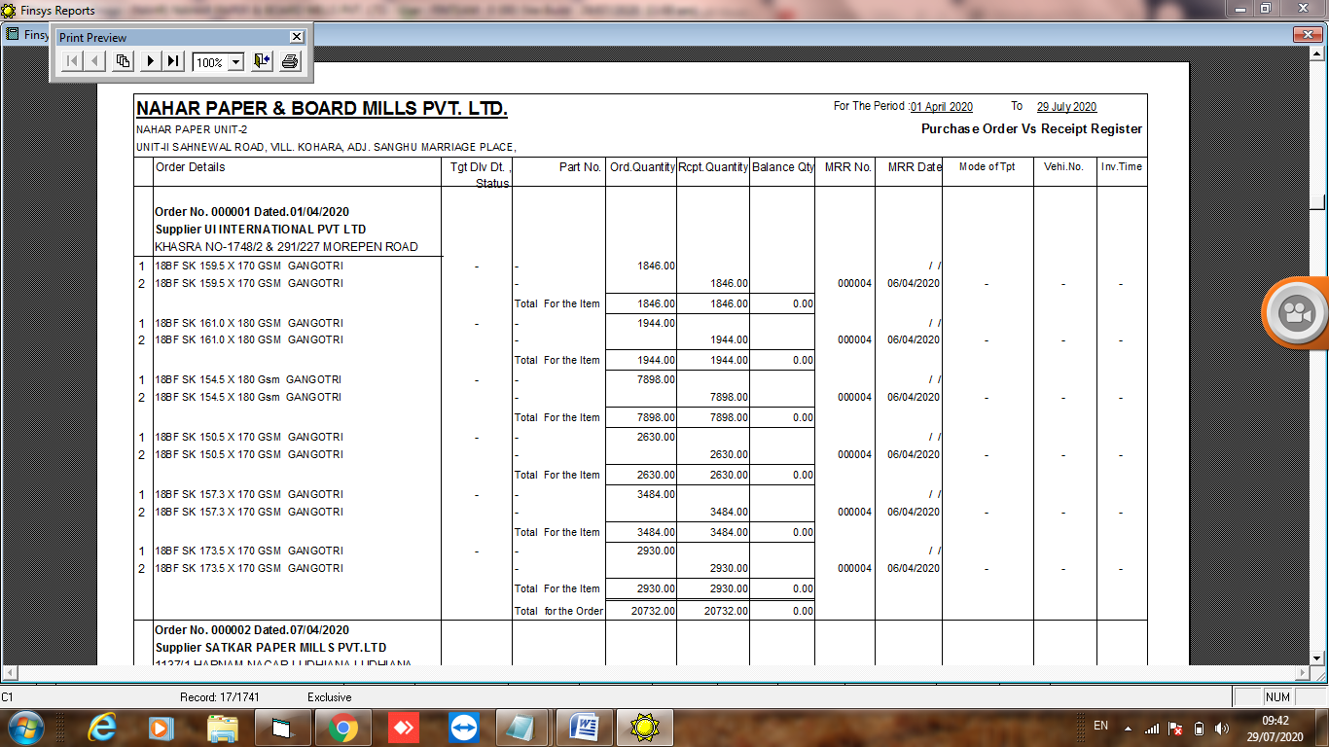
Report

