General Overview:

In a company, payroll is the sum of all financial records of salaries, wages, bonuses, and deductions.

The Payroll module maintains all information on your employees. This includes keeping track of sick and vacation hours accumulated and used during the year. Each employee record includes a Human Resources information page when employee join the firm, date of birth, marital status, date of marriage, date of leaving etc.

FINSYS Payroll stores complete records of the employees, generates Pay-slips and Attendance Register, Computes all allowances and deductions and generates all Statutory and MIS reports.
You may create an unlimited number of deductions and miscellaneous compensations to assign to employees. all formula for P.F, PF TRUST., F.P.F., E.S.I.C. etc. are definable and changeable at User's end

Various allowances, Deductions and miscellaneous compensation that takes care of all your requirements relating to accounting and management of employees’ Payroll.

After this Overview of Payroll system Many Question arises in front of us. Which are :
What are payroll inputs? Does it changes from company to company?

PAYROLL Modules : FINSYS Payroll software modules are categorized as –

- Master Data Entry Form :

- Transaction Entry Form

- Reports

Master Data Entry Form :
Master Basically contains all useful information. So Master Entry is a very sensitive part of any Database System. If Bad input then output comes bad obviously. So here are some precaution which is mandatory.
Preacautions :
- Don’t Enter improper information in the system. Before Feeding the master first gather all mandatory information which has to fill in the Database.
- Only authorized person must allow in feeding of Master. Otherwise any body who don’t know about this can make garbage to all this.
What are the steps in Payroll Management?

What is the software efficient for carrying out payroll tasks?

What are payroll inputs? Does it changes from company to company?

How payroll works?

Master Types

- Employee Master
- Designation Master
- Department Master
- Additional Information Master ( For HR purpose )
- Increment Entry
- Dispensary Master
- Category Master

c
Employee Masters

- Employee General Information This covers basic information about an Employee such as -Name, Emp Code, Fathers/ Husband name, all Contact Addresses, Email Addresses, Mobile Numbers etc.
- Employee Salary Structure This covers complete Employee Salary Structure details covering all Earning and Deduction heads and Benefits.
- Employee Dependent Details This cover all information about Employee Dependents that is required from Payroll and Reimbursement perspectives.
- Employee Payroll Information This cover important information line Bank Details, Account Number, PF and ESIC Number, PAN Number, Blood Group etc.
- Employee Reporting This covers Employee Reporting relationships. Payroll provides facility for an Employee to report Superior
- Joining Details This covers important information of joining date of an Employer.

How to Enter Information in Employee Master in Finsys.

First of all, Enter your name and password in Finsys ( screen shown below )

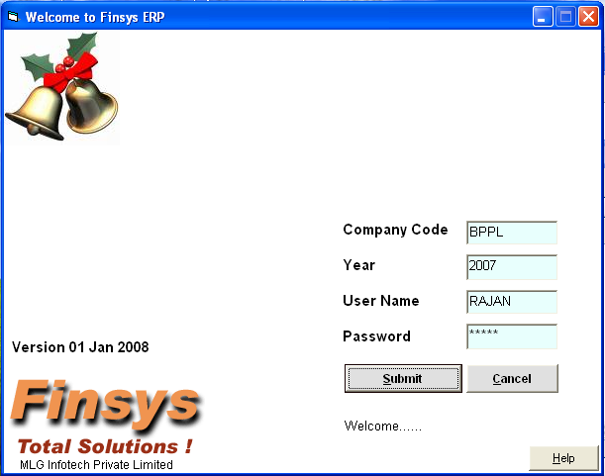
Enter your user name
Enter your password
After Entering user name password

This is the main Employee Master Screen..
This is auto generated Emp. Code

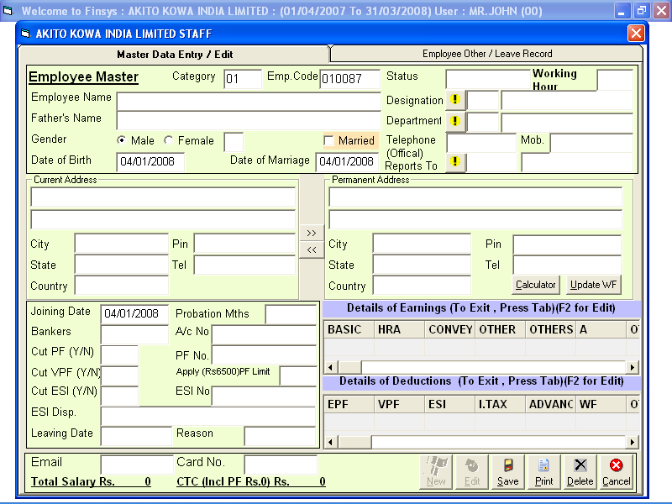

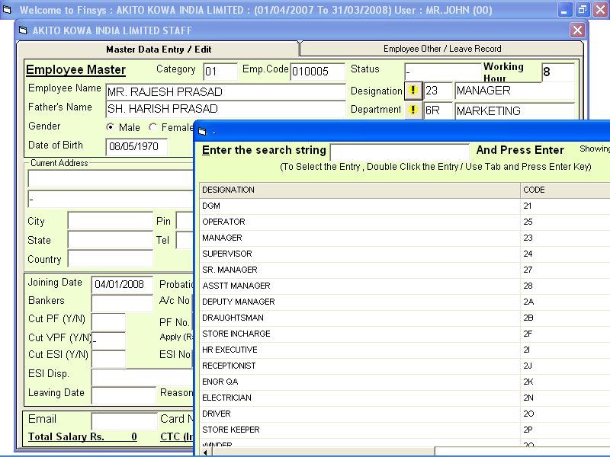
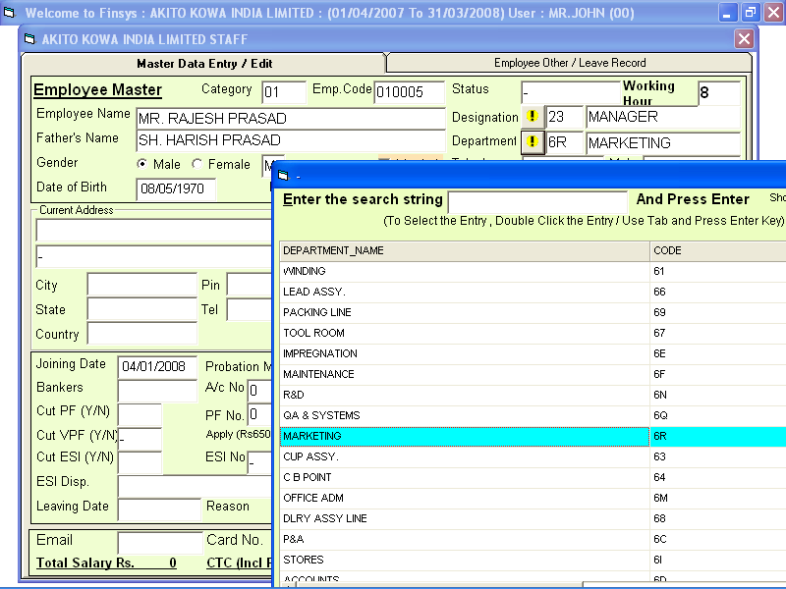
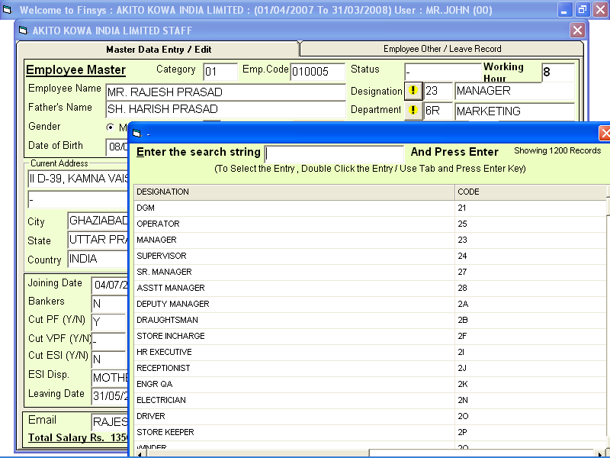
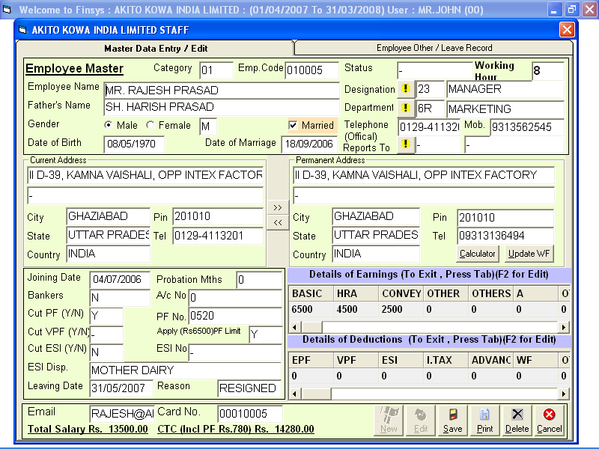
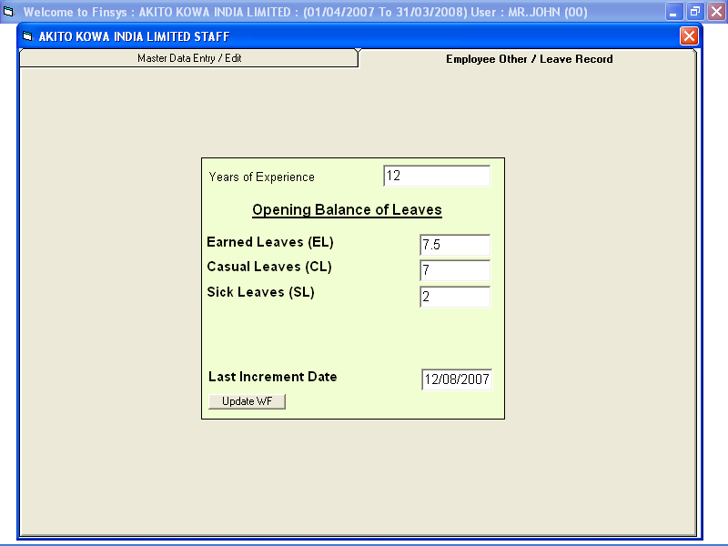
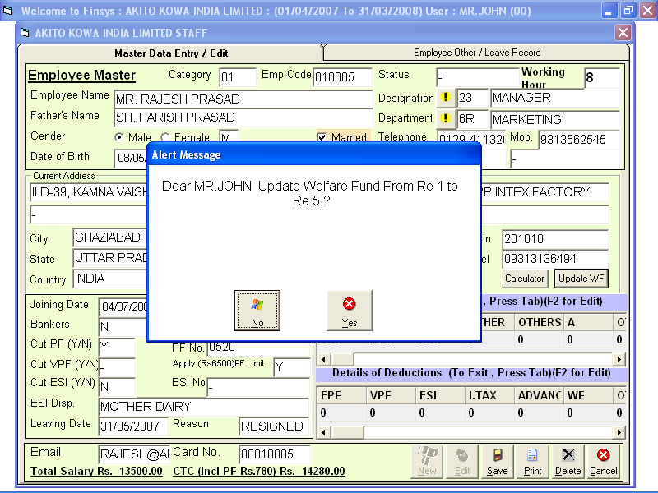

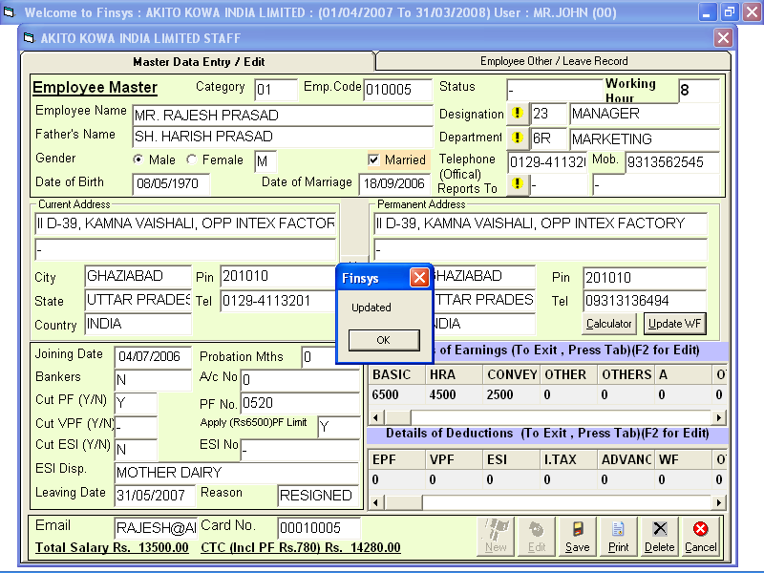

Designation Master

- In Designation Master contain all Desgignation

Precaution: Don’t open appropriate Designation as per company provision.

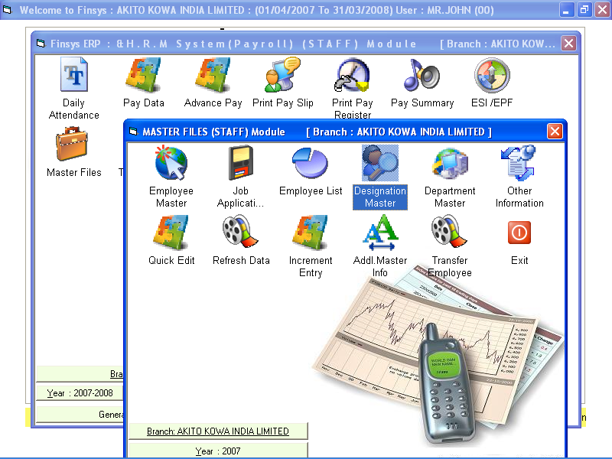
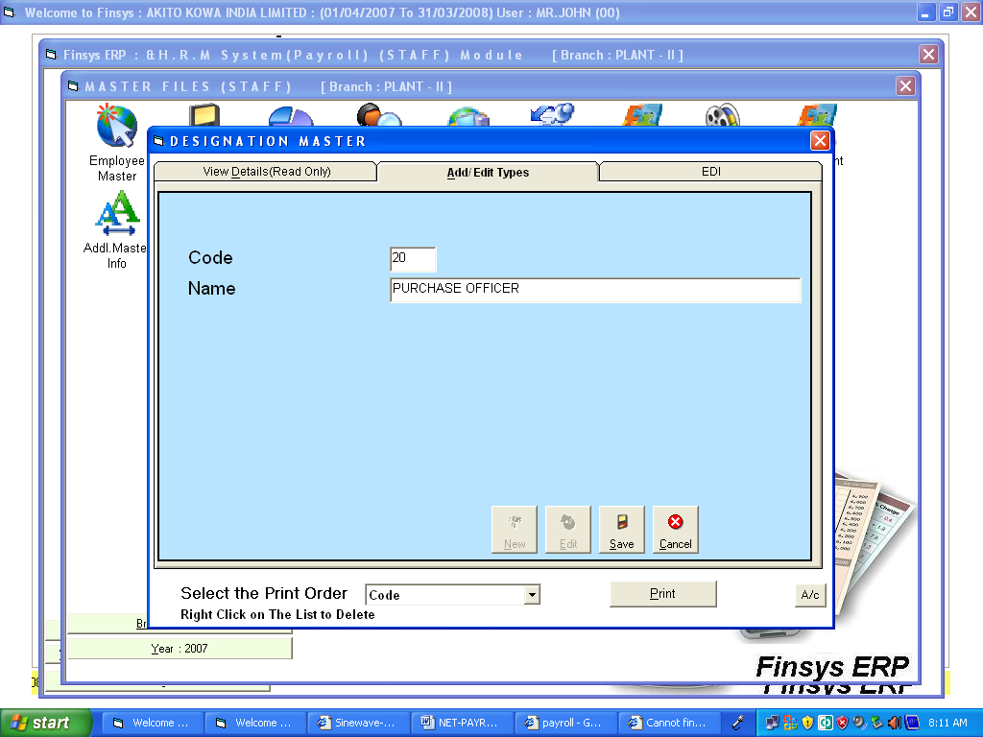
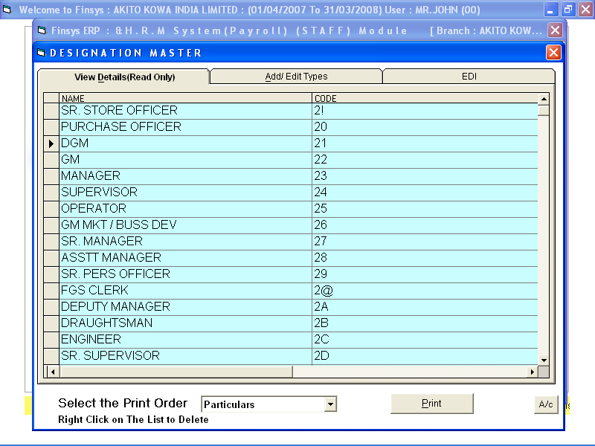
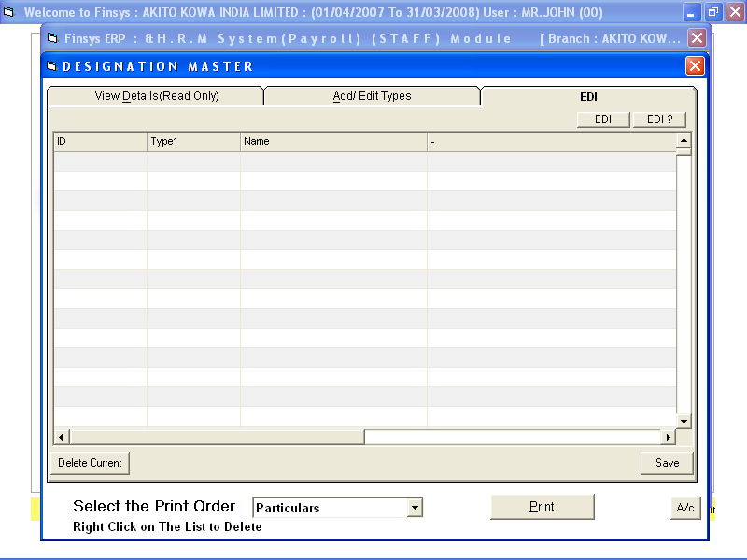

Department Master

- In Department Master contain all Designation

Precaution: Don’t open appropriate Department as per company provision.

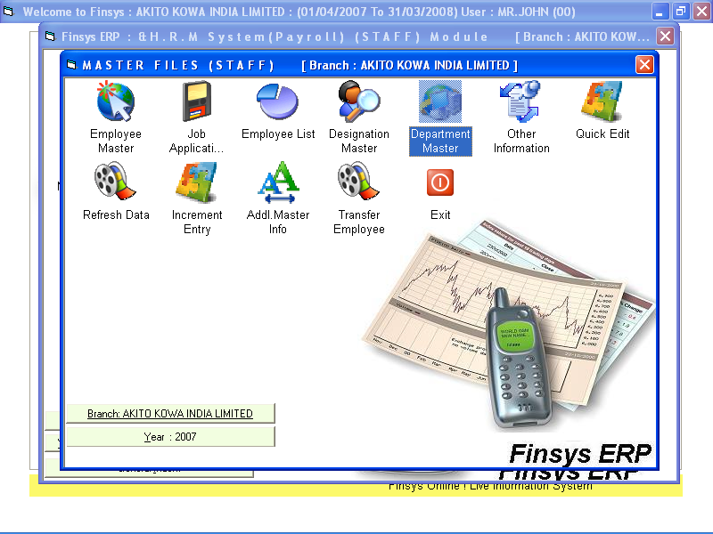
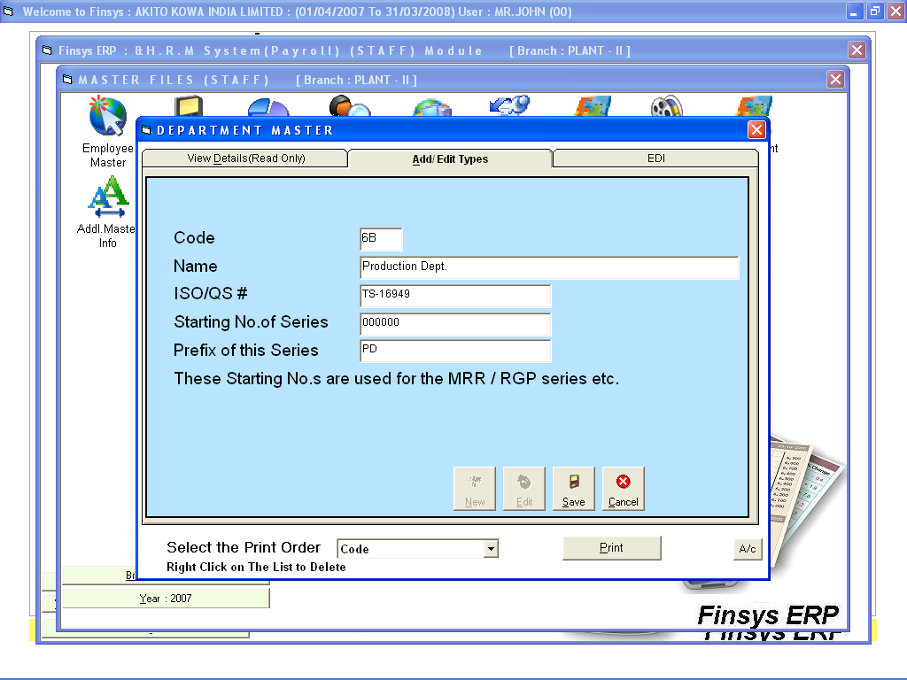

Additional Information Master ( For HR purpose )

- In Additional Information Master contains all personal data of employee of family (Husband/Wife name, date of birth and Details of Children) and increment status.

Precaution: Don’t open appropriate Department as per company provision.

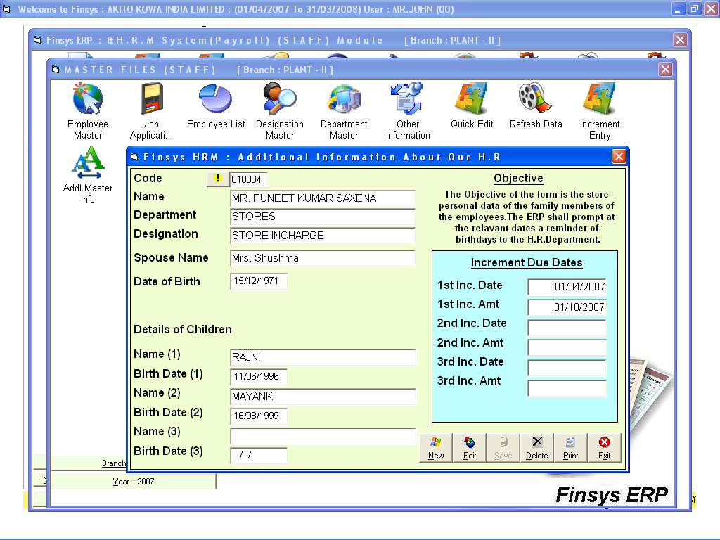
Increment Data increment Form

- Increment Data Entry Form contains all increment given to the employee.



