# E-circular dated 23rd Feb 2018

**Integrated Association of Micro, Small & Medium Enterprises of India**

[***www.iamsmeofindia.com***](http://www.iamsmeofindia.com)

E-mail: [info@iamsmeofindia.com](mailto:info@iamsmeofindia.com), +91-9711123111 (Executive Secretary)

|  |  |  |
| --- | --- | --- |
| Rajive Chawla  Chairman, IamSMEofIndia |  | Description: Description: Sangeet-small-skg-direct eye-40kb-truncate  Sangeet Kr Gupta  Hon. Consultant,  IamSMEofIndia |

Dear Members,

Income Tax Deduction Sec 80D

= Mediclaim + 100% of actual Expenditure

No Mediclaim policy required for the Senior Citizens



**Executive Summary**

As per Old understanding…

if you spend something on the Mediclaim policy premium.. you get a deduction…

Now, this is the latest news

for all of you who / family members are Senior Citizens

80D is allowed for **100% of Actual medical expenditures** subject to the same limits.

Reason : Some of the senior citizens are not eligible for Mediclaim,

So, the Government has allowed… 100% of actual medical expenditure in case of anybody whose age is over 60 years.

**Medical Premium Paid And Maximum Tax Deduction**

**For FY 18-19 ( next year )**

|  |  |  |  |
| --- | --- | --- | --- |
| Description | **Self, Spouse and Dependent Children** | **Parents (Dependent or Not)** | Total |
| No one in the family is a senior citizen | 25,000 | 25,000 | 50,000 |
| No one in your family (you, spouse or children) is a senior citizen,  But your parents (either father, mother or both) are senior citizens | 25,000 | 50,000 | 75,000 |
| One or all your family (you, spouse or children) is a senior citizen,  If your parents (father, mother or both) are senior citizens | 50,000 | 50,000 | 1,00,000 |

**Other points of 80D**

1. Allowed only to Individuals and HUF
   1. OK
2. Allowed only if paid by Cheque / Digital Payments ( any mode other than cash )
   1. OK
3. Actual medical expenditure allowed
   1. For FY 17-18 : Only if that person is age over 80 years
   2. For FY 18-19 : Only if that person is age over 60 years
   3. And is not covered by any mediclaim policy
   4. So, there is no distinction between Senior and Very Senior Citizen now w.e.f. 1st April 2018
4. Preventive Healthcare Checkups
   1. You can get 80D for these payments too
   2. Whether paid by cash or cheque
   3. Sub-limit is Rs 5000 per person per year



**Medical Premium Paid For Maximum Tax Deduction u/s. 80D**

**For FY 17-18**

|  |  |  |  |
| --- | --- | --- | --- |
| Description | **Self, Spouse and Dependent Children** | **Parents (Dependent or Not)** | Total |
| No one in the family is a senior citizen | 25,000 | 25,000 | 50,000 |
| No one in your family (you, spouse or children) is a senior citizen, But your parents (either father, mother or both) are senior citizens | 25,000 | 30,000 | 55,000 |
| One or all your family (you, spouse or children) is a senior citizen, If your parents (father, mother or both) are senior citizens | 30,000 | 30,000 | 60,000 |



**Final conclusion**

1. Insure yourself properly
2. For Senior Citizens, in your family, if the age is 60+, then all the 30000 Rs limits have been changed to Rs 50000 per year
3. And, for Senior Citizens, if you do not take a Mediclaim .. still you / your parent is eligible for Rs 50000 deduction from next year…. If you do any medical expenditure by Digital means
4. Just keep your records properly
5. Tip : Pay by Debit Card / Credit Card for ease in Accounting

< end of the writeup >

**For queries, suggestions and feedback , you can e-mail us**

### Sangeet Kumar Gupta, FCA, DISA, ACMA, PGDMM, B.Com(Hons), Honorary Consultant, Integrated Association of Micro Small and Medium Enterprises of India and Faridabad Small Industries Association, 93126-08426, Camp Off : TB-06, 3rd Floor, Crown Plaza, Sector-15A, Faridabad, Haryana 121007 skgupta[at]finsys.in

### I am SME of India Office … I-am-SME Habitat Centre, B-1/21, Sector 11, Mathura Road, Faridabad

### Subscription to our newsletters/ e-circulars

Please send your details, and request e-mail to [info@iamsmeofindia.com](mailto:info@iamsmeofindia.com) / skgupta[at]finsys.in

### for Discontinuation of this E-mail

To discontinue receipt of e-mails from the author, please reply mentioning "Discontinue" in the Subject.

### Notes & disclaimer

The contents of this circular are for Private circulation & intended for the addressee/s only. We do not warrant that this email is free of mistakes, errors or any other defect. Care has been taken to provide authentic information, but it is advisable to confirm/verify with qualified legal practitioners, professionals before implementing any suggestions. The views expressed are not necessarily those of the Association. We encourage readers, our Members to write to us their opinions, suggestions, ideas, comments, thoughts and bring to our knowledge mistakes, omissions etc. which we’d be pleased to correct/implement.

For personalised suggestions, and solutions, contact our I am SME of India Team and Consultants

Our sponsors :

 

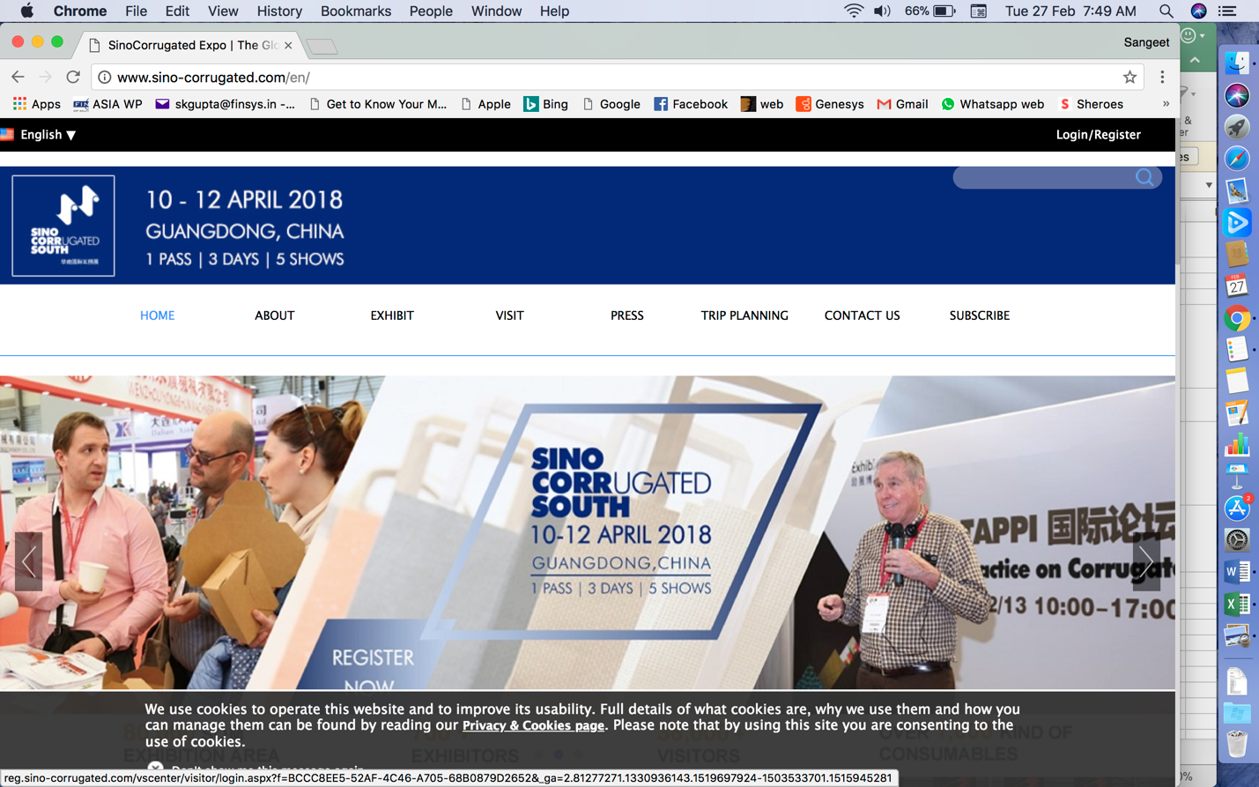

Finsys is participating in Sino Corrugated South

In Guang-dong , China

<http://www.sino-corrugated.com/en/>

Stall number C2-460

10th to 12th April 2018

Our member Finsys is Participating in the upcoming Exhibition : Sino Ccorrugated South.

SinoCorrugated South 2018 is the Asia Pacific’s leading corrugated expo, where more than 36,000 corrugated industry professionals, buyers and end-users come together to build partnerships, place order, learn corrugated industry trends and do business. The exhibition will span 80,000 sqm to showcase more than 1,400 high-end, cost-effective machineries and 1,000 consumables from over 700 brands.

And

Finsys ERP is currently the largest selling ERP Software in the **Corrugated Packaging** domain too

This is the Story In India…. Now, Planning to expand footprint globally.

**Parta Report**

( Profitability Report )





It was a pleasure to hand over the Government Financial Incentive of Rs.53,500/- to each member delegate of Hannover Fair, Germany, 2017. For this year’s delegation also we are providing Rs.50,000 upfront support. Upon return, a similar incentive is expected from the Government also.

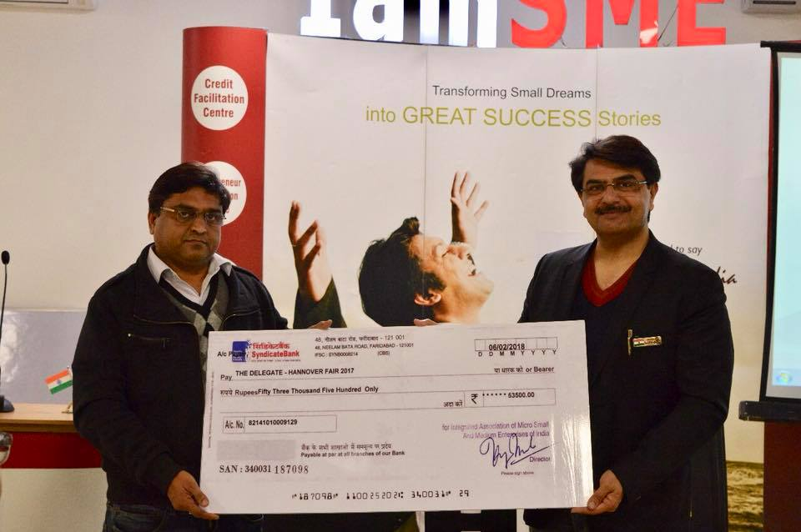

It’s always heartening to be able to do something for our members.Join us, for such other benefits, mail us [info@iamsmeofindia.com](mailto:info@iamsmeofindia.com), +91-9711123111 (Executive Secretary)

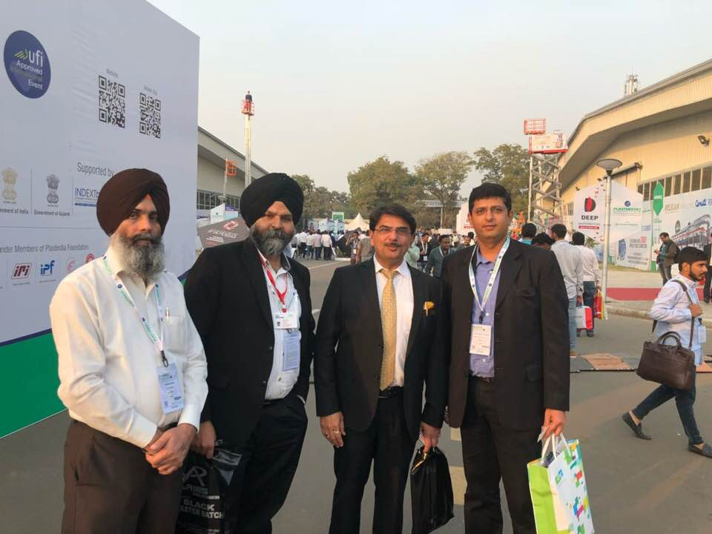

At PlastIndia with 60-Member strong delegation of FICO- IamSMEofIndia  
A memorable day of learning, sharing and warmth of friendship!

We are regularly conducting various Study tours, SME Clusters, Energy Efficiency Programmes, Exhibition Participations, both in India and Abroad. We invite you to remain connected on Emails, our Whatsapp Groups and our Facebook page ! Like us !

<https://www.facebook.com/profile.php?id=631552371>